# Chapter 1A: Assessment of the pollock stock in the Aleutian Islands

Steve Barbeaux, James Ianelli, Ivonne Ortiz, and Ned Laman

Alaska Fisheries Science Center

November 2022

Goode 1884 pollock.tif

# Executive Summary

Model 15.1 (same as the 2015 accepted model) is presented for ABC/OFL advice. The 2021 Aleutian Islands bottom trawl survey index value, 2020-2021 fishery age composition, and updated 2021 and 2022 fishery catch estimates comprised the new data for this year’s assessment. Total 2021 catch in the AI was 1,839 t, and as of September 27 the 2022 catch was at 2,709 t.

## Summary of Changes in Assessment Inputs

Relative to last year’s assessment, the following changes have been made in the current assessment:

### Summary of changes in assessment inputs

* Catches for 1978 to 2022 were updated to latest estimates from the catch accounting system (CAS). There were no significant changes except the addition of the 2022 estimate at 3,000 t.2022 AI bottom trawl survey index estimate was added.
* 2019 and 2020 fishery age composition data were added.

### Summary changes in the assessment model

* There were no changes to the recommended model for ABC/OFL advice. However, for comparison Model 15.2 configuration was again presented which allows for differential natural mortality (*M*) with age. In this configuration, natural mortality for ages 1, 2, and 15 were modeled as deviations from the natural mortality for ages 3-14 fit with a log normal prior on *M* with a mean of 0.2 and CV of 0.2.

## Summary of Results

|  |  |  |  |  |  |  |  |  |
| --- | --- | --- | --- | --- | --- | --- | --- | --- |
|  | As estimated or  *specified last* year for: | | | As estimated or  *recommended this* year for: | | | | |
| **Quantity** | 2022 | | 2023 | 2023 | | | | 2024* |
| *M* (natural mortality r**a**te) | 0.21 | | | 0.21 | | | | |
| Tier | 3a | | | 3a | | | | |
| Total (age 1+) biomass (t*)* | 308,525 | 330,375 | |  | |  | | |
| Female spawning biomass (t)  Projected | 89,516 | 87,650 | |  | |  | | |
| *B100%* | 185,475 | | |  | | | | |
| *B40%* | 74,190 | | |  | | | | |
| *B35%* | 64,916 | | |  | | | | |
| *FOFL* | 0.390 | 0.390 | |  |  | | | |
| *maxFABC* | 0.313 | 0.313 | |  |  | | | |
| *FABC* | 0.313 | 0.313 | |  |  | | | |
| OFL (t) | 61,264 | 61,379 | |  |  | | | |
| maxABC (t) | 50,752 | 50,825 | |  |  | | | |
| ABC (t) | 50,752 | 50,825 | |  |  | | | |
| **Status** | As determined *this* year for: | | | As determined *this* year for: | | | | |
| 2020 | 2021 | | 2021 | | | 2022 | |
| Overfishing | no | no | | no | | | n/a | |
| Overfished | n/a | n/a | | n/a | | | no | |
| Approaching overfished | n/a | n/a | | n/a | | | no | |

* Projection based on estimated catches of 3,000 t for 2022 and xxxx t for 2023, the five-year average *F* (2015-2019) of 0.021, used in place of maximum permissible ABC .

** Long-term equilibrium *F*OFL and *F*ABC were 0.390 and 0.313, respectively.

The stock is not being subject to overfishing, is not currently overfished, nor is it approaching a condition of being overfished. The tests for evaluating these three statements on status determination require examining the official total catch from the most recent complete year and the current model projections of spawning biomass relative to *B*35% for 2019 and 2020. The official total catch for 2019 is 1,663 t which is a small fraction of the 2019 OFL of 66,973 t; therefore, the stock is not being subjected to overfishing. The estimates of spawning biomass for 2021 and 2022 from the current year (2020) projection model are 89,906 t and 85,785 t, respectively. The 2021 estimate is above *B*35% at 64,916 t and the 2022 estimate is above ½ *B*35% and the stock is expected to be above *B*35% in 2032 under projection Scenario 7, therefore, the stock is not currently overfished nor approaching an overfished condition.

## Responses to SSC and Plan Team Comments on Assessments in General

* There were no SSC or Plan Team comments on assessments in general relevant to this assessment.

## Response to SSC and Plan Team comments specific to this assessment

* There were no SSC or Plan Team comments specific to the AI pollock stock assessment.

# Introduction

Walleye pollock (*Gadus chalcogrammus;* Coulson *et al.* 2006; Carr and Marshall 2008; here after pollock) are distributed throughout the Aleutian Islands (AI) with concentrations in areas and depths dependent on diel and seasonal migration. The population of pollock in the AI decreased in abundance from the mid-1980s to the mid-1990s (1986 bottom trawl survey estimate of 444,000 t to a 1994 bottom trawl survey estimate of 78,000 t). Since 1994 the abundance point estimate has been variable, but considering the variance of the survey estimates the trend appears relatively flat (Fig 1A.1). The 2012 survey abundance was a record low at 44,281 t. The 2014 survey abundance estimate at 85,316 t nearly doubled the 2012 estimate. The 2016 biomass estimate was similar to 2014 at 83,070 t, but the 2018 survey biomass estimate was double that of the previous survey at 165,747 t.The low 2012 estimate is thought to be anomalous due to the very low temperatures in the region affecting availability of the species to the bottom trawl survey. The precipitous decline between 1986 and 1991 may be in part due to undocumented fishing by foreign vessels claiming catch from the Central Bering Sea (CBS), as the documented fishing levels alone cannot account for the decline (Table 1A.1). A number of foreign fishing vessels were observed fishing in the AI during this time period (Egan 1988a; Egan 1988b) while claiming catch from the CBS. Since 2004 surveys show that the AI pollock population has been predominantly concentrated in the eastern portion of the Aleutian Island chain, closer to the Eastern Bering Sea shelf. Surveys from the 1980’s and 1990’s estimated higher proportions of pollock biomass in the central and western Aleutians (Fig 1A.1). This spatial change in population abundance may reflect a spatial contraction of the stock in the Eastern Bering Sea after the collapse of the Central Bering Sea population in the early 1990’s, low AI pollock recruitments since the mid 1980’s, documented higher exploitation rate of the AI pollock in the mid- to late 1990’s, and possibly a high undocumented exploitation rate in the late 1980’s by foreign fishers.

The relationship between Aleutian Islands pollock and pollock from neighboring areas is poorly understood. Bailey *et al.* (1999) presented a review of the meta-population structure of pollock throughout the north Pacific region identifying possible meta-populations in the Eastern Bering Sea. At the time of that study, samples from the Aleutian Islands region were unavailable. Recent genetic studies, which includes samples from the Aleutian Islands near Adak Island, have shown a lack of genetic heterogeneity among Northeast Pacific and Bering Sea pollock samples (Grant  *et al.* 2010). Grant *et al.* (2006) found and later confirmed (Grant *et al.* 2010) the greatest genetic differences occurred between samples from Asia and the Eastern North Pacific with mirror-image haplogroup clines between them. Grant *et al.* (2010) interpreted that the genetic differences across the Pacific Ocean and mirror-image haplogroup clines likely reflect divergence during ice-age isolations and subsequent expansion into the central North Pacific on each side with gene flow across the contact zone. The pollock in the AI therefore are most likely a mixed population from both Asian and North American and the result of re-colonization from both sides of the Pacific post ice-age.

Although the genetics evidence points to a mixed population, other evidence suggests that the AI pollock are separated from the EBS stock at smaller temporal time scales than current genetic techniques can identify, including disparate size at age and asynchrony in high recruitment events. It appears that the AI pollock are much more similar to the Gulf of Alaska (GOA) pollock than the EBS pollock in size at age, with the GOA pollock being significantly larger than the EBS fish and AI pollock being significantly larger than the GOA pollock (Figure 1A.2 from Barbeaux *et al.* 2016). This may be a latitudinal effect with the more southern AI pollock encountering a longer summer growing period. Similar latitudinal differences have been observed in both Pacific and Atlantic cod (Gadus *macrocephalus* and *morhua*; Ormseth and Norcross 2009). Although the AI and EBS shared some larger-than-the-mean (normalized at post-1979) recruitment events (1977, 1978, 1982, 1989, 2000, and 2011/2012) the AI shared more with the GOA (1976, 1977, 1978, 1985, 1989, 2000, and 2011/2012). All three regions shared five of these higher recruitment events (1977, 1978, 1989, 2000, and 2011/2012). In addition, the AI had unique high recruitment events in 1981, 1983, 1986, and 1987. Although the evidence is rather weak and not by any means conclusive, the size at age and asynchronous recruitments suggest some degree of separation between the EBS and the pollock of these three regions. In the stock structure presentation (Barbeaux et *al.* 2014) to the Council on Aleutian Islands pollock the Plan Team determined that the current management practices were of “little concern”.

For management purposes, the pollock population in the Eastern Bering Sea and Aleutian Islands (BSAI) has been split into three stocks. These stocks are: Eastern Bering Sea (EBS) pollock occupying the eastern Bering Sea shelf from Unimak Pass to the U.S.-Russia Convention line, Aleutian Islands (AI) pollock encompassing the pollock in the Aleutian Islands shelf region from 170°W to the U.S.-Russia Convention line; and the Central Bering Sea-Bogoslof Island (CBS-BI) pollock. These three management stocks probably have some degree of exchange. The CBS-BI stock is a group that forms a distinct spawning aggregation that has some connection with the deep water region of the Aleutian Basin. This stock assessment concentrates on the pollock of the Aleutian Islands and assumes that these fish are distinct enough from the CBS-BI and EBS meta-populations to model their dynamics separately.

Previously, Ianelli *et al.* (1997) developed a model for Aleutian Islands pollock and concluded that the spatial overlap and the nature of the fisheries precluded a clearly defined “stock” since much of the catch was removed very close to the eastern edge of the region and appeared continuous with catch further to the east. In some years, a large portion of the pollock removed in the Aleutian Islands Region was from deep-water regions and appeared to be most aptly assigned as CBS-BI pollock. Since 2003 these deep-water catches have been excluded from the stock assessment data and only the area designated as the Near-Rat-Andreanof Islands area (NRA) or the area closest to the Aleutian Islands have been used in the stock assessment (Fig 1A.2). In 2003 through 2007 the authors’ preferred stock assessment model excluded the fishery dependent data from east of 174°W longitude in the NRA. In 2007 a CIE review deemed the east-west data split as inappropriate and the authors’ preferred model has since included all fisheries dependent data from the entire NRA region.

# Fishery

## General description

The nature of the pollock fishery in the Aleutian Islands Region has varied considerably since 1977 due to changes in the fleet makeup and in regulations. During the late 1970s through the 1980s the fishing fleet was primarily foreign and joint venture (JV) where US catcher vessels delivered to foreign motherships. The last JV delivery was conducted in 1989 when the domestic fleet began operating in earnest. The distribution of observed catch differed between the foreign and JV fishery (1977-1989; Fig. 1A.3) and the domestic fishery (1989-2009). The JV and foreign fishery operated in the deep basin area extending westward to Bowers Ridge and in the eastern most portions of the Aleutian Islands. Some operations took place out to the west but observer coverage was limited. In the early domestic period (1991-1998) the fishery was more dispersed along the Aleutian Islands chain with no observed catches along Bowers Ridge and fewer operations in the deep basin area. The majority of catch in the beginning of the domestic fishery came from the eastern areas along the 170°W longitude line, and around Seguam Island in both Seguam and Amukta passes (Fig. 1A.3). As the fishery progressed more pollock were removed from the north side of Atka Island around 174°W and later near 177°W northwest of Adak Island inside Bobrof Island. While the overall catch level was relatively low, the domestic fishery moved far to the west near Buldir Island in 1998 (Table 1A.2). In 1999 the North Pacific Fishery Management Council (NPFMC) closed the Aleutian Islands region to directed pollock fishing due to concerns for Steller sea lion recovery.

## Recent fishery performance

In 2003 the entire AI pollock quota was allocated to the Aleut Corporation and in 2005 the directed fishery was reopened. The fishery was still restricted to areas outside of 20 nm of Steller sea lion rookeries and haulouts, limiting fishing to two small areas with commercial concentrations of pollock within easy delivery distance to Adak Island. One area is a 4 mile stretch of shelf break located northwest of Atka Island between Koniuji Island and North Cape of Atka Island, the other is a 7 mile stretch located east of Nazan Bay in an area referred to as Atka flats. Bycatch of Pacific ocean perch (POP) can be very high in both these areas and it appears that pollock and POP share these areas intermittently; depending on time of day, season, and tide. Although there may be other areas further west that may have commercial concentrations of pollock, to date there have been no attempts by the reopened directed fishery to explore these areas.

Two catcher processor vessels attempted directed fishing for pollock in February 2005, but failed to find commercially harvestable quantities outside of Steller sea lion critical habitat closure areas and in the end removed less than 200 t of pollock. In addition, bycatch rates of Pacific ocean perch were prohibitively high in areas where pollock aggregations were observed. The 2005 fishery is thought to have resulted in a net loss of revenue for participating vessels. Data on specific bycatch and discard rates for the 2005 fishery are not presented due to issues of data confidentiality.

In 2006 and 2007 the Aleut Corporation, in partnership with the Alaska Fisheries Science Center (AFSC), Adak Fisheries LLC and the owners and operators of the F/V Muir Milach, conducted the Aleutian Islands Cooperative Acoustic Survey Study (AICASS) to test the technical feasibility of conducting acoustic surveys of pollock in the Aleutian Islands using small (<32 m) commercial fishing vessels (Barbeaux and Fraser 2009). This work was supported under an exempted fishing permit that allowed directed pollock fishing within Steller sea lion critical habitat. A total of 932 t and 1,100 t of pollock were harvested during these studies in 2006 and 2007 respectively, and biological data collected during the studies were treated in the stock assessment as fishery data. In 2008, additional surveys of Aleutian Islands region pollock in the same area were conducted on board the R/V Oscar Dyson and in cooperation with the F/V Muir Milach; the work was funded through a North Pacific Research Board grant and less than 10 t of groundfish were taken for the study. In 2009 the directed pollock fishery in the Aleutian Islands region took 403 t, and 1,326 t were taken as bycatch in other fisheries, predominantly the Pacific cod and rockfish fisheries. In 2010 through 2012, financial problems with the Adak processing plant greatly hindered the directed fishery. In 2010, 2011, 2012, 2013, 2014, 2015, 2016, 2017, and 2018 catches of295 t, 0 t, 0 t, 145 t, 0 t, 54 t, 70 t, 0 t , and 235 t, were harvested in the directed fishery. In 2019 and 2020 an exempted fishing permit (EFP) allowed fishers to take up to 500 t of Pacific ocean perch for the entirety of the fishing season instead of a 5% maximum per delivery. This allowed additional flexibility in 2019 the fishery was hindered by weather and the directed fishery catch remained low at 70 t, but in 2020 the fishery was more successful and the as of August 24, 2020, 711 t had been taken in the directed fishery for 2020.In 2010, 2011, 2012, 2013, 2014, 2015, 2016, 2017,2018, and 2019993 t, 1,208 t, 975 t, 2,819 t, 2,375 t ,860 t, 1,186 t, 1,507 t, 1,625t and 1,592 t were harvested as bycatch in other fisheries. In 2020, as of August 24, 1,774 t had been taken as bycatch in other fisheries.The increase in catch in 2013 and 2014 had been primarily in the arrowtooth flounder fishery. This fishery changed fishing tactics to fish more shallow than in previous years to avoid Greenland turbot bycatch. Table 1A.3 provides a history of ABC, OFL, TAC, and catch for Aleutian Islands pollock since 1991. Since 2005 the TAC has been constrained to 19,000 t or the ABC, whichever is lower, by statute.

Estimates of pollock discard levels have been available since 1990. During the years when directed fishing was allowed pollock discards represented a small fraction of the total catch (Table 1A.4). The majority of catch in the last 11 years has been as bycatch in other target fisheries (Table 1A.5).

## Fishery proportion at age

From 1983 through 1987 the 1978 year class was predominant in the fishery (Fig. 1A.4). It wasn’t until 1990s that the 1989 year class made up a larger proportion of the fishery catch at age data than the 1978 year class.Although the 1981 and 1983 year classes were large in comparison to recent recruitments, they were dwarfed by the 1978 recruitment event. There were insufficient age data collected from the fishery between 1988 and 1993, 1997, and between 1999 and 2005, and from 2009 to 2017 to construct an age distribution.

The age data collected during the 2006-2008 AICASS (Barbeaux *et. al.* 2011) revealed that the 1999 and 2000 year class made up a large portion of the adult population and were relatively large recruitment events for all three study years compared to more recent recruitments for this stock.In 2008, the 1998 year class appeared to be larger than previous years, but this may be due to a high level of aging error as the agreement between age readers was only between 20.5% and 43.6% for this study.The low level of agreement between age readers compared to Bering Sea pollock was due to the high number of older fish in this stock and the low definition of the otolith annuli in the AI pollock. This has been a consistent problem for the AICASS data with aging agreement averaging less than 50% across all years of data. In 2018 there were 121 pollock otoliths collected and aged, this collection shows no substantially overly dominant year class, however the 2012 year class is the most prevalent cohort followed by the 2013 and 2009 cohorts (Fig. 1A.4A)

# Surveys

## Bottom trawl surveys

The National Marine Fisheries Service in conjunction with the Fisheries Agency of Japan conducted bottom trawl surveys in the Aleutian Islands region (from ~165°W to ~170°E) in 1980, 1983, and 1986. The Alaska Fisheries Science Center’s Resource Assessment and Conservation Engineering Division (RACE) conducted bottom trawl surveys in this region in 1991, 1994, 1997, 2000, 2002, 2004, 2006, 2010, 2012, 2014, and 2016. The Aleutian Islands bottom trawl survey planned for 2008 was canceled due to budgetary constraints.The earlier cooperative survey biomass estimates are not comparable with biomass estimates obtained from the RACE trawl surveys because of differences in the nets, fishing power of the vessels, and sampling design. In the early surveys, biomass estimates were computed using relative fishing power coefficients (RFPC) and were based on the most efficient trawl during each survey. Such methods result in pollock biomass estimates that are higher than those obtained using the standard methods employed in the RACE surveys. In the NRA area, the early survey (1980-1986) abundance ranged from 267 to 440 thousand tons and the later surveys (1991-2014) ranged from 44 to 175 thousand tons (Table 1A.4) with a peak in survey abundance in 2002. Plots of CPUE by tow show the relative distribution of pollock to be variable between years and areas (Fig. 1A.1 and Fig. 1A.5) but with an obvious decreasing trend in the Western and Central AI.

The RACE Aleutian Islands bottom trawl (AIBT) surveys prior to 2004 indicated that most of the pollock biomass was distributed roughly equally between the Eastern (541) and Central Aleutian Islands area (542). Since 2004 there has been a shifting of the center of abundance to the east (Barbeaux *et al.* 2016) The 2012, 2014, 2016, and 2018 surveys again show little pollock in the NRA. The general trend for the 2002 through 2018 pollock distribution is a low level of pollock abundance in the Central and Western Aleutians with a more abundant, but patchy distribution of pollock in the Eastern Aleutians resulting in highly imprecise survey estimates. Although the largest proportion of the pollock biomass in the 2012, 2014, and 2016 surveys were observed in the Eastern Aleutians (Area 541), the surveys did not find large concentrations of pollock in the east as it had in the previous three surveys.The 2018 survey saw a more than doubling of pollock biomass in the Eastern Aleutians from 59,119 t in 2016 to 122,291 t in 2018. The central Aleutian Islands areas also saw a large increase from 9,404 t to 27,553 t from 2016 to 2018. The Western Aleutians also saw a slight increase from 14,787 t to 15,902 t. The overall 2018 survey estimate was 165,747 t, a 99.5% increase from 2016 (Fig. 1A.1). The increase in biomass was not proportional for all areas with the central Aleutians showing the highest proportional increase in biomass a 193% increase.

Bottom temperatures increased from 2014 to 2016, with 2016 having the highest overall temperature in the time series. 2018 the temperature decreased, but remained warm for the time series and the second warmest on record, second only to 2016. The bottom temperature anomaly for AI bottom trawl survey 1980-2018 with temperatures weighted by size of AI survey strata are shown below. In this figure “warm” is greater than and“cold” is less than 1 standard deviation from the mean. The warming starting in 2014 peaking in 2016 and continuing to be warm through 2018 were consistent with a warmer Bering Sea and the appearance of “The Blob” of warm water in the Northeastern Pacific Ocean (Peterson *et al.* 2015).

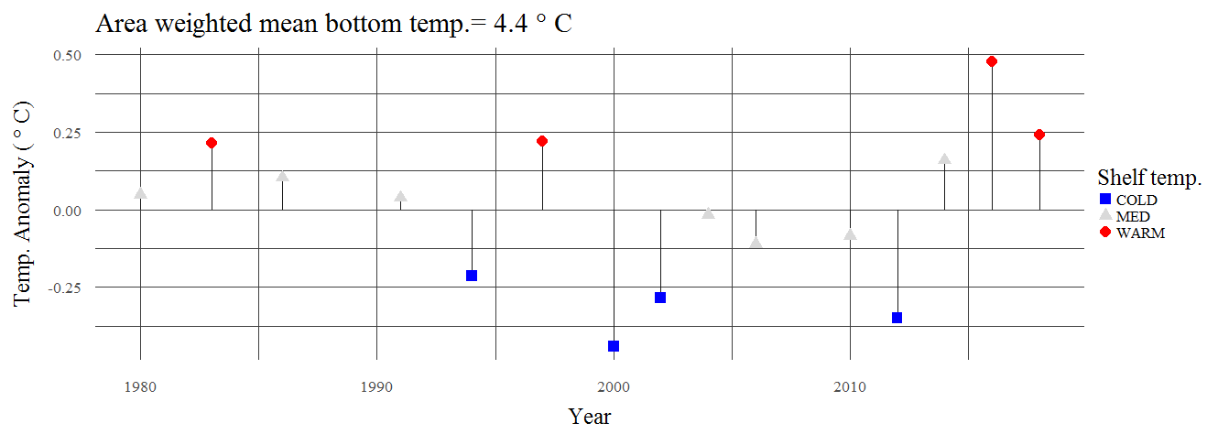

### Survey proportion at age and length frequencies

The survey age composition data from 1991 through 1997 are inconsistent. The 1991 survey age data have high 1988 and 1987 year classes, the 1994 and 1997 surveys however have a large 1989 year class. The 1993 year class is large in the 1994 and 1997 surveys,The 1997 through 2004 surveys don’t show any consistent dominant year class, while the 2006 through 2012 survey age data show the 1999 and 2000 year classes as dominant (Fig. 1A.4 and Table 1A.5). The 2010 survey had a large age-1 mode (2009 year class. The 2012 survey had a dominant age-1 mode (2011 year class) and a smaller age-6 mode (2006 year class). The age-1 mode continued into 2014 as a dominant age-3 mode, and the age-6 mode (2006 year class) appears to have split into a pair of high age-7 and age-8 modes (2006 and 2007 year class). This is likely due to aging error either with age-6s in 2012 or the 7 and 8s in 2014.The 2016 age composition data shows a large 2012 year class, the 2015 year class at age-1 also appears to be large. In 2018 the 2012 cohort was dominant and matches that observed in the fishery. The AIBTS weight-at-age data are presented in Table 1A.6. The 1991 survey age data is questionable since most of the age data were collected in only a few survey hauls in the Western Aleutians area. For this reason the 1991 age composition data have been down-weighted in the stock assessment model.

The length data for the 1980 through 2018 surveys are shown in Figure 1A.6. The 2010, 2012, and 2016 size composition show a higher proportion of fish < 20 cm than has been typical for the Aleutian Islands area. The 2014 survey had a very large mode between 20 and 40 cm which appears to correlate with a large 2011 year class at age 3.This mode continues into the 2016 data, but at much lower proportion and now appears to be assigned to the 2012 year class. The 2016 survey has four separate modes in the length data with the 2006 year class as fish between 50 and 70 cm, a 2012 year class at between 40 and 50 cm, and another large model between 10 and 20 cm which would correlated with a 2015 year class. The 2018 survey length composition shows few fish less than 40cm, but with the main mode being at between 45 and 65 cm, indicative of the 2012 year class also identified in the 2016 survey data and 2018 fishery data.

## Other Surveys

In addition to the bottom trawl survey there has been one echo integration-trawl survey in a portion of the NRA. The R/V Kaiyo Maru conducted a survey between 170°W and 178°W longitude in the winter of 2002 after completing a survey of the Bogoslof region (Nishimura *et al.* 2002). Due to difficulties in operating their large mid-water trawl on the steep slope area, they determined that their biological sampling in this area were insufficient for accurate species identification and biomass estimation.

In 2006 and 2007, acoustic survey studies were completed in the central Aleutian Islands region aboard a 32m commercial trawler (F/V Muir Milach) equipped with a 38 kHz SIMRAD ES-60 acoustic system. The Aleutian Islands Cooperative Acoustic Survey Study (AICASS) was conducted to assess the feasibility of using a small commercial fishing vessel to estimate the abundance of pollock in waters off the central Aleutian Islands. In 2008 this survey was expanded to include the R/V Oscar Dyson to survey the same area as the F/V Muir Milach. The results of the 2006 survey are presented in an AFSC Technical Memorandum (Barbeaux and Fraser 2009) and the 2007 survey results were described in the 2009 Aleutian Islands pollock stock assessment (Barbeaux *et al.* 2009). In summary, both surveys were able to conduct scientific quality acoustic surveys in the Aleutian Islands during the winter months using commercially available echosounders and a commercial fishing vessel. In 2006 there was a high degree of variability between surveys due to the small area being surveyed, pollock movement, and potential overlap with the fishery being conducted during the survey period. In 2007 the spatial distribution of pollock varied between surveys with pollock abundance decreasing in an area inside Boborof Island near Ship Rock and in an area north of Atka Island known as the Knoll and increasing elsewhere in the study area.

The 2008 AICASS was conducted to investigate whether cooperative biomass assessments and surveys could be an effective way to manage fisheries at the local scales that are important to predators such as Steller sea lions. The study included two acoustic surveys one conducted by the R/V Oscar Dyson and the other by the F/V Muir Milach. The first acoustic survey conducted 16-29 February by the R/V Oscar Dyson between 173° W and 178° W resulted in a pollock biomass estimate of 36,135 t for the surveyed area. The second survey conducted 23-27 March between 174.17°W and 178° W resulted in a biomass estimate of 29,041 t. For the same area the R/V Oscar Dyson survey had a biomass estimate of 27,128 t, each of the estimates for the smaller area are within the margin of error of the other. The later F/V Muir Milach survey showed fewer pollock in the Tanaga area and more pollock in the Knoll area. The size of the pollock from the two 2008 surveys were consistent with each other with a mode between 60 and 65 cm, but were larger than the pollock observed in the 2006 and 2007 surveys (See Fig. 1A.9 in Barbeaux *et al.* 2013).

# Data

This section describes data used in the current assessment. It does not attempt to summarize all available data pertaining to walleye pollock in the Aleutian Islands. Descriptions of the trends in these data were provided above in the pertinent sections.

|  |  |  |
| --- | --- | --- |
| **Source** | **Data** | **Years** |
| NMFS AI Bottom Trawl Survey (AI.BIOMASS_INPFC) | Survey Biomass | 1991, 1994, 1997, 2000, 2002, 2004, 2006, 2010, 2012, 2014, 2016, 2018, 2022 |
| NMFS AI Bottom Trawl Survey (RACEBASE.SPECIMEN) | Survey Age Data | 1980, 1983, 1986, 1991, 1994, 1997, 2000, 2002, 2004, 2006, 2010, 2012, 2014, 2016, 2018, |
| AKFIN Domestic Blend (COUNCIL.COMPREHENSIVE_BLEND_CA) | Total Catch | 1991-2022 |
| Ianelli *et al.* 2001 | Total Catch | 1978-1990 |
| Observer Program (OBSINT.DEBRIEFED_AGE) | Fishery Age Data | 1978-1987, 1994-1996, 1998, 2018 |
| AICASS | Fishery Age Data | 2006 - 2008 |

## Fishery

### Catch estimates

Estimates of pollock catch in the Aleutian Islands Region are derived from a variety of data sources (Table 1A.1). The foreign-reported database (held at AFSC) is the main source of information for the early period catches, and was used to derive the official catch statistics until about 1980 when the observer data were introduced to provide more reliable estimates. The foreign and joint-venture (JV) blend data take into account observer data and reported catches and formed the basis of the official catch statistics until 1990. The NMFS Observer data are the raw observed catch estimates and provide an indication of the amount of catch observed relative to the current estimates from the blend data. The foreign reported catch database was used to partition catches among areas for the period 1977-1984, and the observer data were used to apportion catches from 1985-1990 These proportions were then expanded to match the total catch. The Alaska Fisheries Information Network (AKFIN) provides the Domestic Blend data for 1991-2020. Estimates of pollock discard levels have been available since 1990. During the years when directed fishing was allowed pollock discards represented a small fraction of the total catch (Table 1A.7). The majority of catch in the last 11 years has been as bycatch in other target fisheries (Table 1A.8).

### Fishery age composition

Otoliths, weight, and length samples were collected through shore-side sampling and by at-sea observers. The number of age samples and length samples were highly variable (Table 1A.9 and Table 1A.10) and sampling effort in the directed fishery was very low after 1998 through 2017. The age composition data collected in the 2006, 2007, and 2008 AICASS were used as fishery data. Estimates of the catch-age compositions used in this assessment are shown in Table 1A.11. Fishery average weights-at-ages are provided in Table 1A.12.

## Surveys

### NMFS Aleutian Islands Bottom Trawl Survey

#### Abundance Estimates

Design-based, area-swept estimates of total biomass (tons) used in the assessment models examined this year are shown in Table 1A.4 and Fig. 1A.1, together with their respective coefficients of variation.

#### Age Composition

Design-based estimates of the age compositions up to age 15+ from the bottom trawl surveys for the years 1983-2018 are shown in Table 1A.5.

# Analytic Approach

The 2022 Aleutian Islands walleye pollock stock assessment uses the same modeling approach since 2015; implemented through the Assessment Model for Alaska (here referred to as AMAK). AMAK is a variation of the “Stock Assessment Toolbox” model presented to the Plan Team in the 2002 Atka mackerel stock assessment (Lowe *et al.* 2002), with some small adjustments to the model and a user-friendly graphic interface.

The abundance, mortality, recruitment, and selectivity of the Aleutian Islands pollock were assessed with a stock assessment model constructed with AMAK as implemented using the ADMB software. The ADMB is a C++ software language extension and automatic differentiation library. It allows for estimation of large numbers of parameters in non-linear models using automatic differentiation software developed into C++ libraries (Fournier 1998). The optimizer in ADMB is a quasi-Newton routine (Press *et al.* 1992). The model is determined to have converged when the maximum parameter gradient is less than a small constant (set to 1 x 10-7). A feature of ADMB and AMAK is that it includes post-convergence routines to calculate standard errors (or likelihood profiles) for quantities of interest.

## Model structure

AMAK models catch-at-age with the standard Baranov catch equation. The population dynamics follows numbers-at-age over the period of catch history with natural and age-specific fishing mortality occurring throughout the age groups that are modeled (ages 1-15+). Age-1 recruitment in each year is estimated as deviations from a mean value expected from an underlying stock-recruitment curve. Model 15.1 estimates natural mortality across all ages. Model 15.2 estimates natural mortality as a vector of deviations from the mean (see *Natural Mortality* in the Parameters Estimated Inside the Assessment Modelsection below for more detail). For all models, deviations between observations and expected values are quantified with a specified error model and cast in terms of a penalized log-likelihood. This overall log-likelihood (*L*) is the weighted sum of the calculated log-likelihoods for each data component and model penalties. The component weights are inversely proportional to the specified (or in some cases, estimated) variances. Appendix A Tables 1–3 provide a description of the variables used, and the basic equations describing the population dynamics of Aleutian Islands pollock and likelihood equations. The models presented since 2007 were modified from that of Barbeaux *et al.* (2003). These modifications include:

* The addition of a feature that allows a user-specified age-range for which to apply the survey (or other abundance index) catchability. For example, specifying the age-range of 5-12 (as was done for this assessment) means that the average age-specific catchability of the survey is set to the parametric value (either specified as fixed, as in this assessment, or estimated).

The quasi[1] likelihood components and the distribution assumption of the error structure are given below:

|  |  |
| --- | --- |
| **Likelihood Component** | **Distribution Assumption** |
| Catch biomass | Lognormal |
| Catch age composition | Multinomial |
| Survey catch biomass | Lognormal |
| Survey catch age composition | Multinomial |
| Recruitment deviations | Lognormal |
| Stock recruitment curve | Lognormal |
| Selectivity smoothness (in age-coefficients, survey and fishery) | Lognormal |
| Selectivity change over time (fishery only) | Lognormal |
| Priors (where applicable) | Lognormal |

The age-composition components are heavily influenced by the sample size assumptions specified for the multinomial likelihood. In this year’s model the multinomial sample sizes for the fishery were calculated as the minimum of the number of sampled hauls or 100 plus the number of sampled hauls divided by the mean number of sampled hauls.A value of 100 was specified for survey catch-at-age data.

|  |  |  |  |  |  |  |  |  |  |  |
| --- | --- | --- | --- | --- | --- | --- | --- | --- | --- | --- |
| **Fishery data\*** | Year | 1978 | 1979 | 1980 | 1981 | 1982 | 1983 | 1984 | 1985 | 1986 |
|  | 100 | 33 | 100 | 100 | 101 | 101 | 104 | 102 | 101 |
| Year | 1987 | 1988 | 1991 | 1992 | 1993 | 1994 | 1995 | 1996 | 1997 |
|  | 101 | 101 | 101 | 103 | 103 | 103 | 103 | 103 | 101 |
| Year | 1998 | 2006 | 2007 | 2008 | 2018 |  |  |  |  |
|  | 101 | 100 | 100 | 100 | 100 |  |  |  |  |
| **Survey data** | Year | 1983 | 1986 | 1991 | 1994 | 1997 | 2000 | 2002 |  |  |
|  | 1** | 1** | 1** | 100 | 100 | 100 | 100 |  |  |
|  |  |  |  |  |  |  |  |  |  |
| Year | 2004 | 2006 | 2010 | 2012 | 2014 | 2016 | 2018 |  |  |
|  | 100 | 100 | 100 | 100 | 100 | 100 | 100 |  |  |

*2006, 2007, and 2008 effective sample sizes were set at 100 for this assessment

**The 1983-1991 values were down-weighted because the samples collected in these years were not representative of the region considered.

## Parameters Estimated Outside the Assessment Model

### Weight-at-age

We estimated weight-at-age separately for the survey and fishery. We obtained survey estimates from AIBT surveysand computed fishery estimates from observer data and the 2006-2008 AICASS. The fishery weight-at-age values from 1978 to 2022 are given in Table 1A.9 and the survey weight-at-age values are given in Table 1A.12 and Table 1A.13. All weight-at-age by year values were estimated using generalized additive models with time and age as the independent variables (Barbeaux *et al.* 2011). For the time component, five periods were defined (F1 = 1978-1984, F2= 1985-1989, D1=1990-1994, D2=1995-1998, D3=1999-2022). These periods correspond to the following fisheries: early foreign (F1), late foreign and joint venture (F2), early domestic (D1) late domestic (D2), and the recent period of mainly pollock as bycatch (D3). Weight-at-age values are important since they convert model estimated catch-at-age (in numbers) to estimated total annual harvests (by weight) and hence affect the measure of fishery impacts.

### Maturity at Age

Prior to 2008, the maturity schedule developed for the Bering Sea by Wespestad and Terry (1984; Table 1A.14) was used. The CIE panel (at the 2007 Review) commented that given the differences in size-at-age there likely is a difference in maturity-at-age between the Bering Sea and Aleutian Islands. Since Aleutian Islands pollock size at age is more similar to that observed in the Gulf of Alaska (GOA) than in the Bering Sea andpopulation density shares characteristics between these areas (steep slope, relatively narrow shelf areas) the maturity schedule fromthe GOA was adopted (Dorn *et al.* 2013). The difference is that maturation occurs at slightly older ages with 50% maturity at 4 - 5 years while the Bering Sea pollock reach 50% maturity at 3 - 4 years (Table 1A.15 and Fig. 1A.7).

### Recruitment

We used an area-parameterized form of the Beverton-Holt stock recruitment relationship based on Francis (1992). Values for the stock recruitment function parameters *α* and *β* are calculated from the values of *R0* (the number of 0-year-olds in the absence of exploitation and recruitment variability) and the “steepness” (*h*) of the stock-recruit relationship. The “steepness” parameter is the fraction of *R0* to be expected (in the absence of recruitment variability) when the mature biomass is reduced to 20% of its pristine level (Francis 1992). As an example, a value of *h* = 0.7 implies that at 20% of the unfished spawning stock size will result in an expected value of 70% of the unfished recruitment level. The steepness parameter (*h*) was fixed at 0.7 and the recruitment variance ( ) was fixed at a value of 0.6 for both model runs. Since recruitment estimates arise from available age composition data, alternative values of *h* have little effect on historical estimates.

## Parameters Estimated Inside the Assessment Model

Deviations between the observations and the expected values are quantified with a specified error structure. Lognormal error is assumed for estimates of survey and fishery catch, and a multinomial error structure is assumed for analysis of the survey and fishery age compositions. These error structures are used to estimate the following parameters conditionally within the model.

### Fishing Mortality

Fishing mortality in all models was parameterized to be separable with both an age component (selectivity) and a year component. In all models selectivity is conditioned so that the mean value over all ages will be equal to one. To provide regularity in the age component, a smoothness penalty was imposed on abrupt changes in selectivity between ages using the sum of squared second differences. In addition, the age component parameters are assumed constant for the last 8 age groups (ages 8-15). Selectivity was allowed to change in temporal blocks for 1978-1989, 1990-1998, and 1999-2007, and 2008-2022. The 1990 change was selected for the change from a foreign to a domestic fishery, in 1999 the directed fishery for pollock was closed, and in 2005 the data were from the AICASS experimental fishery. Another change was implemented for 2008 when the arrowtooth flounder fishery increased and affected pollock bycatch patterns. However, age data are unavailable for pollock from these fisheries.

### Survey Selectivity and Catchability

In both models presented for the bottom trawl survey, survey selectivity-at-age follows the parameterization similar to the fishery selectivity-at-age presented above but is time invariant. The selectivity-at-age relationship is modeled with a smoothed non-parametric relationship that can take on any shape (with penalties controlling the degree of change and curvature specified by the user) similar to how the fishery selected is modeled. As noted above, the model allows specification of the age-range over which the catchability parameter is applied. For Aleutian Islands pollock, ages 5-12 were selected to have the average catchability (factoring selectivity components) equal to the catchability parameter value.

In the 2004 Aleutian Islands pollock stock assessment, the focus of our analysis was to evaluate a key model assumption: the extent to which the NMFS summer bottom trawl survey catchability should be estimated by the available data (resulting in very high stock sizes), or constrained to be close to a value of 1.0 (implying that the area-swept survey method during the summer months reasonably applies to a fishery that will likely occur during the winter). Based on the dynamics and the lack of informative data to “anchor” the biomass estimates,(i.e., there is relatively little “depletion” of recent cohorts to inform historical stock size) the assumption of catchability equals 1.0 was retained.

### Natural Mortality

For Model 15.1 natural mortality was estimated using a prior with a mean of 0.2 with a *CV* of 0.2. Results of previous assessments (Barbeaux *et al.* 2007) suggested that Aleutian Islands pollock are less productive than the Eastern Bering Sea stock and model fits suggest that *M* should be closer to 0.2 than the value of 0.3 used in the Eastern Bering Sea and Gulf of Alaska pollock assessments (Ianelli *et al.* 2009; Dorn *et al.* 2009). In Model 15.1 we assume a prior value of *M* = 0.2 based on thestudies of Wespestad and Terry (1984) for the Central Bering Sea (Table 1A.14). Natural mortality can be reasonably estimated using the AICASS age data because steepness (*h*), the recruitment variance (), and survey catchability (*q*) are assumed to be known. Model 15.2 allows for age-specific natural mortality rates. An age-specific natural mortality has been used by Ianelli *et al.* (2013) for the Eastern Bering Sea pollock with a higher natural mortality rate for age 1 and 2.In this model we allowed different natural mortality for ages 1, 2, and 15. These were fit as lognormal offsets from natural mortality for ages 3 through 14.In Model 15.2 we fixed the shape of the natural mortality vector iteratively by running the model with different values for 1, 2, and 15, and evaluating the likelihood of each iteration. The best fit model had the lowest –log likelihood.

# Results

## Model Evaluation

Model 15.1 is unchanged from the previous assessment and an alternative, Model 15.2, is the same except for age-varying natural mortality.

Both models were configured with a survey catchability of 1.0 for ages 5-12, a stock recruitment steepness parameter (*h*) of 0.7 and recruitment variance ( ) of 0.6. Natural mortality for Model 15.1 was estimated using a prior with a mean of 0.2 and *CV* of 0.2. For Model 15.2 natural mortality was age-specific and fit for ages 1, 2, and 15 as deviations from the mean value fit for ages 3-14. For both models the aging error component of the models was configured asdescribed by Ianelli *et al.* (2003) in the 2003 Bering Sea pollock stock assessment (Table 1A.16).

Model fit criteria results are shown in Table 1A.17 and key results are presented in Table 1A.18 and Figure 1A.9, Figure 1A.10, Figure 1A.11, Figure 1A.12, Figure 1A.13, and Figure 1A.14. Model 15.1 and Model 15.2 can be compared directly using likelihood methods (Table 1A.17 and Table 1A.18). Model 15.2 does not provide an improvement in fit, except a marginal improvement in recruitment. Similar to previous years, the model fit to the survey index was poor for all models (Fig. 1A.9), particularly for the 1991, 1994, 2012, 2014, and 2016 survey values. This is not surprising given the high level of variance in the survey point estimates, the high intra-annual variability of the estimates, and the fact that the survey estimates are from the summer while the fishery is conducted in the winter. Both models fit the 2018 survey estimate well.

The fit to the survey age composition data was good for both models, except for the data prior to 1993 which, for sampling reasons, were given less weight than the following years (Fig. 1A.11). The fishery age-composition data (Fig. 1A.11) were not fit as well as the survey catch-at-age data, but the fits were still relatively good. Observed and model derived mean ages matched well for both models, except for the 1995 and 2006 fishery data and 1994 survey data (Fig. 1A.12). Fishery age data were highly variable which probably reflects the diversity in sampling locations for the fishery in different years. There doesn’t appear to be any obvious or consistent patterns in the residuals for either the fishery or survey catch-at-age fits (Fig. 1A.13) for any of the models explored.

Like previous years, recruitment variability was high for both models presented (0.91 for Model 15.1 and 0.90 for Model 15.2. The mean natural mortality across all ages was similar for both models; 0.21 for Model 15.1 and 0.235 for Model 15.2. The iterative approach used for Model 15.2 resulted in a U-shaped natural mortality with higher values for the younger ages (1-3) and 15+ age group (Table 1A.14). Selectivity curves for both models (Fig. 1A.14) were similar for both the survey and the fishery. There is an apparent shift in fishery selectivity from Model 15.1 to Model 15.2 with higher selectivity for fish between ages 4 and 7. A shift in the survey selectivity is also apparent from Model 15.1 to Model 15.2 with an increase in selectivity for ages 3 to 8. The increase in age 1, 2, and 15+ natural mortality and decrease in natural mortality for ages 3-14 would explain the model fitting higher selectivity for the age-4 to age-7 pollock for both the fishery and survey.

Although Model 15.2 provides a marginally better fit to the data and gives qualitatively similar results to Model 15.1, Model 15.2 presents a substantial change in the approach to estimating natural mortality. Model 15.1 is recommended for consistency and will be used for evaluating stock status in the sections to follow.

## Time Series Results

### Abundance and exploitation trends

As indicated in the 2004 stock assessment (Barbeaux *et al.* 2004), the abundance trend is highly conditioned on the assumptions made about the area-swept survey trawl catchability. Even with catchability fixed at 1.0, the uncertainty in the abundance trend and level is very high. Bearing in mind the high degree of uncertainty, total biomass estimates (Table 1A.19, Fig. 1A.15, and Fig. 1A.16) in the 1980’s for the Aleutian Islands area reached a peak of 1,012,610 t in 1982 primarily due to the 1978 year class which was well above average (Table 1A.20 and Table 1A.21, Fig. 1A.18, Fig. 1A.19, Fig. 1A.20). The model shows a large decline in the stock since its 1982 peak, hitting a low biomass levels in 2000 at 174,917 t. Total age 1+ biomass increased from 2000 to 2004 after cessation of directed fishing in the area. The increasing trend leveled off after 2005 due to poor recruitment after 2000. Average recruitments for 1990-1999 (77 million) and 2000-2009 (45 million) were well below the average for 1978-1989 (323 million).Biomass increased from 2007 onward due to low fishing pressure and the more prominent year classes in the recent survey age data with the 2007-2018 average recruitment at 72 million age-1 fish.Estimated pollock catch at age in numbers from 1978 to 2016 are given in Table 1A.22.

Female Spawning Stock Biomass (SSB) rose to a peak of 316,278 t in 1984 from 161,198 t in 1978 due to the large 1978 year class (Fig.1A.15 and Fig. 1A.16). SSB remained high in the late 1980’s as the larger than average 1981, 1983 and 1987 year classes matured. Even though there was a higher than average 1989 year class the SSB began to drop in the early 1990s in response to heavy fishing pressure and dipped to 60,753 t in 2003 (*B33%* or 20% of the 1988 value) after a decade of poor recruitments and high fishing pressure. The highest full selection fishing mortality occurred in 1995 (*Ffull* = 0.22 and Catch/biomass = 0.32) when the fishery harvested more than 82% of the 1994 survey biomass estimate (Fig. 1A.17 and Fig.1A.18). The authors’ preferred Model 15.1 shows higher exploitation rates beginning in 1990 continuing through 1998 (*Favg* = 0.16; Table 1A.23). The early 1990s fishery appeared to concentrate on the older fish, particularly the 1978 year class, this is consistent with a switch in the domestic fishery to concentrating on spawning aggregations for roe (Fig. 1A.18, and Fig. 1A.19). The status of AI pollock in 2019 and 2020 was assessed to be well above *B*20% and had low exploitation rates (Fig. 1A.21).

There was a steep decline in pollock abundance in the Aleutian Islands as the 1978 year class diminished with age and relatively high fishery removals. Estimates of exploitation rates suggest they were below *FOFL*, during this period. However, given poor recruitment, catches near the 1990s level were unsustainable. To examine the role of the 1978 year class, estimated recruitment was projected forward from that year but in the absence of fishing mortality (to estimate “dynamic *B0*”). This showed that a significant decline occurred simply due to changes in recruitment.The “no fishing” projection suggests that the 2020 female spawning stock biomass would be at 92% of what it would have been without fishing (with a low point in 1997 at 30% of the unfished stock). Since the cessation of directed fishing in 1999 and very low removal levels since 2005, the stock has stabilized and increased (Fig.1A.22).

### Recruitment

Recruitment variance ( ) was specified to be 0.6 yet the actual recruitment variability was 1.00. The 1978 year-class is the largest (1.712 billion age-1 recruits; Table 1A.24 and Fig. 1A.20) and is highly influential with a large part of the fishery removals being composed of this year class (Fig. 1A.18 and Fig. 1A.19). The years 1976-1986 had several large year classes in comparison to more recent recruitment. The mean recruitment of age-1 pollock for 1978-1989 was 323 million, while the mean recruitment at age-1 between 1998 and 2008 was 45 million fish, with no year classes since the 1989 year class exceeding the overall 1978-2008 mean recruitment of 164 million age-1 recruits. Since the start of the domestic fishery in 1990, the three largest year classes have been the 1989 year class at 270 million age-1 recruits, the 1993 year class at 139 million age-1 recruits and the 2000 year class with 101 million age-1 recruits. The 2011 and 2012 year classes were also relatively large at 104 and 141 million age-1 recruits.Given our limited time series we are unable to determine whether the larger year classes in the late 1970’s and early 1980’s were anomalous or whether they are part of a larger cycle. The bottom line is that pollock year class strength has been much lower in the 1990’s and 2000’s than in the previous decade leading to lower abundance of pollock in the Aleutian Islands, even without substantial local fishing pressure over the previous nine years.

The 1978 year class in particular was highly influential. The mean recruitment for 1978 - 2008 without the 1978 year class was 67% (111 million) of the mean recruitment with the 1978 year class (164 million). If the 1978 year class is anomalous, it may be inflating the biological reference points and may be causing an overestimation of the expected productivity of this system, particularly if the 1978 year class originated elsewhere. Whether AI pollock recruitment is synchronous with other areas is an open question (e.g., the 1978, 1989, 2000, and 2012 year classes are also strong in the EBS region, Ianelli *et al.* 2005). The AI recruitment appears to be just as, or even more, correlated with the Gulf of Alaska (GOA) stock (Fig. 1A.3 in Barbeaux *et al.* 2009) and the extent to which these adjacent stocks interact is an active area of research.

There is some conflict in the data with respect to the 2011 and 2012 year classes. Both the Gulf of Alaska and Bering Sea have observed a very high 2012 year class, however the 2012 and 2014 survey age data indicate that the dominant year class was 2011. The 2016 AI bottom trawl survey age composition data indicate a high 2012 year class, however due to the high uncertainty introduced through the aging error matrix, the model identifies these as 2011 year class fish as there are data from two previous surveys identifying this strong year class as 2011. Given the large 2012 year class in surrounding areas, the model could be misidentifying this year class. Given the steep maturity schedule for this stock, this likely has little impact on current spawning stock biomass estimates.

### Retrospective analysis

We systematically removed each year’s data from the model for 10 years to evaluate the retrospective pattern in the preferred model’s performance. For the past 20+ years the estimates from the data limited models are not outside of the 95% confidence intervals. However there is a trend in the more recent estimates which are consistently lower than the current model estimates (Fig. 1A.23). The performance of the Aleutian Islands pollock preferred model was reasonable given the unexpectedly low estimates of abundance in the bottom trawl survey estimates for 2012 through 2016 and then quick increase in 2018. Mohn’s rho for the authors’ preferred Model 15.1 was estimated at 0.156, Woods Hole rho was 0.088, and retrospective RMSE was 0.118.

# Projections and harvest alternatives

For management purposes we use the yield projections estimated from the 2022 authors’ preferred Model 15.1. We used the estimated terminal (2008-2022) fishery selectivity at age (Table 1A.20 and Fig. 1A.14) for all projections.

## Reference fishing mortality rates and yields

Amendment 56 to the BSAI Groundfish Fishery Management Plan (FMP) defines “overfishing level” (OFL), the fishing mortality rate used to set OFL (*FOFL*), the maximum permissible ABC, and the fishing mortality rate used to set the maximum permissible ABC (*max FABC*). The fishing mortality rate used to set ABC (*FABC*) may be less than or equal to this maximum permissible level. The overfishing and maximum allowable ABC fishing mortality rates are given in terms of percentages of unfished female spawning biomass (*FSPR%*), on fully selected age groups. The associated long-term average female spawning biomass that would be expected under average estimated recruitment from 1978-2020 for the authors’ preferred model (128.4 million age 1 fish) and *F* equal to *F40%* and *F35%* are denoted *B40%* and *B35%* , respectively. The Tiers require reference point estimates for biomass level determinations. We present the following reference points for NRA pollock for Tier 3 of Amendment 56. For our analyses, we estimated the following values from the authors’ preferred model:

|  |  |  |
| --- | --- | --- |
| Female spawning biomass | Model 15.1 | |
| *B100%* | 174,218 t |
| *B40%* | 69,687 t |
| *B35%* | 60,976 t |
| *B2022* | 82,810 t |

### Specification of OFL and Maximum Permissible ABC

For the authors’ preferred Model 15.1, the projected year 2023 female spawning biomass (*SB23*) is estimated to be 75,328 t, above the *B40%* value of 69,687 t placing NRA pollock in Tier 3a. The maximum permissible ABC and OFL values under Tier 3a for 2023 are:

|  |  |  |  |
| --- | --- | --- | --- |
| Harvest Strategy | FSPR% | Fishing Mortality Rate | 2019 Projected yield (t) |
| *max FABC* | *F40%* | 0.31 | 43,413 t |
| *FOFL* | *F35%* | 0.38 | 52,384 t |

If the estimates of *B40%, F40% ,* and *F35%* were deemed not reliable, then under Tier 5 with estimated natural mortality of 0.20 and the 2023 AIBT survey biomass, the 2023 ABC would be 16,517 t (110,110 t x 0.75 x 0.20 = 16,517 t) and under Tier 5 with an assumed natural mortality of 0.3 the 2023 ABC would be 24,775 t.

## ABC Considerations and Recommendation

### ABC Considerations

There remains considerable uncertainty in the Aleutian Islands pollock assessment. We’ve noted some concerns below:

1. The level of interaction between the Aleutian stock and the Eastern Bering Sea stock is unknown. It is evident that some interaction does occur and that the abundance and composition of the eastern portion of the Aleutian Islands stock is highly confounded with that of the Eastern Bering Sea stock. Overestimation of the Aleutian Islands pollock stock productivity due to an influx of Eastern Bering Sea stock is a significant risk.
2. As indicated in the 2004 AI pollock stock assessment (Barbeaux *et al.* 2004), AIBT survey catchability is probably less than 1.0, but we have no data to concretely anchor the value at anywhere less than 1.0. We therefore employ a default value for catchability of 1.00. This provides a conservative total biomass estimate.
3. Recent (1991 through 2022) AI bottom trawl surveys are highly uncertain with an average *CV* of 0.4375. The 2002, 2004, 2006, 2010, 2012, 2014, 2016, 2018, and 2022 estimates of *CV* are 0.38, 0.78, 0.48, 0.33, 0.55, 0.24, 0.33, 0.41, and 0.47 respectively. This results in considerable uncertainty in the model results.
4. Aging error is a significant concern for this stock with aging comparisons for the 2006 through 2008 age data at between 20% and 47% agreement.
5. If the 1978 year class is anomalous, it may be inflating the biological reference points, and in turn may be causing an overestimation of the expected productivity of this system, particularly if the 1978 year class originated elsewhere.
6. The low 2012 through 2016 bottom trawl survey estimates can’t be explained by estimated natural mortality or catch. The availability of pollock to the survey may not be static and therefore the index could be unreliable. Migration of pollock outside the survey area could also explain this decline. The sudden increase in biomass in 2018 is commensurate with a steep increase in temperature on the Bering Sea shelf, although this increase is now consistent with the model, there still appears to be an availability issue not addressed in this modeling framework.
7. Due to COVID 19 restrictions, there was no 2020 survey.
8. With little fishing occurring there are also little age composition data collected. This results in little information for the stock assessment. Future assessments should consider using length composition data to offset this limitation.

### ABC Recommendations

The pollock spawning stock biomass and total age 1+ biomass in the NRA appears to have reached an asymptote or slightly decreasing since 2018. The projected total age 1+ biomass for 2023 is 264,173 t. Assuming the five year average *F* of 0.026, the estimated female spawning biomass projected for 2023 is 75,328 t. Under this scenario the maximum permissible Tier 3a 2023 ABC (*FmaxABC* = 0.305) is 43,413 t and OFL (*FOFL* = 0.380) is 52,384 t and the 2024 ABC (*FmaxABC* = 0.305) is 43,092 t and OFL (*FOFL* = 0.380) is 52,044 t which are the authors’ recommended ABC and OFLs.

### Risk Table and ABC Recommendation

The following template is used to complete the risk table:

|  |  |  |  |  |
| --- | --- | --- | --- | --- |
|  | *Assessment-related considerations* | *Population dynamics considerations* | *Environmental/ecosystem considerations* | *Fishery Performance* |
| Level 1: Normal | Typical to moderately increased uncertainty/minor unresolved issues in assessment. | Stock trends are typical for the stock; recent recruitment is within normal range. | No apparent environmental/ecosystem concerns | No apparent fishery/resource-use performance and/or behavior concerns |
| Level 2: Substantially increased concerns | Substantially increased assessment uncertainty/ unresolved issues. | Stock trends are unusual; abundance increasing or decreasing faster than has been seen recently, or recruitment pattern is atypical. | Some indicators showingadverse signals relevant to the stock but the pattern is not consistent across all indicators. | Some indicators showing adverse signals but the pattern is not consistent across all indicators |
| Level 3: Major Concern | Major problems with the stock assessment; very poor fits to data; high level of uncertainty; strong retrospective bias. | Stock trends are highly unusual; very rapid changes in stock abundance, or highly atypical recruitment patterns. | Multiple indicators showing consistent adverse signals a) across the same trophic level as the stock, and/or b) up or down trophic levels (i.e., predators and prey of the stock) | Multiple indicators showing consistent adverse signals a) across different sectors, and/or b) different gear types |
| Level 4: Extreme concern | Severe problems with the stock assessment; severe retrospective bias. Assessment considered unreliable. | Stock trends are unprecedented; More rapid changes in stock abundance than have ever been seen previously, or a very long stretch of poor recruitment compared to previous patterns. | Extreme anomalies in multiple ecosystem indicators that are highly likely to impact the stock; Potential for cascading effects on other ecosystem components | Extreme anomalies in multiple performanceindicators that are highly likely to impact the stock |

“The table is applied by evaluating the severity of four types of considerations that could be used to support a scientific recommendation to reduce the ABC from the maximum permissible. These considerations are stock assessment considerations, population dynamics considerations, environmental/ecosystem considerations, and fishery performance. Examples of the types of concerns that might be relevant include the following:

1. “Assessment considerations—data-inputs: biased ages, skipped surveys, lack of fishery-independent trend data; model fits: poor fits to fits to fishery or survey data, inability to simultaneously fit multiple data inputs; model performance: poor model convergence, multiple minima in the likelihood surface, parameters hitting bounds; estimation uncertainty: poorly-estimated but influential year classes; retrospective bias in biomass estimates.
2. “Population dynamics considerations—decreasing biomass trend, poor recent recruitment, inability of the stock to rebuild, abrupt increase or decrease in stock abundance.
3. “Environmental/ecosystem considerations—adverse trends in environmental/ecosystem indicators, ecosystem model results, decreases in ecosystem productivity, decreases in prey abundance or availability, increases or increases in predator abundance or productivity.
4. “Fishery performance—fishery CPUE is showing a contrasting pattern from the stock biomass trend, unusual spatial pattern of fishing, changes in the percent of TAC taken, changes in the duration of fishery openings.”

**Assessment considerations.**The AI pollock assessment does not show a strong retrospective bias, and fits to the age composition data well. There is however a lack of recent fishery and survey age composition data in the model leading to a larger degree of uncertainty in the model performance.

**Population dynamics considerations.** Female spawning biomass is currently estimated to be at B47% and given low exploitation expected to continue to increase even at lower than average recruitment. The authors have no concerns with this stock concerning population dynamics.

**Environmental/Ecosystem considerations.**.

**Fishery Performance.** There hasn’t been a substantial pollock fishery in the Aleutian Islands since 1998. From 2005 to the present catch in the AI has been less than 3,500 t. Although an experimental fishing permit was developed for the 2019 and 2020 fishery, the catch remained below 3,500 t. There is no consistent metric available to assess fishery performance for this fishery. The TAC for this stock is limited to 19,000 t, less than half of the annual ABC. We have no concerns about fishery performance that would suggest a drop in ABC would be required.

We consider the concern level to be 1 – normal.

These results are summarized in the table below:

|  |  |  |  |
| --- | --- | --- | --- |
| Assessment-related considerations | Population dynamics considerations | Environmental/ecosystem considerations | Fishery Performance |
| Level 1: Normal | Level 1: Normal | Level 1: Normal | Level 1: Normal |

The authors suggest that setting the ABC below the maximum permissible is not warranted at this time.

## Standard Harvest Scenarios and Projection Methodology

A standard set of projections is required for each stock managed under Tiers 1, 2, or 3, of Amendment 56. This set of projections encompasses eight harvest scenarios designed to satisfy the requirements of Amendment 56, the National Environmental Policy Act, and the Magnuson-Stevens Fishery Conservation and Management Act (MSFCMA).

For each scenario, the projections begin with the vector of 2022 numbers at age estimated in the assessment. This vector is then projected forward to the beginning of 2023 using the schedules of natural mortality and selectivity described in the assessment and the best available estimate of total (year-end) catch for 2022 of 3,000 t. For 2023 the five-year average *F* (2017-2021) of 0.026, used in place of maximum permissible ABC resulting in a catch estimate of 1,670 t.In each subsequent year, the fishing mortality rate is prescribed on the basis of the spawning biomass in that year and the respective harvest scenario. In each year, recruitment is drawn from an inverse Gaussian distribution whose parameters consist of maximum likelihood estimates determined from recruitments estimated in the assessment. Spawning biomass is computed in each year based on the time of peak spawning and the maturity and weight schedules described in the assessment. Total catch is assumed to equal the catch associated with the respective harvest scenario in all years. This projection scheme is run 1000 times to obtain distributions of possible future stock sizes, fishing mortality rates, and catches.

Five of the seven standard scenarios are sometimes used in an Environmental Assessment prepared in conjunction with the final SAFE. These five scenarios, which are designed to provide a range of harvest alternatives that are likely to bracket the final TAC for 2023 and 2024, are as follows (a “*max* *FABC*” refers to the maximum permissible value of *FABC* under Amendment 56):

*Scenario 1*: In all future years, *F* is set equal to *max* *FABC*. (Rationale: Historically, TAC has been constrained by ABC, so this scenario provides a likely upper limit on future TACs.)

*Scenario 2*: In all future years, F is set equal to a constant fraction (“author’s F”) of max F*ABC*, where this fraction is equal to the ratio of the F*ABC* value for 2023 recommended in the assessment to the max F*ABC* for 2023, and where catches for 2023 and 2024 are estimated at their most likely values given the 2023 and 2024 recommended ABCs under this scenario.(Rationale:When FABC is set at a value below max F*ABC*, it is often set at the value recommended in the stock assessment; also, catch tends not to equal ABC exactly.)

*Scenario 3*: In all future years, *F* is set equal to the 2017-2021 average *F*. (Rationale: For some stocks, TAC can be well below ABC, and recent average *F* may provide a better indicator of *FTAC* than *FABC*.)

*Scenario 4*: In all future years, *F* is set equal to *F75%*. (Rationale: This scenario represents a very conservative harvest rate and was requested by the Alaska Regional Office based on public comment.)

*Scenario 5*: In all future years, *F* is set equal to zero. (Rationale: In extreme cases, TAC may be set at a level close to zero.)

Two other scenarios are needed to satisfy the MSFCMA’s requirement to determine whether a stock is currently in an overfished condition or is approaching an overfished condition. These two scenarios are as follow (for Tier 3 stocks, the MSY level is defined as *B35%*):

*Scenario 6*:In all future years, *F* is set equal to *FOFL*. (Rationale: This scenario determines whether a stock is overfished. If the stock is expected to be 1) above its MSY level in 2022 or 2) above 1/2 of its MSY level in 2022 and above its MSY level in 2032 under this scenario, then the stock is not overfished.)

*Scenario 7*: In 2023 and 2024, *F* is set equal to *max FABC*, and in all subsequent years, *F* is set equal to *FOFL*. (Rationale: This scenario determines whether a stock is approaching an overfished condition. If the stock is expected to be above its MSY level in 2034 under this scenario, then the stock is not approaching an overfished condition.)

The author included one more scenario in order to take into consideration the congressionally mandated TAC cap on pollock harvest from the Aleutian Islands area.

*Scenario 8*: In 2023 through 2035 the TAC is increased to 19,000 t or *max* *FABC* whichever is lower. (Rationale: 19,000 is the AI pollock cap set by Congressional mandate).

### Projections and status determination

*Is the stock currently overfished?* This depends on the stock’s estimated spawning biomass in 2022:

a. If spawning biomass for 2022 is estimated to be below ½ *B35%*, the stock is below its MSST.

b. If spawning biomass for 2022 is estimated to be above *B35%* the stock is above its MSST.

c. If spawning biomass for 2022 is estimated to be above ½ *B35%* but below *B35%*, the stock’s status relative to MSST is determined by referring to harvest Scenario #6. If the mean spawning biomass for 2032 is below *B35%*, the stock is below its MSST. Otherwise, the stock is above its MSST.

*Is the stock approaching an overfished condition?* This is determined by referring to harvest Scenario #7:

a. If the mean spawning biomass for 2022 is below 1/2 *B35%*, the stock is approaching an overfished condition.

b. If the mean spawning biomass for 2022 is above *B35%*, the stock is not approaching an overfished condition.

c. If the mean spawning biomass for 2022 is above 1/2 *B35%* but below *B35%*, the determination depends on the mean spawning biomass for 2034. If the mean spawning biomass for 2034 is below *B35%*, the stock is approaching an overfished condition. Otherwise, the stock is not approaching an overfished condition.

The projected yields, female spawning biomass, and the associated fishing mortality rates for the eight harvest strategies for the authors’ preferred model are shown in Table 1A.25. In the authors’ preferred model under a Tier 3a harvest strategy of *F40%* (Scenario 1), female spawning biomass is projected to be above *B35%* through 2024, be below *B40%* from 2025 through 2028, then be above *B40%* for the remainder of the projection (Fig.1A.24 and Fig.1A.25). Female spawning biomass is projected be above *B35%* except for 2025 through 2027 when fishing at *FOFL* (Fig.1A.26) in Scenario 7. The female spawning biomass is projected to be above *B35%* from 2028 through the end of the projection for both Scenario 6 and Scenario 7. Please note again that the fishing mortality rates are prescribed on the basis of the harvest scenario and the spawning biomass in each year. Thus, fishing mortality rates may not be constant within the projection if spawning biomass drops below *B40%* in any run due to the harvest control rules.

The associated long-term average female spawning biomass that would be expected under average estimated recruitment from 1978-2020 (128.4 million age 1 fish) and *F* = *F35%*, denoted *B35%* is estimated to be 60,976 t. This value (*B35%*), is used in the status determination criteria. Female spawning biomass for 2022 (82,810 t) is projected to be above 1/2 *B35%* thus, the NRA pollock stock is *above* its minimum stock size threshold (MSST) and is *not overfished*. Female spawning biomass for 2035 is projected to be above *B35%* in Scenario 7, and is expected to be above *B35%* in 2032 in Scenario 6, therefore the NRA pollock stock is *not* expected to fall below its MSST in two years and is *not approaching an overfished condition*.

Projections under Scenario 8 (Fig.1A.24, Fig.1A.25, and Table 1A.25), show that the stock could support a constant catch of 19,000 t. The stock is currently at *B47%* and the long-term expected yield at *B40%* is 40,465 t and at *B35%*.is 42,776 t, well above the 19,000 t cap.

|  |
| --- |
| The 2022 OFL given this year’s model would have produced a sum of apical F of 0.4416. |

# Ecosystem Considerations

Pollock is a commercially important species. It is also important as prey to other fish, birds, and marine mammals, and has been the focus of substantial research in Alaskan ecosystems, especially in the Gulf of Alaska (GOA; Hollowed *et al.* 2000). To determine the ecosystem relationships of juvenile and adult pollock in the Aleutian Islands (AI), we first examined the diet data collected for pollock. Diet data are collected aboard NMFS bottom trawl surveys in the AI ecosystem during the summer (May – August). In the AI, a total of 1,458 pollock stomachs were collected from the 1991 and 1994 bottom trawl surveys (n=688 and 770, respectively) and used in this analysis. The diet compositions reported here reflect the size and spatial distribution of pollock in each survey (see Appendix A, “Diet calculations” for detailed methods from Barbeaux *et al.* 2006). Juvenile pollock were defined as fish less than 20 cm in length, which roughly corresponds to 0 and 1 year old fish, and adult pollock were defined as fish 20 cm in length or greater, roughly corresponding to age 2+ fish.

In the AI, pollock diet data reflects a closer connection with open oceanic environments than in either the Eastern Bering Sea (EBS) or the GOA. Similar to the other ecosystems, euphausiids and copepods together make up the largest proportion of AI adult pollock diet (29% and 19%, respectively); however, it is only in the AI that adult pollock rely on mesopelagic forage fish in the family Myctophidae for 24% of their diet, and AI juvenile pollock have a lower proportion of euphausiids and a higher proportion of gelatinous filter feeders than in the GOA or EBS (Fig.1A. 27, left panels). We took this diet composition information and convert it to broad ranges of tons consumed annually by pollock in the AI using the Sense routine (Aydin *et al.* 1997), which incorporates information on pollock consumption derived from the stock assessment (see Appendix A from Barbeaux *et al.* 2006, “ration calculations” for detailed methods), as well as uncertainty in all other food web model parameters. As estimated by the Sense routine, AI adult pollock consumed between 100 and 900 thousand metric tons of euphausiids annually during the early 1990s, with similar ranges of myctophid and copepod consumption. Juvenile AI pollock consumed an additional estimated 100 to 900 thousand tons of copepods per year (Fig.1A.27, right panels).

Using diet data for all predators of pollock and consumption estimates for those predators, as well as fishery catch data, we next estimated the sources of pollock mortality in the AI. Sources of mortality were compared against the total production of pollock as estimated in the AI pollock stock assessment model. In the AI, integration of this single species information with predation within the food web model suggests that most adult pollock mortality was caused by the pollock trawl fishery during the early 1990s (48%; Fig.1A.28, left panels). Fishery catch of pollock in the AI has subsequently declined to less than half the early 1990s catch by the late 1990s, and the directed fishery was closed in 1999 (Ianelli *et al.* 2005). Therefore, AI pollock likely now experience predation mortality exceeding fishing mortality as in the EBS and GOA ecosystems.) The major predators of AI adult pollock are Pacific cod, Steller sea lions, pollock themselves, halibut, and skates. In the AI, juvenile pollock have a very different set of predators from adult pollock; Atka mackerel cause most juvenile pollock mortality (71%). Estimates of the tonnage of adult pollock consumed by predators from the Sense routines (Aydin *et al.*1997) ranged from 8 to 27 thousand tons consumed by Pacific cod annually during the early 1990s, while Atka mackerel were estimated to consume between 75 and 410 thousand tons of juvenile pollock annually in the AI ecosystem (Fig.1A.28, right panels).

After reviewing the diet compositions and mortality sources of pollock in the AI, we shifted focus slightly to view pollock and the pollock fishery within the context of the larger AI food web. When viewed within the AI food web, the pollock trawl fishery (in red; Fig.1A.29) is a relatively high trophic level (TL) predator which interacts mostly with adult pollock (Fig. 1A.30), but also with many other species (in green; Fig. 1A.31). The diverse pollock fishery bycatch ranges from high TL predators such as salmon sharks, sleeper sharks, and arrowtooth flounder, to mid TL pelagic forage fish and squid, to low TL benthic invertebrates such as crabs and shrimp, but all of these catches represent extremely small flows. Because the pollock trawl fishery contributes significant fishery offal and discards back into each ecosystem, these flows to fishery detritus groups are represented as the only “predator consumption” flows from the fishery; the biomass of retained catch represents a permanent removal from the system.

In the AI food web model, we included detailed information on bycatch for each fishery. This data was collected in the early 1990s when the AI pollock fishery was much larger than it is at present. During the early 1990’s, the pollock trawl fishery was extremely species-specific in the AI ecosystem, with pollock representing over 90% of its total catch by weight (Fig.1A. 30). No single bycatch species accounted for more than 1% of the catch. Although these catches are small in terms of percentage, the high volume pollock fisheries still account for the majority of bycatch of pelagic species in the BSAI management areas, including smelts, salmon sharks, and squids (Gaichas *et al.* 2004).

Pollock is also a very important prey species in the wider AI food web. When both adult and juvenile pollock food web relationships are included, over two thirds of all species groups turn out to be directly linked to pollock either as predators or prey in the food web model (Fig.1A.31). In the AI, the significant predators of pollock (blue boxes joined by blue lines) include halibut, cod, Alaska skates, Steller sea lions, and the pollock trawl fishery. Significant prey of pollock (green boxes joined by green lines) are myctophids, euphausiids, copepods, benthic shrimps, and amphipods, with juveniles preying on the euphausiids and copepods.

We investigated whether these differences in pollock diet, mortality, and relationships between the EBS and AI might suggest different ecosystem roles for pollock in these areas. We used the diet and mortality results integrated with information on uncertainty in the food web using the Sense routines (Aydin et al in review) and a perturbation analysis with each model food web to explore the ecosystem relationships of pollock further. Two questions are important in determining the ecosystem role of pollock: which species groups are pollock important to, and which species groups are important to pollock?

First, the importance of pollock to other groups within the AI ecosystem was assessed using a model simulation analysis where pollock survival was decreased (mortality was increased) by a small amount, 10%, over 30 years to determine the potential effects on other living groups. This analysis also incorporated the uncertainty in model parameters using the Sense routines, resulting in ranges of possible outcomes. Figure 1A.32 shows the resulting percent change in the biomass of each species after 30 years for 50% of feasible ecosystems with 95% confidence intervals (error bars in Figure1A.32. Species showing the largest median changes from baseline conditions are presented in descending order from left to right. Therefore, the largest change resulting from a 10% decrease in pollock survival in both ecosystems is a decrease in adult pollock biomass, as might have been expected from such a perturbation. However, the decrease in pollock biomass resulting from the 10% survival reduction is uncertain in AI: the 50% intervals range from a 5-37% decrease in the AI (Fig.1A.32, upper panel). Along with the decrease in pollock biomass predicted in this simulation is a decrease in pollock fishery catch. The next largest median effect is on juvenile pollock, which are predicted to decrease in 50% of feasible ecosystems, but the 95% interval includes zero, suggesting that the decrease is uncertain. The simulation further suggests the possibility that herring, Atka mackerel, and other miscellaneous deep water fish might increase slightly as a result of a decrease in pollock survival; however, for all of these species groups the 95% intervals cross zero, so the direction of change is uncertain. Therefore, this analysis suggests that in the AI ecosystem during the early 1990’s, pollock were most important to themselves, and to the pollock fishery.

To determine which groups were most important to pollock in each ecosystem, we conducted the inverse of the analysis presented above. In this simulation, each species group in the ecosystem had survival reduced by 10% and the system was allowed to adjust over 30 years. The strongest median effects on AI adult pollock are presented in Fig. 1A.32 (lower panel). The largest effect on adult pollock was the reduction in biomass resulting from the reduced survival of juvenile pollock, although the 95% intervals include zero change, indicating considerable uncertainty in this result. (The same caution applies to the interpretation of all of the results of this simulation as all of the 95% intervals contain zero). It is interesting, however, that reduced survival of juvenile Atka mackerel had a larger median effect on adult pollock biomass than the direct effect of reduced adult pollock survival itself (Fig. 1A.32, lower panel), and that the effect is positive. Adult Atka mackerel show the same pattern, which is likely explained by the amount of mortality caused by Atka mackerel on juvenile pollock in the AI food web model (see Fig. 1A.28, lower panels). Reduced survival of Atka mackerel adults or juveniles apparently relieves considerable mortality on juvenile pollock in this model, accounting for the increases in pollock biomass predicted (which is similar in magnitude to the increase predicted from reducing the pollock fishery catch by 10%). Although this result is uncertain, it does indicate an important interaction between two commercially important species in the AI ecosystem which might be further investigated.

## Ecosystem effects on Aleutian Islands Walleye Pollock

The following ecosystem considerations are summarized in Table 1A.26.

### Prey availability/abundance trends

Adult walleye pollock in the Aleutian Islands consume a variety of prey, primarily large zooplankton, copepods, and myctophids. Figure 1A.31 highlights the trophic level of pollock in relation to its prey and predators. No time series of information is available on Aleutian Islands for large zooplankton, copepod, or myctophid abundance.

### Predator population trends

The abundance trend of Aleutian Islands Pacific cod is decreasing, and the trend for Aleutian Islands arrowtooth flounder is relatively stable. Northern fur seals and Steller sea lions west of 178°W longitude are showing declines, while Steller sea lions east of 178°W longitude have shown some slight increases. Declining trends in predator abundance could lead to possible decreases in walleye pollock mortality. The population trends of seabirds are mixed, some increases, some decreases, and others stable. Seabird population trends could affect young-of-the-year mortality.

### Changes in habitat quality

Water temperature in the Aleutian Islands is variable among survey years particularly for bottom depth at the preferred depth range of pollock (Fig. 1A.33 and Fig. 1A.34). The 2012 Aleutian Islands summer bottom temperatures indicated that water temperatures were substantially cooler than the 2004-2010 surveys (Lowe *et al.* 2012). Bottom temperatures could possibly affect fish distribution. The 2014 through 2018 AI bottom trawl surveys show a swing of bottom and surface temperature values to above the means for the entire time series (1991-2018) and higher than the 2004-2010 bottom temperatures.

## AI pollock fishery effects on the ecosystem

### AI pollock fishery contribution to bycatch

Prior to 1998, levels of bycatch in the pollock fishery of prohibited species, forage, HAPC biota, marine mammals and birds, and other sensitive non-target species was very low compared to other fisheries in the region. The AI pollock fishery opening in 2005 was limited to only four hauls, within these four hauls the bycatch level of POP was very high (~50%). In addition to the lack of commercially harvestable levels of pollock, the high levels of POP bycatch convinced fishers to discontinue the fishery in 2005. The 2006 and 2007 AI pollock fisheries were conducted in conjunction with the AICASS, Pacific ocean perch was the most substantial bycatch species and made up 3% of the catch in 2006 and 11% in 2007. The 2008 directed pollock fishery had an observed bycatch rate of 1% with 97% of this being POP. In 2009 there was no observer coverage of the directed fishery and in 2010 there was less than 1% bycatch in the directed fishery which caught less than 50 tons of pollock. There was no directed pollock fishery in the Aleutians in 2011 through 2014, a limited fishery of 62 t in 2015, no directed fishery in 2016 and 2017. The directed fishery in 2018 was limited to 188 t from two hauls from a single vessel. The 2019 and 2020 directed fishery was conducted under an experimental fishing permit that allowed up to 500 t of Pacific ocean perch bycatch. Bycatch in the 2019 targeted AI pollock fishery resulted in 42 t of Pacific ocean perch bycatch with 70 t of pollock catch and the 2020 targeted AI pollock fishery resulted in 78t of Pacific ocean perch bycatch with 712 t of pollock. In 2021 there was no directed pollock fishery in the AI and in 2022 there was 217 of pollock caught in a directed fishery with 22 t of POP bycatch, Table 1A.27.

### Concentration of AI pollock catches in time and space

For 2023 amd 2024 the level of catch of pollock is not expected to be large and will be much lower than the 19,000 t cap, there is not expected to be a localized impact of this fishery.

### AI pollock fishery effects on amount of large size walleye pollock

The AI pollock fishery in the Aleutian Islands was closed between 1999 and 2005. There was only a very limited fishery in 2005 ( < 200t), 2006 (932 t), 2007 (1,300 t), 2008 (382 t), 2009 (400 t), 2010 (50 t), 2011 (0 t), 2012 (0 t), 2013 (0 t), 2014 (0 t), 2015 (62 t), 2016 (0 t), 2017 (0 t) and 2018 (188 t). In 2019 and 2020 there was an EFP which allowed up to 500t of POP bycatch, the directed fishery in 2019 and 2020 was 72 t in 2019 and 712 t in 2020, the most since the 2007 acoustic project EFP. In 2021 there were no directed fishery catch of pollock however in 2022 to date there has been 217t caught as of October 9, 2022. Year to year differences observed in the previous decade cannot be attributed to the fishery and must be attributed to natural fluctuations in recruitment. Fishers have indicated that the larger pollock in the Aleutian Islands will be targeted. But the low level of fishing mortality is not expected to greatly affect the size distribution of pollock in the AI.

### AI pollock fishery contribution to discards and offal production

The 2023 Aleutian Islands pollock fishery, if pursued, is expected to be conducted by catcher vessels delivering unsorted catch to a processing plant in Adak, and therefore very little discard or offal production is expected from this fishery.

### AI Pollock fishery effects on AI pollock age-at-maturity and fecundity

The effects of the fishery on the age-at-maturity and fecundity of AI pollock are unknown. No studies on AI pollock age-at-maturity or fecundity have been conducted. Studies are needed to determine if there have been changes over time and whether changes could be attributed to the fishery. Little impact is expected if the fishery continues to be conducted in the limited capacity it has been over recent years.

# Data gaps and research priorities

Very little is known about the AI pollock stock structure and their relation to Western Bering Sea, Eastern Bering Sea, Gulf of Alaska, Bogoslof and Central Bering Sea pollock. Studies on the migration of pollock in the North Pacific should be explored in order to obtain an understanding of how the stocks relate spatially and temporally and how neighboring fisheries affect local abundances. Time series data sets on prey species abundance in the Aleutian Islands would be useful for a more clear understanding of ecosystem affects. Studies to determine the impacts of environmental indicators such as temperature regime on AI Aleutian pollock are needed. Currently, we rely on studies from the eastern Bering Sea and Gulf of Alaska for our estimates of life history parameters (e.g. maturity-at-age, fecundity, and natural mortality) for the NRA pollock. Studies specific to the NRA to determine whether there are any differences from the eastern Bering Sea and Gulf of Alaska stocks and whether there have been any changes in life history parameters over time would be informative.

# Acknowledgements

We thank the AFSC survey personnel, observer program staff, and fisheries observers for the collection of data and providing biomass estimates. We also thank the staff of the AFSC Age and Growth Unit for the ageing of otoliths used to determine the age compositions in the assessment.

# Literature Cited

Aydin, K., S. Gaichas, I. Ortiz, D. Kinzey, and N. Friday. 2007. A comparison of the Bering Sea, Gulf of Alaska, and Aleutian Islands large marine ecosystems through food web modeling, 298 p. NTIS No. PB2008-107111. At: <http://www.afsc.noaa.gov/Publications/AFSC-TM/NOAA-TM-AFSC-178.pdf>

Bailey, K. M., T. J. Quinn, P., Bentzen, and W.S. Grant. 1999. Population structure and dynamics of walleye pollock, Theragra chalcogramma. Advances in Marine Biology, 37, 179–255.

Barbeaux, S. J., and D. Fraser. 2009. Aleutian Islands cooperative acoustic survey study for 2006. U. S. Dep. Commer., NOAA Tech. Memo. NMFS-AFSC-198, 91 p. <http://www.afsc.noaa.gov/Publications/AFSC-TM/NOAA-TM-AFSC-198.pdf>

Barbeaux, S., J. Ianelli, S. Gaichas, and M. Wilkins. 2011. Aleutian Islands walleye pollock SAFE. In: Stock assessment and fishery evaluation report for the groundfish resources of the Bering Sea/Aleutian Islands regions. North Pac. Fish. Mgmt. Council, P.O. Box 103136, Anchorage, AK 99510., Section 1A

Barbeaux, S., J. Ianelli, and W. Paulson. 2014. Aleutian Islands walleye pollock SAFE. In: Stock assessment and fishery evaluation report for the groundfish resources of the Bering Sea/Aleutian Islands regions. North Pac. Fish. Mgmt. Council, P.O. Box 103136, Anchorage, AK 99510., Section 1A

Barbeaux, S., J. Ianelli, S. Gaichas, and M. Wilkins. 2009. Aleutian Islands walleye pollock SAFE. In: Stock assessment and fishery evaluation report for the groundfish resources of the Bering Sea/Aleutian Islands regions. North Pac. Fish. Mgmt. Council, P.O. Box 103136, Anchorage, AK 99510., Section 1A

Barbeaux, S., J. Ianelli, S. Gaichas, and M. Wilkins. 2006. Aleutian Islands walleye pollock SAFE. In: Stock assessment and fishery evaluation report for the groundfish resources of the Bering Sea/Aleutian Islands regions. North Pac. Fish. Mgmt. Council, P.O. Box 103136, Anchorage, AK 99510. Section 1A

Barbeaux, S., J. Ianelli, E. Brown. 2004. Aleutian Islands walleye pollock SAFE. In: Stock assessment and fishery evaluation report for the groundfish resources of the Bering Sea/Aleutian Islands regions. North Pac. Fish. Mgmt. Council, P.O. Box 103136, Anchorage, AK 99510. Section 1A.

Barbeaux, S., J. Ianelli, E. Brown. 2003. Aleutian Islands walleye pollock SAFE. In: Stock assessment and fishery evaluation report for the groundfish resources of the Bering Sea/Aleutian Islands regions. North Pac. Fish. Mgmt. Council, P.O. Box 103136, Anchorage, AK 99510. Section 1A:839-888.

Batten, S.D., Ruggerone, G.T. and Ortiz, I., 2018. Pink salmon induce a trophic cascade in plankton populations in the southern Bering Sea and around the Aleutian Islands. Fisheries Oceanography, 27(6), pp.548-559.

Carr, S. M., and H. Dawn Marshall. 2008. Phylogeographic analysis of complete mtDNA genomes from Walleye Pollock (Gadus chalcogrammus Pallas, 1811) shows an ancient origin of genetic biodiversity. Mitochondrial DNA 19:490-496.

Coulson, M. W., H. D. Marshall, P. Pepin, and S. M. Carr. 2006. Mitochondrial genomics of gadine fishes: implications for taxonomy and biogeographic origins from whole-genome data sets. Genome 49:1115-1130.

Dorn, M.W., K. Aydin, S. Barbeaux, M. Guttormsen, B. Megrey, K. Spalinger, and M. Wilkins. 2009. Assessment of the walleye pollock stock in the Gulf of Alaska. *In* Stock Assessment and Fishery Evaluation Report for Groundfish Resources of the Gulf of Alaska. North Pac. Fish. Mgmt. Council, P.O. Box 103136, Anchorage, AK 99510. Section 1: 61-164

Dorn, M.W., S. Barbeaux, B, M. Guttormsen, B. Megrey, A. Hollowed, M. Wilkins, and K. Spalinger. 2003. Assessment of the walleye pollock stock in the Gulf of Alaska. *In* Stock Assessment and Fishery Evaluation Report for Groundfish Resources of the Gulf of Alaska. North Pac. Fish. Mgmt. Council, P.O. Box 103136, Anchorage, AK 99510. Section 1: 61-164

Egan, T. 1988a. Foreign trawlers accused of violating U.S. zone. New York Times. 21 Jan 1988

Egan, T. 1988b. Japanese, Reacting to Allegations Of Illegal Fishing, Plan New Rules. New York Times. 5 Feb1988

Fournier, D. 1998. An Introduction to AD model builder for use in nonlinear modeling and statistics. Otter Research Ltd. PO Box 2040, Sidney BC V8L3S3, Canada, 53p.

Francis, R.I.C.C. 1992. Use of risk analysis to assess fishery management strategies: a case study using orange roughy (*Hoplostethus atlanticus*) on the Chatham Rise, New Zealand. Can. J. Fish. Aquat. Sci. 49: 922-930.

Gaichas, S. D. Courtney, T. TenBrink, M. Nelson1, S. Lowe, J. Hoff, B. Matta, and J. Boldt. 2004. Bering Sea Aleutian Islands Squid and Other Species Stock Assessment. In: Stock assessment and fishery evaluation report for the groundfish resources of the Bering Sea/Aleutian Islands regions. North Pac. Fish. Mgmt. Council, P.O. Box 103136, Anchorage, AK 99510. Section 16: 927-1008

Grant, W. S., Spies, I. B., and Canino, M. F. 2006. Biogeographic evidence for selection on mitochondrial DNA in North Pacific walleye pollock Theragra chalcogramma. Journal of Heredity, 97: 571–580.

Grant, W. S., Spies, I., and Canino, M. F. 2010. Shifting-balance stock structure in North Pacific walleye pollock (Gadus chalcogrammus). – ICES Journal of Marine Science, 67: 1687–1696.Harrison, R. C. 1993. Data Report: 1991 bottom trawl survey of the Aleutian Islands area. Natl. Oceanic Atmos. Admin., Natl. Mar. Fish. Serv., NOAA Tech. Memo. NMFS-AFSC‑12.

Hollowed, A. B., Bax, N., Beamish, R., Collie, J., Fogarty, M., Livingston, P., Pope, J., *et al.* 2000. Are multispecies models an improvement on single-species models for measuring fishing impacts on marine ecosystems? ICES Journal of Marine Science, 57: 707–719.

Ianelli, J.N., S. Barbeaux, T. Honkalehto, S. Kotwicki, K. Aydin, and N. Williamson. 2009. Bering Sea-Aleutian Islands Walleye Pollock Assessment for 2005. In: Stock assessment and fishery evaluation report for the groundfish resources of the Bering Sea/Aleutian Islands regions. North Pac. Fish. Mgmt. Council, Anchorage, AK, section 1:49-148.

Ianelli, J.N., S. Barbeaux, T. Honkalehto, N. Williamson and G. Walters. 2005. Bering Sea-Aleutian Islands Walleye Pollock Assessment for 2005. In: Stock assessment and fishery evaluation report for the groundfish resources of the Bering Sea/Aleutian Islands regions. North Pac. Fish. Mgmt. Council, Anchorage, AK, section 1:32-124.

Ianelli, J.N., S. Barbeaux, G. Walters, and N. Williamson. 2003. Bering Sea-Aleutian Islands Walleye Pollock Assessment for 2004. In: Stock assessment and fishery evaluation report for the groundfish resources of the Bering Sea/Aleutian Islands regions. North Pac. Fish. Mgmt. Council, Anchorage, AK, section 1:39-126.

Ianelli, J.N., L. Fritz, T. Honkalehto, N. Williamson and G. Walters 1997. Bering Sea-Aleutian Islands Walleye Pollock Assessment for 1998. *In*: Stock assessment and fishery evaluation report for the groundfish resources of the Bering Sea/Aleutian Islands regions. North Pac. Fish. Mgmt. Council, P.O. Box 103136, Anchorage, AK 99510. Section 1:1-79.

Kimura, D.K. 1989. Variability in estimating catch-in-numbers-at-age and its impact on cohort analysis. In R.J. Beamish and G.A. McFarlane (eds.), Effects on ocean variability on recruitment and an evaluation of parameters used in stock assessment models. Can. Spec. Publ. Fish. Aq. Sci. 108:57-66.

Lowe, S., J.N. Ianelli, H. Zenger, K. and R Rueter 2002. Assessment of Aleutian Islands Atka Mackerel . In: Stock assessment and fishery evaluation report for the groundfish resources of the Bering Sea/Aleutian Islands regions. North Pac. Fish. Mgmt. Council, P.O. Box 103136, Anchorage, AK 99510. Section 14:609-668

Lowe, S., J.N. Ianelli, M. Wilkins, K. Aydin, R. Lauth, and I. Spies. 2008. Assessment of Aleutian Islands Atka Mackerel . In: Stock assessment and fishery evaluation report for the groundfish resources of the Bering Sea/Aleutian Islands regions. North Pac. Fish. Mgmt. Council, P.O. Box 103136, Anchorage, AK 99510. Section 16:979-1054

Matta, M.E., Rand, K.M., Arrington, M.B. and Black, B.A., 2020. Competition-driven growth of Atka mackerel in the Aleutian Islands ecosystem revealed by an otolith biochronology. Estuarine, Coastal and Shelf Science, p.106775.

Nishimura, A., T. Yanagimoto, Y. Takoa. 2002. Cruise results of the winter 2002 Bering Sea pollock survey (Kaiyo Maru), Document for the 2002 statistical meeting, Central Bering Sea Convention, September 2002. Available: Hokkaido National Fisheries Research Institute, Hokkaido, Japan

Ormseth, O. A., and Norcross, B. L. 2009. Causes and consequences of life-history variation in North American stocks of Pacific cod. – ICES Journal of Marine Science, 66: 349–357.

Peterson, W., M. Robert, and N. Bond. 2015. The warm blob – Conditions in the northeastern Pacific Ocean. PICES Press 23.1: 36-38.

Press, W.H., S.A. Teukolsky, W.T. Vetterling, and B.P. Flannery. 1992. Numerical recipes in C. Second ed. Cambridge University Press. 994p.

Springer, A.M. and van Vliet, G.B., 2014. Climate change, pink salmon, and the nexus between bottom-up and top-down forcing in the subarctic Pacific Ocean and Bering Sea. Proceedings of the National Academy of Sciences, 111(18), pp.E1880-E1888.

Wespestad, V. G. and J. M. Terry. 1984. Biological and economic yields for eastern Bering Sea walleye pollock under differing fishing regimes. N. Amer. J. Fish. Manage., 4:204-215.

Wespestad, V. G., J. Ianelli, L. Fritz, T. Honkalehto, G. Walters. 1996. Bering Sea-Aleutian Islands Walleye Pollock Assessment for 1997. In: Stock assessment and fishery evaluation report for the groundfish resources of the Bering Sea/Aleutian Islands regions. North Pac. Fish. Mgmt. Council, P.O. Box 103136, Anchorage, AK 99510.Section 1:1-73.

# Tables

Table 1A.1. Estimates of walleye pollock catches from the entire Aleutian Islands Region by source, 1977-2022. Units are in metric tons.

|  |  |  |  |  |  |
| --- | --- | --- | --- | --- | --- |
| Year | Official Foreign &  JV Blend | Domestic  Blend | Foreign  Reported | NMFS  Observed  Catch* | Total Best Estimates |
| 1977 | 7,367 |  | 7,827 | 5 | 7,367 |
| 1978 | 6,283 |  | 6,283 | 234 | 6,283 |
| 1979 | 9,446 |  | 9,505 | 58 | 9,446 |
| 1980 | 58,157 |  | 58,477 | 883 | 58,157 |
| 1981 | 55,517 |  | 57,056 | 2,679 | 31,258 |
| 1982 | 57,753 |  | 62,624 | 11,847 | 50,322 |
| 1983 | 59,021 |  | 44,544 | 12,429 | 44,442 |
| 1984 | 77,595 |  | 67,103 | 48,538 | 42,901 |
| 1985 | 58,147 |  | 48,733 | 43,844 | 47,070 |
| 1986 | 45,439 |  | 14,392 | 29,464 | 23,810 |
| 1987 | 28,471 |  |  | 17,944 | 26,257 |
| 1988 | 41,203 |  |  | 21,987 | 36,864 |
| 1989 | 10,569 |  |  | 5,316 | 10,569 |
| 1990 |  | 79,025 |  | 59,935 | 79,025 |
| 1991 |  | 98,604 |  | 53,647 | 98,604 |
| 1992 |  | 52,352 |  | 36,581 | 52,352 |
| 1993 |  | 57,132 |  | 44,552 | 57,132 |
| 1994 |  | 58,659 |  | 43,430 | 58,659 |
| 1995 |  | 64,925 |  | 53,647 | 64,925 |
| 1996 |  | 29,062 |  | 23,482 | 29,062 |
| 1997 |  | 25,940 |  | 19,623 | 25,940 |
| 1998 |  | 23,798 |  | 21,032 | 23,798 |
| 1999 |  | 1,010 |  | 492 | 1,010 |
| 2000 |  | 1,244 |  | 573 | 1,244 |
| 2001 |  | 1,010 |  | 477 | 1,010 |
| 2002 |  | 1,177 |  | 519 | 1,177 |
| 2003 |  | 1,649 |  | 1,562 | 1,649 |
| 2004 |  | 1,158 |  | 1,074 | 1,158 |
| 2005 |  | 1,621 |  | 1,359 | 1,621 |
| 2006 |  | 1,745 |  | 540 | 1,745 |
| 2007 |  | 2,519 |  | 1,182 | 2,519 |
| 2008 |  | 1,278 |  | 996 | 1,278 |
| 2009 |  | 1,662 |  | 1,409 | 1,662 |
| 2010 |  | 1,285 |  | 1,261 | 1,285 |
| 2011 |  | 1,208 |  | 1,198 | 1,208 |
| 2012 |  | 975 |  | 927 | 975 |
| 2013 |  | 2,964 |  | 2,953 | 2,964 |
| 2014 |  | 2,375 |  | 2,369 | 2,375 |
| 2015 |  | 915 |  | 914 | 915 |
| 2016 |  | 1,257 |  | 1,251 | 1,257 |
| 2017 |  | 1,507 |  | 1,505 | 1,507 |
| 2018 |  | 1,860 |  | 1,827 | 1,860 |
| 2019 |  | 1,663 |  | 1,660 | 1,663 |
| 2020 |  | 3,202 |  | 3,080 | 3,202 |
| 2021 |  | 1,840 |  | 1,762 | 1,840 |
| 2022** |  | 2,726 |  | 1,960 | 2,726 |

*Extrapolated catch from observed fishing not a total catch estimate. ** as of October 9, 2022

Table 1A.2. Estimates of Aleutian Islands Region walleye pollock catch by the three management sub-areas. Units are in metric tons.

|  |  |  |  |  |  |  |  |  |  |  |  |
| --- | --- | --- | --- | --- | --- | --- | --- | --- | --- | --- | --- |
| **Year** | **East** | **Central** | | **West** | **Total** | **Year** | **East** | **Central** | | **West** | **Total** |
| **541** | **542** | | **543** | **541** | **542** | | **543** |
| 1977 | 4,402 | 0 | | 2,965 | 7,367 | 2000 | 615 | 461 | | 169 | 1,244 |
| 1978 | 5,267 | 712 | 305 | | 6,283 | 2001 | 333 | 387 | 105 | | 1,010 |
| 1979 | 1,488 | 1,756 | 6,203 | | 9,446 | 2002 | 862 | 182 | 133 | | 1,177 |
| 1980 | 28,284 | 7,097 | 22,775 | | 58,157 | 2003 | 565 | 758 | 326 | | 1,649 |
| 1981 | 43,461 | 10,074 | 1,982 | | 55,517 | 2004 | 397 | 513 | 248 | | 1,158 |
| 1982 | 54,173 | 1,205 | 2,376 | | 57,753 | 2005 | 689 | 415 | 517 | | 1,621 |
| 1983 | 56,577 | 1,250 | 1,194 | | 59,021 | 2006 | 1,036 | 488 | 220 | | 1,745 |
| 1984 | 64,172 | 5,760 | 7,663 | | 77,595 | 2007 | 1,919 | 476 | 124 | | 2,519 |
| 1985 | 19,885 | 38,163 | 100 | | 58,147 | 2008 | 872 | 293 | 112 | | 1,278 |
| 1986 | 38,361 | 7,078 | 0 | | 45,439 | 2009 | 1,020 | 400 | 243 | | 1,662 |
| 1987 | 28,086 | 386 | 0 | | 28,471 | 2010 | 754 | 382 | 150 | | 1,285 |
| 1988 | 40,685 | 517 | 0 | | 41,203 | 2011 | 695 | 447 | 66 | | 1,208 |
| 1989 | 10,569 | 0 | 0 | | 10,569 | 2012 | 503 | 427 | 45 | | 975 |
| 1990 | 69,170 | 9,425 | 430 | | 79,025 | 2013 | 2,342 | 309 | 313 | | 2,964 |
| 1991 | 98,032 | 561 | 11 | | 98,604 | 2014 | 2,088 | 176 | 111 | | 2,375 |
| 1992 | 52,140 | 206 | 6 | | 52,352 | 2015 | 565 | 264 | 87 | | 916 |
| 1993 | 54,512 | 2,536 | 83 | | 57,132 | 2016 | 899 | 195 | 162 | | 1,257 |
| 1994 | 58,091 | 554 | 15 | | 58,659 | 2017 | 688 | 517 | 302 | | 1,507 |
| 1995 | 28,109 | 36,714 | 102 | | 64,925 | 2018 | 1,060 | 546 | 254 | | 1,860 |
| 1996 | 9,226 | 19,574 | 261 | | 29,062 | 2019 | 1,000 | 415 | 248 | | 1,663 |
| 1997 | 8,110 | 16,799 | 1,031 | | 25,940 | 2020 | 2,166 | 671 | 365 | | 3,202 |
| 1998 | 1,374 | 2,603 | 19,821 | | 23,798 | 2021 | 1,322 | 273 | 245 | | 1,840 |
| 1999 | 484 | 420 | 105 | | 1,010 | 2022* | 1,899 | 317 | 510 | | 2,726 |

*as of October 9, 2022

Table 1A.3. Time series of ABC, TAC, OFL, and total catch for Aleutian Islands Region walleye pollock fisheries 1994-2022. Units are in metric tons.

|  |  |  |  |  |  |
| --- | --- | --- | --- | --- | --- |
| YEAR | ABC | TAC | OFL | CATCH | CATCH/TAC |
| 1995 | 56,600 | 56,600 | 60,400 | 64,925 | 115% |
| 1996 | 35,600 | 35,600 | 47,000 | 29,062 | 82% |
| 1997 | 28,000 | 28,000 | 38,000 | 25,940 | 93% |
| 1998 | 23,800 | 23,800 | 31,700 | 23,798 | 100% |
| 1999 | 23,800 | 2,000 | 31,700 | 1,010 | 51% |
| 2000 | 23,800 | 2,000 | 31,700 | 1,244 | 62% |
| 2001 | 23,800 | 2,000 | 31,700 | 825 | 41% |
| 2002 | 23,800 | 1,000 | 31,700 | 1,177 | 116% |
| 2003 | 39,400 | 1,000 | 52,600 | 1,649 | 167% |
| 2004 | 39,400 | 1,000 | 52,600 | 1,158 | 116% |
| 2005 | 29,400 | 19,000 | 39,100 | 1,621 | 9% |
| 2006 | 29,400 | 19,000 | 39,100 | 1,745 | 9% |
| 2007 | 44,500 | 19,000 | 54,500 | 2,519 | 13% |
| 2008 | 28,160 | 19,000 | 34,040 | 1,278 | 7% |
| 2009 | 26,873 | 19,000 | 32,553 | 1,662 | 9% |
| 2010 | 33,100 | 19,000 | 40,000 | 1,285 | 7% |
| 2011 | 36,700 | 19,000 | 44,500 | 1,208 | 6% |
| 2012 | 32,500 | 19,000 | 39,600 | 975 | 5% |
| 2013 | 37,300 | 19,000 | 45,600 | 2,964 | 16% |
| 2014 | 35,048 | 19,000 | 42,811 | 2,375 | 13% |
| 2015 | 29,659 | 19,000 | 36,005 | 915 | 5% |
| 2016 | 32,227 | 19,000 | 39,075 | 1,257 | 7% |
| 2017 | 36,061 | 19,000 | 43,650 | 1,507 | 8% |
| 2018 | 40,788 | 19,000 | 49,289 | 1,860 | 10% |
| 2019 | 52,887 | 19,000 | 64,240 | 1,663 | 9% |
| 2020 | 55,120 | 19,000 | 66,973 | 3,202 | 17% |
| 2021 | 51,241 | 19,000 | 61,856 | 1,840 | 10% |
| 2022 | 50,752 | 19,000 | 61,264 | 2,726 | 14% |
| * as of August 25, 2020 | | | | | |

Table 1A.4. Pollock biomass estimates (t) from the Aleutian Islands Groundfish Survey, 1980-2018.

|  |  |  |  |  |  |  |
| --- | --- | --- | --- | --- | --- | --- |
|  | Eastern  Area 541 | Central  Area 542 | Western  Area 543 | Unalaska-Umnak Area (~165W‑170W) | NRA  170W - 170E | |
|  | Biomass | CV |
| **1980** | 80,242 | 180,227 | 6,884 | 6,770 | 267,353 | 0.34 |
| **1983** | 164,286 | 183,542 | 118,234 | 104,515 | 466,063 | 0.17 |
| **1986** | 211,589 | 175,886 | 55,732 | 40,059 | 443,208 | 0.23 |
|  |  |  |  |  |  |  |
| **1991** | 60,932 | 50,259 | 26,701 | 51,644 | 137,891 | 0.19 |
| **1994** | 37,355 | 27,174 | 14,213 | 39,696 | 78,741 | 0.19 |
| **1997** | 38,541 | 36,764 | 18,115 | 65,400 | 93,420 | 0.22 |
| **2000** | 56,084 | 42,969 | 6,870 | 22,462 | 105,922 | 0.28 |
| **2002** | 54,634 | 108,179 | 13,140 | 181,334 | 175,953 | 0.38 |
| **2004** | 112,040 | 11,763 | 6,605 | 235,658 | 130,408 | 0.78 |
| **2006** | 69,996 | 18,002 | 6,514 | 18,006 | 94,512 | 0.48 |
| **2010** | 104,320 | 28,675 | 7,938 | 110,986 | 140,932 | 0.33 |
| **2012** | 31,488 | 7,433 | 5,360 | 13,237 | 44,281 | 0.55 |
| **2014** | 63,723 | 6,807 | 14,787 | 69,168 | 85,316 | 0.24 |
| **2016** | 59,119 | 9,404 | 14,547 | 10,047 | 83,070 | 0.33 |
| **2018** | 122,291 | 27,553 | 15,902 | 31,435 | 165,747 | 0.41 |
| **2020** | 90,473 | 13,753 | 5,885 | 53,696 | 110,110 | 0.47 |

Table 1A.5. Aleutian Islands bottom trawl survey pollock proportion-at-age used in authors’ preferred model (top panel). Shaded cells are the highest proportion for the year. Aleutian Islands bottom trawl survey pollock proportion-at-age sample sizes (bottom panel).

|  |  |  |  |  |  |  |  |  |  |  |  |  |  |  |  |
| --- | --- | --- | --- | --- | --- | --- | --- | --- | --- | --- | --- | --- | --- | --- | --- |
| Year | 1 | 2 | 3 | 4 | 5 | 6 | 7 | 8 | 9 | 10 | 11 | 12 | 13 | 14 | 15+ |
| 1983 | 0 | 0.064 | 0.033 | 0.022 | 0.482 | 0.178 | 0.065 | 0.062 | 0.051 | 0.026 | 0.009 | 0.005 | 0.001 | 0 | 0 |
| 1986 | 0 | 0.088 | 0.418 | 0.027 | 0.115 | 0.048 | 0.06 | 0.126 | 0.077 | 0.017 | 0.013 | 0.009 | 0.001 | 0 | 0 |
| 1991 | 0.058 | 0.044 | 0.101 | 0.262 | 0.125 | 0.03 | 0.035 | 0.023 | 0.069 | 0.036 | 0.066 | 0.027 | 0.054 | 0.039 | 0.032 |
| 1994 | 0.411 | 0.025 | 0.045 | 0.086 | 0.123 | 0.061 | 0.034 | 0.038 | 0.022 | 0.047 | 0.047 | 0.029 | 0.008 | 0.006 | 0.02 |
| 1997 | 0.033 | 0.035 | 0.041 | 0.115 | 0.127 | 0.08 | 0.06 | 0.111 | 0.083 | 0.041 | 0.075 | 0.049 | 0.056 | 0.04 | 0.055 |
| 2000 | 0.192 | 0.012 | 0.034 | 0.096 | 0.122 | 0.1 | 0.091 | 0.072 | 0.03 | 0.033 | 0.066 | 0.042 | 0.037 | 0.058 | 0.016 |
| 2002 | 0.022 | 0.021 | 0.045 | 0.058 | 0.059 | 0.075 | 0.101 | 0.071 | 0.077 | 0.093 | 0.073 | 0.079 | 0.065 | 0.061 | 0.101 |
| 2004 | 0.058 | 0.004 | 0.03 | 0.091 | 0.103 | 0.094 | 0.071 | 0.062 | 0.074 | 0.039 | 0.079 | 0.073 | 0.083 | 0.064 | 0.074 |
| 2006 | 0.024 | 0.001 | 0.043 | 0.057 | 0.079 | 0.193 | 0.133 | 0.091 | 0.036 | 0.045 | 0.048 | 0.045 | 0.044 | 0.074 | 0.086 |
| 2010 | 0.289 | 0.001 | 0.023 | 0.08 | 0.086 | 0.028 | 0.028 | 0.049 | 0.071 | 0.075 | 0.116 | 0.051 | 0.04 | 0.005 | 0.057 |
| 2012 | 0.26 | 0.014 | 0.035 | 0.01 | 0.043 | 0.159 | 0.076 | 0.024 | 0.013 | 0.038 | 0.048 | 0.13 | 0.079 | 0.052 | 0.02 |
| 2014 | 0.089 | 0.077 | 0.182 | 0.027 | 0.069 | 0.015 | 0.159 | 0.157 | 0.057 | 0.017 | 0.002 | 0.007 | 0.024 | 0.04 | 0.08 |
| 2016 | 0.237 | 0.056 | 0.081 | 0.115 | 0.091 | 0.064 | 0.083 | 0.044 | 0.07 | 0.073 | 0.043 | 0.017 | 0.006 | 0.004 | 0.018 |
| 2018 | 0.021 | 0.057 | 0.009 | 0.028 | 0.083 | 0.257 | 0.125 | 0.092 | 0.085 | 0.035 | 0.051 | 0.088 | 0.033 | 0.009 | 0.026 |

|  |  |  |  |  |  |  |  |  |  |  |  |  |  |  |  |
| --- | --- | --- | --- | --- | --- | --- | --- | --- | --- | --- | --- | --- | --- | --- | --- |
| Year | 1 | 2 | 3 | 4 | 5 | 6 | 7 | 8 | 9 | 10 | 11 | 12 | 13 | 14 | 15+ |
| 1983 | 11 | 663 | 173 | 668 | 2892 | 1107 | 345 | 228 | 171 | 78 | 36 | 16 | 4 | 1 | 0 |
| 1986 | 31 | 130 | 729 | 88 | 344 | 152 | 185 | 376 | 194 | 50 | 14 | 16 | 6 | 0 | 0 |
| 1991 | 0 | 25 | 60 | 198 | 93 | 26 | 38 | 23 | 60 | 28 | 41 | 15 | 52 | 34 | 14 |
| 1994 | 162 | 112 | 125 | 91 | 127 | 62 | 50 | 41 | 25 | 61 | 51 | 33 | 17 | 10 | 7 |
| 1997 | 97 | 106 | 114 | 118 | 105 | 75 | 58 | 112 | 69 | 39 | 49 | 38 | 33 | 23 | 22 |
| 2000 | 107 | 59 | 60 | 84 | 88 | 78 | 77 | 58 | 29 | 37 | 70 | 39 | 33 | 29 | 9 |
| 2002 | 119 | 116 | 183 | 122 | 75 | 104 | 103 | 77 | 81 | 74 | 61 | 54 | 75 | 34 | 24 |
| 2004 | 43 | 7 | 26 | 134 | 65 | 51 | 29 | 42 | 32 | 21 | 29 | 39 | 19 | 22 | 10 |
| 2006 | 41 | 4 | 26 | 33 | 48 | 121 | 72 | 45 | 17 | 29 | 27 | 22 | 23 | 34 | 20 |
| 2010 | 39 | 5 | 37 | 80 | 66 | 20 | 8 | 20 | 27 | 39 | 38 | 18 | 13 | 2 | 8 |
| 2012 | 82 | 8 | 13 | 16 | 42 | 138 | 58 | 14 | 11 | 31 | 29 | 53 | 34 | 19 | 5 |
| 2014 | 85 | 100 | 94 | 14 | 42 | 33 | 93 | 115 | 52 | 16 | 2 | 8 | 14 | 21 | 28 |
| 2016 | 48 | 51 | 71 | 110 | 69 | 50 | 82 | 50 | 57 | 84 | 36 | 14 | 9 | 7 | 18 |
| 2018 | 54 | 108 | 14 | 22 | 72 | 341 | 84 | 60 | 51 | 23 | 20 | 29 | 13 | 5 | 8 |

Table 1A.6. Aleutian Islands bottom trawl survey pollock average weight-at-age in kilograms used in authors’ preferred model.

|  |  |  |  |  |  |  |  |  |  |  |  |  |  |  |  |
| --- | --- | --- | --- | --- | --- | --- | --- | --- | --- | --- | --- | --- | --- | --- | --- |
| Year | 1 | 2 | 3 | 4 | 5 | 6 | 7 | 8 | 9 | 10 | 11 | 12 | 13 | 14 | 15+ |
| 1978 | 0.064 | 0.168 | 0.42 | 0.671 | 0.703 | 0.786 | 0.926 | 0.903 | 0.944 | 1.125 | 1.058 | 0.996 | 1.51 | 2.149 | 1.593 |
| 1979 | 0.064 | 0.168 | 0.42 | 0.671 | 0.703 | 0.786 | 0.926 | 0.903 | 0.944 | 1.125 | 1.058 | 0.996 | 1.51 | 2.149 | 1.593 |
| 1980 | 0.064 | 0.168 | 0.42 | 0.671 | 0.703 | 0.786 | 0.926 | 0.903 | 0.944 | 1.125 | 1.058 | 0.996 | 1.51 | 2.149 | 1.593 |
| 1981 | 0.064 | 0.168 | 0.42 | 0.671 | 0.703 | 0.786 | 0.926 | 0.903 | 0.944 | 1.125 | 1.058 | 0.996 | 1.51 | 2.149 | 1.593 |
| 1982 | 0.064 | 0.168 | 0.42 | 0.671 | 0.703 | 0.786 | 0.926 | 0.903 | 0.944 | 1.125 | 1.058 | 0.996 | 1.51 | 2.149 | 1.593 |
| 1983 | 0.064 | 0.163 | 0.448 | 0.649 | 0.709 | 0.803 | 0.857 | 0.988 | 0.923 | 1.034 | 1.225 | 0.937 | 1.284 | 2.744 | 1.444 |
| 1984 | 0.064 | 0.168 | 0.42 | 0.671 | 0.703 | 0.786 | 0.926 | 0.903 | 0.944 | 1.125 | 1.058 | 0.996 | 1.51 | 2.149 | 1.593 |
| 1985 | 0.064 | 0.168 | 0.42 | 0.671 | 0.703 | 0.786 | 0.926 | 0.903 | 0.944 | 1.125 | 1.058 | 0.996 | 1.51 | 2.149 | 1.593 |
| 1986 | 0.055 | 0.197 | 0.458 | 0.587 | 0.705 | 0.771 | 0.836 | 0.911 | 0.981 | 1.041 | 1.032 | 0.927 | 1.102 | 1.186 | 1.273 |
| 1987 | 0.065 | 0.18 | 0.39 | 0.599 | 0.726 | 0.797 | 0.854 | 0.915 | 0.976 | 1.009 | 1.006 | 1.012 | 1.072 | 1.171 | 1.275 |
| 1988 | 0.065 | 0.18 | 0.39 | 0.599 | 0.726 | 0.797 | 0.854 | 0.915 | 0.976 | 1.009 | 1.006 | 1.012 | 1.072 | 1.171 | 1.275 |
| 1989 | 0.065 | 0.18 | 0.39 | 0.599 | 0.726 | 0.797 | 0.854 | 0.915 | 0.976 | 1.009 | 1.006 | 1.012 | 1.072 | 1.171 | 1.275 |
| 1990 | 0.065 | 0.18 | 0.39 | 0.599 | 0.726 | 0.797 | 0.854 | 0.915 | 0.976 | 1.009 | 1.006 | 1.012 | 1.072 | 1.171 | 1.275 |
| 1991 | 0.112 | 0.2 | 0.527 | 0.756 | 0.833 | 0.963 | 1.049 | 1.147 | 1.169 | 1.129 | 1.162 | 0.981 | 1.238 | 1.085 | 1.007 |
| 1992 | 0.079 | 0.205 | 0.446 | 0.736 | 0.945 | 1.061 | 1.155 | 1.243 | 1.285 | 1.278 | 1.282 | 1.338 | 1.393 | 1.35 | 1.211 |
| 1993 | 0.079 | 0.205 | 0.446 | 0.736 | 0.945 | 1.061 | 1.155 | 1.243 | 1.285 | 1.278 | 1.282 | 1.338 | 1.393 | 1.35 | 1.211 |
| 1994 | 0.049 | 0.204 | 0.462 | 0.821 | 0.954 | 1.116 | 1.267 | 1.278 | 1.559 | 1.443 | 1.367 | 1.385 | 2.463 | 1.377 | 1.462 |
| 1995 | 0.079 | 0.205 | 0.446 | 0.736 | 0.945 | 1.061 | 1.155 | 1.243 | 1.285 | 1.278 | 1.282 | 1.338 | 1.393 | 1.35 | 1.211 |
| 1996 | 0.044 | 0.161 | 0.417 | 0.704 | 0.906 | 1.045 | 1.161 | 1.261 | 1.321 | 1.351 | 1.383 | 1.398 | 1.372 | 1.373 | 1.451 |
| 1997 | 0.051 | 0.211 | 0.382 | 0.709 | 0.897 | 0.999 | 1.144 | 1.253 | 1.25 | 1.315 | 1.335 | 1.298 | 1.313 | 1.267 | 1.4 |
| 1998 | 0.044 | 0.161 | 0.417 | 0.704 | 0.906 | 1.045 | 1.161 | 1.261 | 1.321 | 1.351 | 1.383 | 1.398 | 1.372 | 1.373 | 1.451 |
| 1999 | 0.044 | 0.161 | 0.417 | 0.704 | 0.906 | 1.045 | 1.161 | 1.261 | 1.321 | 1.351 | 1.383 | 1.398 | 1.372 | 1.373 | 1.451 |
| 2000 | 0.03 | 0.166 | 0.451 | 0.725 | 0.925 | 0.961 | 1.201 | 1.34 | 1.362 | 1.314 | 1.541 | 1.468 | 1.478 | 1.383 | 1.563 |
| 2001 | 0.041 | 0.189 | 0.481 | 0.716 | 0.913 | 1.107 | 1.231 | 1.354 | 1.512 | 1.608 | 1.644 | 1.666 | 1.636 | 1.578 | 1.554 |
| 2002 | 0.037 | 0.225 | 0.464 | 0.701 | 1.036 | 1.18 | 1.343 | 1.3 | 1.625 | 1.762 | 1.658 | 1.793 | 1.577 | 1.57 | 1.578 |
| 2003 | 0.041 | 0.189 | 0.481 | 0.716 | 0.913 | 1.107 | 1.231 | 1.354 | 1.512 | 1.608 | 1.644 | 1.666 | 1.636 | 1.578 | 1.554 |
| 2004 | 0.031 | 0.214 | 0.487 | 0.801 | 0.94 | 1.014 | 1.329 | 1.322 | 1.735 | 1.585 | 1.688 | 1.583 | 1.445 | 1.567 | 1.479 |
| 2005 | 0.041 | 0.189 | 0.481 | 0.716 | 0.913 | 1.107 | 1.231 | 1.354 | 1.512 | 1.608 | 1.644 | 1.666 | 1.636 | 1.578 | 1.554 |
| 2006 | 0.047 | 0.198 | 0.474 | 0.628 | 0.966 | 1.224 | 1.249 | 1.332 | 1.481 | 1.745 | 1.546 | 1.526 | 1.629 | 1.608 | 1.47 |
| 2007 | 0.041 | 0.189 | 0.481 | 0.716 | 0.913 | 1.107 | 1.231 | 1.354 | 1.512 | 1.608 | 1.644 | 1.666 | 1.636 | 1.578 | 1.554 |
| 2008 | 0.041 | 0.189 | 0.481 | 0.716 | 0.913 | 1.107 | 1.231 | 1.354 | 1.512 | 1.608 | 1.644 | 1.666 | 1.636 | 1.578 | 1.554 |
| 2009 | 0.041 | 0.189 | 0.481 | 0.716 | 0.913 | 1.107 | 1.231 | 1.354 | 1.512 | 1.608 | 1.644 | 1.666 | 1.636 | 1.578 | 1.554 |
| 2010 | 0.046 | 0.225 | 0.451 | 0.728 | 0.961 | 1.025 | 1.489 | 1.55 | 1.518 | 1.69 | 1.862 | 1.911 | 1.726 | 1.72 | 1.723 |
| 2011 | 0.041 | 0.189 | 0.481 | 0.716 | 0.913 | 1.107 | 1.231 | 1.354 | 1.512 | 1.608 | 1.644 | 1.666 | 1.636 | 1.578 | 1.554 |
| 2012 | 0.035 | 0.167 | 0.459 | 0.788 | 1.043 | 1.166 | 1.379 | 1.958 | 1.743 | 1.603 | 1.773 | 1.943 | 1.732 | 1.677 | 1.671 |
| 2013 | 0.041 | 0.189 | 0.481 | 0.716 | 0.913 | 1.107 | 1.231 | 1.354 | 1.512 | 1.608 | 1.644 | 1.666 | 1.636 | 1.578 | 1.554 |
| 2014 | 0.04 | 0.207 | 0.447 | 0.59 | 0.878 | 1.096 | 1.354 | 1.457 | 1.535 | 1.797 | 1.962 | 1.541 | 1.439 | 1.645 | 1.686 |
| 2015 | 0.041 | 0.189 | 0.481 | 0.716 | 0.913 | 1.107 | 1.231 | 1.354 | 1.512 | 1.608 | 1.644 | 1.666 | 1.636 | 1.578 | 1.554 |
| 2016 | 0.041 | 0.191 | 0.477 | 0.645 | 0.923 | 0.874 | 0.961 | 1.074 | 1.354 | 1.486 | 1.529 | 1.644 | 1.921 | 1.486 | 1.464 |
| 2017 | 0.041 | 0.189 | 0.481 | 0.716 | 0.913 | 1.107 | 1.231 | 1.354 | 1.512 | 1.608 | 1.644 | 1.666 | 1.636 | 1.578 | 1.554 |
| 2018 | 0.04 | 0.241 | 0.424 | 0.803 | 0.926 | 0.867 | 1.084 | 1.058 | 1.138 | 1.17 | 1.428 | 1.47 | 1.375 | 1.688 | 1.298 |
| 2019 | 0.041 | 0.189 | 0.481 | 0.716 | 0.913 | 1.107 | 1.231 | 1.354 | 1.512 | 1.608 | 1.644 | 1.666 | 1.636 | 1.578 | 1.554 |
| 2020 | 0.041 | 0.189 | 0.481 | 0.716 | 0.913 | 1.107 | 1.231 | 1.354 | 1.512 | 1.608 | 1.644 | 1.666 | 1.636 | 1.578 | 1.554 |
| 2021 | 0.041 | 0.189 | 0.481 | 0.716 | 0.913 | 1.107 | 1.231 | 1.354 | 1.512 | 1.608 | 1.644 | 1.666 | 1.636 | 1.578 | 1.554 |
| 2022 | 0.041 | 0.189 | 0.481 | 0.716 | 0.913 | 1.107 | 1.231 | 1.354 | 1.512 | 1.608 | 1.644 | 1.666 | 1.636 | 1.578 | 1.554 |

Table 1A.7. Estimated walleye pollock catch discarded and retained for the Aleutian Islands Region based on NMFS blend data, 1997-2022.

|  |  |  |  |  |
| --- | --- | --- | --- | --- |
|  | Catch |  |  | Discard |
| Year | Retained | Discard | Total | Percentage |
| 1997 | 25,323 | 618 | 25,940 | 2% |
| 1998 | 23,636 | 162 | 23,798 | 1% |
| 1999 | 529 | 480 | 1,010 | 48% |
| 2000 | 455 | 790 | 1,244 | 63% |
| 2001 | 445 | 380 | 825 | 46% |
| 2002 | 398 | 779 | 1,177 | 66% |
| 2003 | 1,181 | 468 | 1,649 | 28% |
| 2004 | 871 | 287 | 1,158 | 25% |
| 2005 | 1,297 | 324 | 1,621 | 20% |
| 2006 | 1,434 | 311 | 1,745 | 18% |
| 2007 | 2,094 | 425 | 2,519 | 17% |
| 2008 | 1,197 | 81 | 1,278 | 6% |
| 2009 | 1,268 | 395 | 1,662 | 24% |
| 2010 | 1,143 | 142 | 1,285 | 11% |
| 2011 | 1,133 | 75 | 1,208 | 6% |
| 2012 | 880 | 95 | 975 | 10% |
| 2013 | 2,856 | 107 | 2,964 | 4% |
| 2014 | 2,237 | 138 | 2,375 | 6% |
| 2015 | 896 | 19 | 915 | 2% |
| 2016 | 1,198 | 59 | 1,257 | 5% |
| 2017 | 1,488 | 18 | 1,507 | 1% |
| 2018 | 1,644 | 216 | 1,860 | 12% |
| 2019 | 1,598 | 65 | 1,663 | 4% |
| 2020* | 2,828957 | 231 | 3,2022,597 | 8% |
| 2021 | 1,595 | 244 | 1,840 | % |
| 2022* | 2,423 | 303 | 2,726 | % |

* As of October 9, 2022

Table 1A.8. Catch of pollock in the Aleutian Islands for other target fisheries 2018-2022. 2022 data are through October 9, 2022

|  |  |  |  |  |  |  |  |  |  |  |  |
| --- | --- | --- | --- | --- | --- | --- | --- | --- | --- | --- | --- |
| **Target Fishery** | **2018** | **2019** | | **2020** | | **2021** | | **2022** | | **Total** | |
| Arrowtooth Flounder | 0 | | 0.13 | | 88.65 | | 42.32 | | 4.70 | | 135.8 | |
| Atka Mackerel | 773 | | 533.11 | | 462.83 | | 404.03 | | 685.12 | | 2858.09 | |
| Greenland Turbot - BSAI | 0 | | 0 | | 0 | | 0 | | 0 | | 0 | |
| Halibut | 0.11 | | 0.10 | | 0.23 | | 0.37 | | 0.02 | | 0.83 | |
| Kamchatka Flounder - BSAI | 84.23 | | 96.49 | | 534.08 | | 409.32 | | 1126.12 | | 2250.24 | |
| Pacific Cod | 6.05 | | 8.33 | | 75.75 | | 58.79 | | 43.82 | | 192.74 | |
| Rockfish | 761.66 | | 954.18 | | 1,329 | | 925 | | 649 | | 4618.84 | |
| Sablefish | 0 | | 0.01 | | 0.20 | | 0.26 | | 0.03 | | 0.5 | |
| **Total** | 1625.05 | | 1592.35 | | 2490.74 | | 1840.09 | | 2508.81 | |  | |

Table 1A.9. Sampling levels in Aleutian Islands Region sub-regions based on foreign, J.V., and domestic walleye pollock observer data 1978 - 2022

|  |  |  |  |  |  |  |
| --- | --- | --- | --- | --- | --- | --- |
|  | **NRA Area** | | | **Aleutian Islands Area Basin** | | |
| Year | Fish Measured | Hauls Sampled | Vessels Sampled | Fish Measured | Hauls Sampled | Vessels Sampled |
| 1978 | 6,229 | 112 | 11 | 0 | 0 | 0 |
| 1979 | 2,294 | 33 | 6 | 0 | 0 | 0 |
| 1980 | 6,779 | 116 | 10 | 0 | 0 | 0 |
| 1981 | 11,143 | 94 | 13 | 1,913 | 15 | 3 |
| 1982 | 36,932 | 331 | 25 | 11,151 | 84 | 7 |
| 1983 | 27,474 | 240 | 21 | 20,744 | 174 | 21 |
| 1984 | 54,980 | 527 | 35 | 157,388 | 1,223 | 81 |
| 1985 | 29,185 | 228 | 25 | 68,923 | 460 | 58 |
| 1986 | 22,918 | 193 | 15 | 39,875 | 268 | 48 |
| 1987 | 47,138 | 352 | 26 | 2,665 | 26 | 8 |
| 1988 | 23,376 | 192 | 18 | 4,528 | 37 | 14 |
| 1989 | 7,431 | 57 | 7 | 0 | 0 | 0 |
| 1990 | 67,280 | 582 | 35 | 55 | 35 | 11 |
| 1991 | 3,957 | 34 | 13 | 24,025 | 396 | 24 |
| 1992 | 22,120 | 185 | 40 | 26,525 | 234 | 26 |
| 1993 | 23,559 | 214 | 30 | 26,218 | 225 | 31 |
| 1994 | 20,838 | 203 | 41 | 19,524 | 205 | 35 |
| 1995 | 31,082 | 350 | 34 | 340 | 32 | 16 |
| 1996 | 18,745 | 194 | 40 | 90 | 1 | 1 |
| 1997 | 17,722 | 190 | 31 | 77 | 1 | 1 |
| 1998 | 10,494 | 123 | 15 | 93 | 1 | 1 |
| 1999 | 135 | 6 | 4 | 0 | 0 | 0 |
| 2000 | 186 | 10 | 5 | 0 | 0 | 0 |
| 2001 | 119 | 6 | 3 | 0 | 0 | 0 |
| 2002 | 112 | 4 | 4 | 0 | 0 | 0 |
| 2003 | 544 | 25 | 7 | 21 | 1 | 1 |
| 2004 | 331 | 15 | 4 | 34 | 2 | 1 |
| 2005 | 559 | 27 | 8 | 10 | 1 | 1 |
| 2006 | 59 | 3 | 3 | 30 | 2 | 1 |
| 2007 | 830 | 21 | 10 | 330 | 12 | 1 |
| 2008 | 129 | 7 | 4 | 0 | 0 | 0 |
| 2009 | 647 | 29 | 11 | 0 | 0 | 0 |
| 2010 | 529 | 17 | 8 | 0 | 0 | 0 |
| 2011 | 697 | 63 | 6 | 0 | 0 | 0 |
| 2012 | 154 | 13 | 5 | 0 | 0 | 0 |
| 2013 | 930 | 42 | 9 | 0 | 0 | 0 |
| 2014 | 527 | 26 | 6 | 0 | 0 | 0 |
| 2015 | 811 | 31 | 5 | 0 | 0 | 0 |
| 2016 | 183 | 5 | 3 | 0 | 0 | 0 |
| 2017 | 332 | 9 | 6 | 0 | 0 | 0 |
| 2018 | 914 | 20 | 8 | 0 | 0 | 0 |
| 2019 | 659 | 22 | 8 | 0 | 0 | 0 |
| 2020 | 2,737 | 83 | 9 | 0 | 0 | 0 |
| 2021 | 1,697 | 44 | 6 | 0 | 0 | 0 |
| 2022 | 2,243 | 45 | 7 | 0 | 0 | 0 |

Table 1A.10. Number of aged and weighed fish in the NRA pollock fishery used to estimate fishery age composition. Age data from the AICASS used in the model for 2006, 2007, and 2008 are in bold.

|  |  |  |  |  |  |  |
| --- | --- | --- | --- | --- | --- | --- |
|  | Number Aged | | | Number Weighed | | |
| Year | Males | Females | Total | Males | Females | Total |
| 1978 | 167 | 273 | 440 | 187 | 294 | 481 |
| 1979 | 124 | 178 | 302 | 126 | 183 | 309 |
| 1980 | 93 | 167 | 260 | 188 | 291 | 479 |
| 1981 | 117 | 143 | 260 | 246 | 270 | 516 |
| 1982 | 464 | 519 | 983 | 572 | 642 | 1214 |
| 1983 | 60 | 63 | 123 | 278 | 308 | 586 |
| 1984 | 80 | 65 | 145 | 139 | 151 | 290 |
| 1985 | 77 | 113 | 190 | 295 | 355 | 650 |
| 1986 | 140 | 147 | 287 | 323 | 324 | 647 |
| 1987 | 131 | 142 | 273 | 136 | 147 | 283 |
| 1988 | 34 | 33 | 67 | 66 | 65 | 131 |
| 1989 | 0 | 0 | 0 | 112 | 147 | 259 |
| 1990 | 46 | 49 | 95 | 340 | 410 | 750 |
| 1991 | 80 | 77 | 157 | 20 | 30 | 50 |
| 1992 | 110 | 121 | 231 | 34 | 45 | 79 |
| 1993 | 81 | 82 | 163 | 48 | 56 | 104 |
| 1994 | 157 | 151 | 308 | 102 | 106 | 208 |
| 1995 | 74 | 106 | 180 | 147 | 158 | 305 |
| 1996 | 95 | 84 | 179 | 93 | 83 | 176 |
| 1997 | 15 | 15 | 30 | 15 | 15 | 30 |
| 1998 | 144 | 170 | 314 | 126 | 145 | 271 |
| 1999 | 0 | 0 | 0 | 0 | 0 | 0 |
| 2000 | 0 | 1 | 1 | 3 | 17 | 20 |
| 2001 | 0 | 1 | 1 | 12 | 7 | 19 |
| 2002 | 0 | 0 | 0 | 1 | 1 | 2 |
| 2003 | 1 | 0 | 1 | 33 | 31 | 64 |
| 2004 | 0 | 0 | 0 | 4 | 15 | 19 |
| 2005 | 2 | 2 | 4 | 21 | 9 | 30 |
| 2006 | **150/**1 | **183**/0 | **333**/0 | **1,315**/0 | **1,630**/0 | **2,945/**0 |
| 2007 | **542**/0 | **526**/0 | **1,068**/0 | **701**/71 | **605**/58 | **1,306**/129 |
| 2008 | **366**/0 | **359**/0 | **725**/0 | **1,142**/1 | **1,031**/1 | **2,173**/2 |
| 2009 | 10 | 5 | 15 | 50 | 40 | 90 |
| 2010 | 0 | 0 | 0 | 29 | 38 | 67 |
| 2011 | 0 | 0 | 0 | 37 | 37 | 74 |
| 2012 | 0 | 0 | 0 | 8 | 9 | 17 |
| 2013 | 0 | 0 | 0 | 57 | 87 | 144 |
| 2014 | 0 | 0 | 0 | 18 | 41 | 59 |
| 2015 | 0 | 0 | 0 | 57 | 84 | 141 |
| 2016 | 5 | 7 | 12 | 7 | 13 | 20 |
| 2017 | 14 | 10 | 24 | 21 | 19 | 30 |
| 2018 | 43 | 78 | 121 | 45 | 85 | 130 |
| 2019 | 10 | 27 | 37 | 23 | 74 | 97 |
| 2020 | 0 | 0 | 0 | 166 | 230 | 396 |
| 2021 | 0 | 0 | 0 | 103 | 169 | 272 |
| 2022 | 0 | 0 | 0 | 98 | 213 | 311 |

Table 1A.11. Estimates of catch-age composition from the Aleutian Islands commercial fishery 1978-1987, 1994-1996, 1998, 2018, and the Aleutian Islands cooperative acoustic surveys for 2006-2008. Shaded cells are the highest proportion for the year.

|  |  |  |  |  |  |  |  |  |  |  |  |  |  |  |  |
| --- | --- | --- | --- | --- | --- | --- | --- | --- | --- | --- | --- | --- | --- | --- | --- |
| Year | 1 | 2 | 3 | 4 | 5 | 6 | 7 | 8 | 9 | 10 | 11 | 12 | 13 | 14 | 15+ |
| 1978 | 0.014 | 0 | 0.02 | 0.091 | 0.052 | 0.326 | 0.082 | 0.099 | 0.115 | 0.098 | 0.072 | 0.018 | 0.007 | 0.001 | 0.004 |
| 1979 | 0.01 | 0.004 | 0.117 | 0.138 | 0.133 | 0.179 | 0.148 | 0.078 | 0.079 | 0.045 | 0.031 | 0.028 | 0.003 | 0.001 | 0.006 |
| 1980 | 0 | 0.127 | 0.06 | 0.049 | 0.09 | 0.194 | 0.146 | 0.144 | 0.08 | 0.07 | 0.024 | 0.008 | 0.004 | 0.004 | 0.001 |
| 1981 | 0.031 | 0 | 0.113 | 0.091 | 0.064 | 0.093 | 0.156 | 0.152 | 0.113 | 0.093 | 0.036 | 0.027 | 0.015 | 0.013 | 0.003 |
| 1982 | 0.001 | 0 | 0.001 | 0.685 | 0.095 | 0.019 | 0.028 | 0.051 | 0.054 | 0.034 | 0.014 | 0.007 | 0.005 | 0.003 | 0.002 |
| 1983 | 0.06 | 0 | 0 | 0 | 0.534 | 0.112 | 0.069 | 0.053 | 0.074 | 0.059 | 0.034 | 0 | 0 | 0.005 | 0 |
| 1984 | 0.071 | 0.002 | 0.087 | 0 | 0.038 | 0.506 | 0.12 | 0.1 | 0.058 | 0.016 | 0.001 | 0 | 0.001 | 0 | 0 |
| 1985 | 0.002 | 0.005 | 0.016 | 0.225 | 0.051 | 0.128 | 0.426 | 0.082 | 0.038 | 0.021 | 0.003 | 0.003 | 0 | 0.001 | 0 |
| 1986 | 0.002 | 0 | 0.087 | 0.006 | 0.131 | 0.018 | 0.095 | 0.332 | 0.134 | 0.056 | 0.094 | 0.018 | 0.026 | 0 | 0 |
| 1987 | 0.011 | 0 | 0 | 0.245 | 0.068 | 0.068 | 0.01 | 0.033 | 0.423 | 0.04 | 0.042 | 0.002 | 0.022 | 0.015 | 0.018 |
| 1994 | 0.006 | 0 | 0 | 0.018 | 0.282 | 0.057 | 0.102 | 0.107 | 0.067 | 0.054 | 0.032 | 0.08 | 0.034 | 0.02 | 0.141 |
| 1995 | 0.006 | 0 | 0.018 | 0.049 | 0 | 0.267 | 0.014 | 0.11 | 0.111 | 0.022 | 0.065 | 0.046 | 0.086 | 0.02 | 0.187 |
| 1996 | 0.03 | 0 | 0 | 0.013 | 0.055 | 0.071 | 0.274 | 0.126 | 0.099 | 0.085 | 0.037 | 0.033 | 0.013 | 0.057 | 0.106 |
| 1998 | 0.004 | 0 | 0.015 | 0.003 | 0.266 | 0.085 | 0.055 | 0.038 | 0.074 | 0.063 | 0.052 | 0.144 | 0.062 | 0.07 | 0.07 |
| 2006 | 0.023 | 0 | 0.01 | 0 | 0.021 | 0.357 | 0.146 | 0.026 | 0.01 | 0.044 | 0.047 | 0.042 | 0.029 | 0.089 | 0.156 |
| 2007 | 0.001 | 0 | 0.004 | 0.009 | 0.007 | 0.045 | 0.272 | 0.25 | 0.075 | 0.041 | 0.039 | 0.064 | 0.022 | 0.04 | 0.13 |
| 2008 | 0.003 | 0 | 0.001 | 0.004 | 0.008 | 0.02 | 0.038 | 0.199 | 0.215 | 0.103 | 0.02 | 0.072 | 0.072 | 0.065 | 0.179 |
| 2018 | 0.014 | 0 | 0 | 0.117 | 0.164 | 0.255 | 0.06 | 0.112 | 0.142 | 0.004 | 0.043 | 0.059 | 0.018 | 0 | 0.012 |

Table 1A.12. NRA pollock fishery average weight-at-age in kilograms used in authors’ preferred model.

|  |  |  |  |  |  |  |  |  |  |  |  |  |  |  |  |
| --- | --- | --- | --- | --- | --- | --- | --- | --- | --- | --- | --- | --- | --- | --- | --- |
| Year | 1 | 2 | 3 | 4 | 5 | 6 | 7 | 8 | 9 | 10 | 11 | 12 | 13 | 14 | 15+ |
| 1978 | 0.160 | 0.122 | 0.358 | 0.568 | 0.675 | 0.753 | 0.856 | 0.986 | 1.106 | 1.187 | 1.249 | 1.341 | 1.467 | 1.497 | 1.243 |
| 1979 | 0.160 | 0.146 | 0.383 | 0.555 | 0.620 | 0.663 | 0.731 | 0.825 | 0.912 | 0.963 | 0.991 | 1.045 | 1.145 | 1.196 | 1.025 |
| 1980 | 0.160 | 0.197 | 0.510 | 0.762 | 0.878 | 0.937 | 0.999 | 1.088 | 1.183 | 1.244 | 1.262 | 1.285 | 1.348 | 1.374 | 1.196 |
| 1981 | 0.160 | 0.126 | 0.335 | 0.546 | 0.681 | 0.744 | 0.773 | 0.812 | 0.873 | 0.924 | 0.929 | 0.905 | 0.894 | 0.879 | 0.787 |
| 1982 | 0.160 | 0.125 | 0.316 | 0.535 | 0.717 | 0.817 | 0.845 | 0.871 | 0.934 | 0.997 | 0.989 | 0.917 | 0.867 | 0.866 | 0.864 |
| 1983 | 0.160 | 0.149 | 0.318 | 0.508 | 0.698 | 0.829 | 0.879 | 0.911 | 0.981 | 1.048 | 1.016 | 0.899 | 0.851 | 0.933 | 1.133 |
| 1984 | 0.160 | 0.215 | 0.380 | 0.534 | 0.698 | 0.845 | 0.932 | 0.993 | 1.080 | 1.146 | 1.092 | 0.961 | 0.939 | 1.157 | 1.752 |
| 1985 | 0.160 | 0.319 | 0.512 | 0.616 | 0.735 | 0.877 | 0.996 | 1.098 | 1.209 | 1.278 | 1.211 | 1.075 | 1.082 | 1.403 | 2.453 |
| 1986 | 0.160 | 0.248 | 0.493 | 0.579 | 0.636 | 0.720 | 0.807 | 0.895 | 0.994 | 1.066 | 1.033 | 0.927 | 0.907 | 1.158 | 1.734 |
| 1987 | 0.160 | 0.096 | 0.430 | 0.697 | 0.817 | 0.870 | 0.886 | 0.912 | 0.991 | 1.111 | 1.194 | 1.180 | 1.126 | 1.105 | 1.060 |
| 1988 | 0.160 | 0.253 | 0.395 | 0.564 | 0.704 | 0.791 | 0.855 | 0.926 | 1.000 | 1.049 | 1.065 | 1.060 | 1.045 | 1.011 | 0.950 |
| 1989 | 0.160 | 0.253 | 0.395 | 0.564 | 0.704 | 0.791 | 0.855 | 0.926 | 1.000 | 1.049 | 1.065 | 1.060 | 1.045 | 1.011 | 0.950 |
| 1990 | 0.160 | 0.253 | 0.395 | 0.564 | 0.704 | 0.791 | 0.855 | 0.926 | 1.000 | 1.049 | 1.065 | 1.060 | 1.045 | 1.011 | 0.950 |
| 1991 | 0.416 | 0.494 | 0.588 | 0.706 | 0.855 | 1.029 | 1.202 | 1.340 | 1.423 | 1.457 | 1.465 | 1.463 | 1.453 | 1.431 | 1.396 |
| 1992 | 0.416 | 0.494 | 0.588 | 0.706 | 0.855 | 1.029 | 1.202 | 1.340 | 1.423 | 1.457 | 1.465 | 1.463 | 1.453 | 1.431 | 1.396 |
| 1993 | 0.416 | 0.494 | 0.588 | 0.706 | 0.855 | 1.029 | 1.202 | 1.340 | 1.423 | 1.457 | 1.465 | 1.463 | 1.453 | 1.431 | 1.396 |
| 1994 | 0.416 | 0.508 | 0.583 | 0.683 | 0.813 | 0.962 | 1.107 | 1.221 | 1.290 | 1.317 | 1.319 | 1.309 | 1.295 | 1.275 | 1.247 |
| 1995 | 0.416 | 0.602 | 0.691 | 0.813 | 0.976 | 1.165 | 1.351 | 1.495 | 1.578 | 1.607 | 1.606 | 1.594 | 1.579 | 1.557 | 1.525 |
| 1996 | 0.179 | 0.177 | 0.248 | 0.405 | 0.649 | 0.954 | 1.219 | 1.372 | 1.441 | 1.471 | 1.467 | 1.420 | 1.346 | 1.293 | 1.299 |
| 1997 | 0.179 | 0.256 | 0.371 | 0.558 | 0.859 | 1.238 | 1.540 | 1.652 | 1.650 | 1.670 | 1.748 | 1.827 | 1.840 | 1.791 | 1.740 |
| 1998 | 0.179 | 0.277 | 0.383 | 0.552 | 0.774 | 0.995 | 1.157 | 1.253 | 1.312 | 1.362 | 1.400 | 1.413 | 1.400 | 1.385 | 1.397 |
| 1999 | 0.179 | 0.256 | 0.371 | 0.558 | 0.859 | 1.238 | 1.540 | 1.652 | 1.650 | 1.670 | 1.748 | 1.827 | 1.840 | 1.791 | 1.740 |
| 2000 | 0.179 | 0.256 | 0.371 | 0.558 | 0.859 | 1.238 | 1.540 | 1.652 | 1.650 | 1.670 | 1.748 | 1.827 | 1.840 | 1.791 | 1.740 |
| 2001 | 0.179 | 0.256 | 0.371 | 0.558 | 0.859 | 1.238 | 1.540 | 1.652 | 1.650 | 1.670 | 1.748 | 1.827 | 1.840 | 1.791 | 1.740 |
| 2002 | 0.179 | 0.256 | 0.371 | 0.558 | 0.859 | 1.238 | 1.540 | 1.652 | 1.650 | 1.670 | 1.748 | 1.827 | 1.840 | 1.791 | 1.740 |
| 2003 | 0.179 | 0.256 | 0.371 | 0.558 | 0.859 | 1.238 | 1.540 | 1.652 | 1.650 | 1.670 | 1.748 | 1.827 | 1.840 | 1.791 | 1.740 |
| 2004 | 0.179 | 0.256 | 0.371 | 0.558 | 0.859 | 1.238 | 1.540 | 1.652 | 1.650 | 1.670 | 1.748 | 1.827 | 1.840 | 1.791 | 1.740 |
| 2005 | 0.179 | 0.256 | 0.371 | 0.558 | 0.859 | 1.238 | 1.540 | 1.652 | 1.650 | 1.670 | 1.748 | 1.827 | 1.840 | 1.791 | 1.740 |
| 2006 | 0.179 | 0.319 | 0.459 | 0.705 | 1.048 | 1.392 | 1.621 | 1.722 | 1.772 | 1.844 | 1.951 | 2.052 | 2.085 | 2.021 | 1.893 |
| 2007 | 0.179 | 0.251 | 0.375 | 0.610 | 0.963 | 1.327 | 1.561 | 1.643 | 1.665 | 1.710 | 1.801 | 1.898 | 1.939 | 1.892 | 1.784 |
| 2008 | 0.179 | 0.223 | 0.345 | 0.575 | 0.930 | 1.316 | 1.589 | 1.706 | 1.744 | 1.789 | 1.869 | 1.958 | 2.003 | 1.974 | 1.890 |
| 2009 | 0.179 | 0.256 | 0.371 | 0.558 | 0.859 | 1.238 | 1.540 | 1.652 | 1.650 | 1.670 | 1.748 | 1.827 | 1.840 | 1.791 | 1.740 |
| 2010 | 0.179 | 0.256 | 0.371 | 0.558 | 0.859 | 1.238 | 1.540 | 1.652 | 1.650 | 1.670 | 1.748 | 1.827 | 1.840 | 1.791 | 1.740 |
| 2011 | 0.179 | 0.256 | 0.371 | 0.558 | 0.859 | 1.238 | 1.540 | 1.652 | 1.650 | 1.670 | 1.748 | 1.827 | 1.840 | 1.791 | 1.740 |
| 2012 | 0.179 | 0.256 | 0.371 | 0.558 | 0.859 | 1.238 | 1.540 | 1.652 | 1.650 | 1.670 | 1.748 | 1.827 | 1.840 | 1.791 | 1.740 |
| 2013 | 0.179 | 0.256 | 0.371 | 0.558 | 0.859 | 1.238 | 1.540 | 1.652 | 1.650 | 1.670 | 1.748 | 1.827 | 1.840 | 1.791 | 1.740 |
| 2014 | 0.179 | 0.256 | 0.371 | 0.558 | 0.859 | 1.238 | 1.540 | 1.652 | 1.650 | 1.670 | 1.748 | 1.827 | 1.840 | 1.791 | 1.740 |
| 2015 | 0.179 | 0.256 | 0.371 | 0.558 | 0.859 | 1.238 | 1.540 | 1.652 | 1.650 | 1.670 | 1.748 | 1.827 | 1.840 | 1.791 | 1.740 |
| 2016 | 0.179 | 0.256 | 0.371 | 0.558 | 0.859 | 1.238 | 1.540 | 1.652 | 1.650 | 1.670 | 1.748 | 1.827 | 1.840 | 1.791 | 1.740 |
| 2017 | 0.179 | 0.256 | 0.371 | 0.558 | 0.859 | 1.238 | 1.540 | 1.652 | 1.650 | 1.670 | 1.748 | 1.827 | 1.840 | 1.791 | 1.740 |
| 2018 | 0.179 | 0.256 | 0.371 | 0.558 | 0.859 | 1.238 | 1.540 | 1.652 | 1.650 | 1.670 | 1.748 | 1.827 | 1.840 | 1.791 | 1.740 |
| 2019 | 0.179 | 0.256 | 0.371 | 0.558 | 0.859 | 1.238 | 1.540 | 1.652 | 1.650 | 1.670 | 1.748 | 1.827 | 1.840 | 1.791 | 1.740 |
| 2020 | 0.179 | 0.256 | 0.371 | 0.558 | 0.859 | 1.238 | 1.540 | 1.652 | 1.650 | 1.670 | 1.748 | 1.827 | 1.840 | 1.791 | 1.740 |
| 2021 | 0.179 | 0.256 | 0.371 | 0.558 | 0.859 | 1.238 | 1.540 | 1.652 | 1.650 | 1.670 | 1.748 | 1.827 | 1.840 | 1.791 | 1.740 |
| 2022 | 0.179 | 0.256 | 0.371 | 0.558 | 0.859 | 1.238 | 1.540 | 1.652 | 1.650 | 1.670 | 1.748 | 1.827 | 1.840 | 1.791 | 1.740 |

Table 1A.13. Estimated von Bertalanffy growth curve parameters and length-weight regression parameters for walleye pollock sampled during the U.S.-Japan 1980, 1983, and 1986 groundfish surveys and the 1991, 1994, 1997, 2000, 2002, 2006, 2010, 2012, 2014, 2016, 2018, and 2022 RACE groundfish surveys. *Age data are not yet available for 2022.

|  |  |  |  |  |  |
| --- | --- | --- | --- | --- | --- |
|  | ***L*inf** | ***K*** | ***t*0** | ***a*** | ***b*** |
| 1980 | 52.97 | 0.420 | -0.495 | 0.0132 | 2.858 |
| 1983 | 53.91 | 0.362 | -0.128 | 0.0233 | 2.696 |
| 1986 | 53.32 | 0.362 | -0.454 | 0.0136 | 2.842 |
| 1991 | 54.48 | 0.407 | -0.200 | 0.0089 | 2.955 |
| 1994 | 62.24 | 0.315 | -0.130 | 0.0065 | 3.032 |
| 1997 | 61.40 | 0.273 | -0.410 | 0.0071 | 3.006 |
| 2000 | 62.27 | 0.315 | 0.006 | 0.0062 | 3.032 |
| 2002 | 64.88 | 0.285 | -0.122 | 0.0060 | 3.041 |
| 2004 | 61.81 | 0.331 | 0.009 | 0.0066 | 3.024 |
| 2006 | 64.43 | 0.271 | -0.271 | 0.0074 | 2.990 |
| 2010 | 65.01 | 0.267 | -0.279 | 0.0082 | 2.979 |
| 2012 | 66.70 | 0.260 | -0.144 | 0.0070 | 3.004 |
| 2014 | 65.55 | 0.257 | -0.284 | 0.0071 | 2.997 |
| 2016 | 63.24 | 0.257 | -0.445 | 0.0075 | 2.983 |
| 2018 | 59.80 | 0.271 | -0.527 | 0.0072 | 3.003 |
| 2022* | - | - | - | 0.0053 | 3.1804 |

Table 1A.14. Percentage mature females at age from Wespestad and Terry (1984) for the BSAI and mean percentage of mature females at age for the Gulf of Alaska from Dorn *et al.* (2009) for 1983-2006 (GOA).

|  |  |  |  |  |  |  |  |  |  |  |  |  |  |
| --- | --- | --- | --- | --- | --- | --- | --- | --- | --- | --- | --- | --- | --- |
| Age | 1 | 2 | 3 | 4 | 5 | 6 | 7 | 8 | 9 | 10 | 11 | 12 | 13-15 |
| BSAI | 0.0 | 0.8 | 28.9 | 64.1 | 84.2 | 90.1 | 94.7 | 96.3 | 97.0 | 97.8 | 98.4 | 99.0 | 100 |
| GOA | 0.0 | 0.1 | 2.1 | 26.9 | 56.5 | 81.3 | 89.9 | 95.9 | 98.4 | 99.0 | 100 | 100 | 100 |

Table 1A.15. Estimated instantaneous natural mortality rates (M) by age from Wespestad and Terry (1984) for the Bering Sea and natural mortality rates in Model 15.1 (M1) and Model 15.2 (M2).

|  |  |  |  |  |  |  |  |  |  |  |  |  |  |  |  |
| --- | --- | --- | --- | --- | --- | --- | --- | --- | --- | --- | --- | --- | --- | --- | --- |
| Age | 1 | 2 | 3 | 4 | 5 | 6 | 7 | 8 | 9 | 10 | 11 | 12 | 13 | 14 | 15+ |
| M | 0.85 | 0.45 | 0.3 | 0.3 | 0.3 | 0.3 | 0.3 | 0.3 | 0.3 | 0.3 | 0.4 | 0.4 | 0.4 | 0.5 | 0.5 |
| M1 | 0.21 | 0.21 | 0.21 | 0.21 | 0.21 | 0.21 | 0.21 | 0.21 | 0.21 | 0.21 | 0.21 | 0.21 | 0.21 | 0.21 | 0.21 |
| M2 | 0.34 | 0.26 | 0.26 | 0.26 | 0.26 | 0.26 | 0.26 | 0.26 | 0.26 | 0.26 | 0.26 | 0.26 | 0.26 | 0.26 | 0.14 |

Table 1A.16. Aging error matrix used in the authors’ preferred model developed from aging validation tests for 2006-2008.

|  |  |  |  |  |  |  |  |  |  |  |  |  |  |  |  |
| --- | --- | --- | --- | --- | --- | --- | --- | --- | --- | --- | --- | --- | --- | --- | --- |
| Age | 1 | 2 | 3 | 4 | 5 | 6 | 7 | 8 | 9 | 10 | 11 | 12 | 13 | 14 | 15+ |
| 1 | 0.9744 | 0.0256 | 0.0000 | 0.0000 | 0.0000 | 0.0000 | 0.0000 | 0.0000 | 0.0000 | 0.0000 | 0.0000 | 0.0000 | 0.0000 | 0.0000 | 0.0000 |
| 2 | 0.0256 | 0.9488 | 0.0256 | 0.0000 | 0.0000 | 0.0000 | 0.0000 | 0.0000 | 0.0000 | 0.0000 | 0.0000 | 0.0000 | 0.0000 | 0.0000 | 0.0000 |
| 3 | 0.0000 | 0.0389 | 0.9222 | 0.0389 | 0.0000 | 0.0000 | 0.0000 | 0.0000 | 0.0000 | 0.0000 | 0.0000 | 0.0000 | 0.0000 | 0.0000 | 0.0000 |
| 4 | 0.0000 | 0.0000 | 0.0537 | 0.8927 | 0.0537 | 0.0000 | 0.0000 | 0.0000 | 0.0000 | 0.0000 | 0.0000 | 0.0000 | 0.0000 | 0.0000 | 0.0000 |
| 5 | 0.0000 | 0.0000 | 0.0000 | 0.0692 | 0.8615 | 0.0692 | 0.0000 | 0.0000 | 0.0000 | 0.0000 | 0.0000 | 0.0000 | 0.0000 | 0.0000 | 0.0000 |
| 6 | 0.0000 | 0.0000 | 0.0000 | 0.0000 | 0.0851 | 0.8299 | 0.0851 | 0.0000 | 0.0000 | 0.0000 | 0.0000 | 0.0000 | 0.0000 | 0.0000 | 0.0000 |
| 7 | 0.0000 | 0.0000 | 0.0000 | 0.0000 | 0.0001 | 0.1007 | 0.7985 | 0.1007 | 0.0001 | 0.0000 | 0.0000 | 0.0000 | 0.0000 | 0.0000 | 0.0000 |
| 8 | 0.0000 | 0.0000 | 0.0000 | 0.0000 | 0.0000 | 0.0002 | 0.1159 | 0.7678 | 0.1159 | 0.0002 | 0.0000 | 0.0000 | 0.0000 | 0.0000 | 0.0000 |
| 9 | 0.0000 | 0.0000 | 0.0000 | 0.0000 | 0.0000 | 0.0000 | 0.0004 | 0.1305 | 0.7383 | 0.1305 | 0.0004 | 0.0000 | 0.0000 | 0.0000 | 0.0000 |
| 10 | 0.0000 | 0.0000 | 0.0000 | 0.0000 | 0.0000 | 0.0000 | 0.0000 | 0.0007 | 0.1442 | 0.7100 | 0.1442 | 0.0007 | 0.0000 | 0.0000 | 0.0000 |
| 11 | 0.0000 | 0.0000 | 0.0000 | 0.0000 | 0.0000 | 0.0000 | 0.0000 | 0.0000 | 0.0013 | 0.1571 | 0.6832 | 0.1571 | 0.0013 | 0.0000 | 0.0000 |
| 12 | 0.0000 | 0.0000 | 0.0000 | 0.0000 | 0.0000 | 0.0000 | 0.0000 | 0.0000 | 0.0000 | 0.0022 | 0.1689 | 0.6577 | 0.1689 | 0.0022 | 0.0000 |
| 13 | 0.0000 | 0.0000 | 0.0000 | 0.0000 | 0.0000 | 0.0000 | 0.0000 | 0.0000 | 0.0000 | 0.0000 | 0.0034 | 0.1798 | 0.6337 | 0.1798 | 0.0034 |
| 14 | 0.0000 | 0.0000 | 0.0000 | 0.0000 | 0.0000 | 0.0000 | 0.0000 | 0.0000 | 0.0000 | 0.0000 | 0.0000 | 0.0049 | 0.1896 | 0.6110 | 0.1945 |
| 15+ | 0.0000 | 0.0000 | 0.0000 | 0.0000 | 0.0000 | 0.0000 | 0.0000 | 0.0000 | 0.0000 | 0.0000 | 0.0000 | 0.0000 | 0.0068 | 0.1985 | 0.7948 |

Table 1A.17. Evaluation of 2016 Aleutian Islands pollock models.

|  |  |  |
| --- | --- | --- |
|  |  |  |
|  | **Model 15.1** | **Model 15.2** |
| Number of Parameters | 154 | 154 |
| Survey Catchability | 1.00 | 1.00 |
| Fishery Average Effective *N* | 48.24 | 48.46 |
| Survey Average Effective *N* | 54.37 | 48.43 |
| RMSE Survey | 65.86 | 70.31 |
| -Log Likelihoods |  |  |
| Survey Index | 25.83 | 28.16 |
| Fishery Age Comp | 281.95 | 285.49 |
| Survey Age Comp | 146.11 | 159.08 |
| Catch | 0.81 | 0.84 |
| ***Sub Total*** | 454.69 | 473.55 |
| -log Penalties |  |  |
| Recruitment | 30.98 | 30.38 |
| Selectivity Constraints |  |  |
| Survey | 12.35 | 13.95 |
| Fishery | 14.64 | 16.08 |
| Prior | 0.002 | 0.002 |
| Fpen | 0.07 | 0.17 |
| Residual | 512.76 | 559.53 |
| ***Total*** | 25.83 | 28.16 |

Table 1A.18. Key results for the evaluations of Aleutian Islands pollock models.

|  |  |  |
| --- | --- | --- |
|  | Model 15.1 | Model 15.2 |
| Model Conditions |  |  |
| Survey Catchability | 1.00 | 1.00 |
| Mean Natural Mortality | 0.21 | 0.26 |
| Fishing Mortalities |  |  |
| Max *F* 1978 – 2022 | 0.227 | 0.214 |
| *F* 2019 | 0.011 | 0.012 |
| Stock Abundance |  |  |
| Initial Biomass (1978; thousands of tons) | 466.21 | 637.58 |
| *CV* | 10% | 11% |
| 2022Total Biomass 1+ (thousands of tons) | 217.17 | 235.85 |
| *CV* | 15% | 16% |
| 2022 Female SSB(thousands of tons) | 79.83 | 78.26 |
| CV | 14% | 14% |
| 1978 Year Class (billions at age 1) | 1.55 | 2.84 |
|  | 11% | 13% |
| Recruitment Variability (1978-2010) | 0.28 | 0.51 |
| Recruitment variance ( ) | 0.60 | 0.60 |
| Steepness (*h*) | 0.70 | 0.70 |

Table 1A.19. The 2018 and 2020 authors’ preferred model estimates of pollock biomass with 2020 Model 15.1 approximate lower (LCI) and upper (UCI) 95% confidence bounds for age 1+ biomass and female spawning stock biomass (SSB) estimates.

|  |  |  |  |  |  |  |  |  |  |  |  |  |
| --- | --- | --- | --- | --- | --- | --- | --- | --- | --- | --- | --- | --- |
|  | **Total Biomass (Age 1+)** | | | | | | |  | **Female SSB** | | | |
| **Year** | **2020**  **Model** | |  | **LCI** | | **UCI** | |  | **2020 Model** |  | **LCI** | **UCI** |
| 1978 | 544,321 | 466,214 | | | 381,699 | | 569,443 |  | 161,198 | 147,787 | 120,183 | 181,731 |
| 1979 | 621,480 | 483,868 | | | 399,509 | | 586,041 |  | 174,463 | 159,925 | 131,129 | 195,045 |
| 1980 | 800,141 | 490,883 | | | 406,823 | | 592,311 |  | 179,495 | 163,998 | 134,558 | 199,880 |
| 1981 | 981,105 | 883,524 | | | 735,343 | | 1,061,566 |  | 168,931 | 152,428 | 122,919 | 189,021 |
| 1982 | 1,012,610 | 897,765 | | | 749,104 | | 1,075,927 |  | 226,571 | 204,278 | 168,030 | 248,346 |
| 1983 | 975,680 | 822,585 | | | 684,696 | | 988,245 |  | 285,435 | 257,347 | 212,730 | 311,321 |
| 1984 | 967,627 | 838,749 | | | 701,363 | | 1,003,047 |  | 316,278 | 285,257 | 236,112 | 344,630 |
| 1985 | 945,474 | 776,372 | | | 651,190 | | 925,620 |  | 301,170 | 272,039 | 225,913 | 327,583 |
| 1986 | 951,384 | 862,922 | | | 738,302 | | 1,008,576 |  | 295,384 | 268,076 | 223,919 | 320,940 |
| 1987 | 936,706 | 851,240 | | | 738,468 | | 981,234 |  | 312,537 | 287,343 | 244,842 | 337,220 |
| 1988 | 886,204 | 791,909 | | | 695,561 | | 901,604 |  | 310,548 | 289,116 | 251,122 | 332,859 |
| 1989 | 823,181 | 759,286 | | | 676,322 | | 852,427 |  | 298,500 | 280,749 | 247,179 | 318,879 |
| 1990 | 783,588 | 729,445 | | | 659,400 | | 806,930 |  | 280,351 | 265,908 | 237,864 | 297,258 |
| 1991 | 645,210 | 576,538 | | | 519,938 | | 639,299 |  | 226,308 | 215,361 | 192,941 | 240,386 |
| 1992 | 539,605 | 507,029 | | | 454,108 | | 566,117 |  | 183,105 | 174,633 | 156,084 | 195,386 |
| 1993 | 467,937 | 435,168 | | | 389,533 | | 486,149 |  | 160,974 | 153,681 | 137,551 | 171,703 |
| 1994 | 393,919 | 362,031 | | | 321,858 | | 407,218 |  | 137,071 | 130,711 | 116,367 | 146,821 |
| 1995 | 324,048 | 286,674 | | | 250,656 | | 327,867 |  | 110,967 | 105,355 | 92,275 | 120,289 |
| 1996 | 266,708 | 244,154 | | | 207,252 | | 287,626 |  | 85,648 | 80,609 | 68,931 | 94,265 |
| 1997 | 233,796 | 208,235 | | | 173,869 | | 249,393 |  | 76,406 | 71,423 | 59,939 | 85,107 |
| 1998 | 210,675 | 189,537 | | | 155,791 | | 230,592 |  | 70,515 | 65,483 | 53,927 | 79,517 |
| 1999 | 179,910 | 160,809 | | | 129,136 | | 200,250 |  | 63,954 | 58,956 | 47,499 | 73,177 |
| 2000 | 174,917 | 154,018 | | | 124,610 | | 190,366 |  | 63,786 | 59,025 | 47,915 | 72,711 |
| 2001 | 178,040 | 149,556 | | | 121,755 | | 183,706 |  | 63,231 | 58,729 | 47,977 | 71,891 |
| 2002 | 188,025 | 159,379 | | | 130,264 | | 195,001 |  | 61,247 | 57,076 | 46,903 | 69,454 |
| 2003 | 193,229 | 175,731 | | | 143,980 | | 214,483 |  | 60,753 | 56,702 | 46,789 | 68,715 |
| 2004 | 187,223 | 170,806 | | | 140,391 | | 207,810 |  | 64,055 | 59,801 | 49,467 | 72,295 |
| 2005 | 176,147 | 160,786 | | | 132,609 | | 194,950 |  | 66,642 | 62,246 | 51,558 | 75,150 |
| 2006 | 161,893 | 147,904 | | | 122,244 | | 178,951 |  | 65,049 | 60,812 | 50,385 | 73,396 |
| 2007 | 151,588 | 133,639 | | | 110,625 | | 161,440 |  | 60,393 | 56,539 | 46,848 | 68,236 |
| 2008 | 151,714 | 126,227 | | | 104,304 | | 152,758 |  | 55,679 | 52,192 | 43,181 | 63,083 |
| 2009 | 158,414 | 139,675 | | | 115,405 | | 169,047 |  | 51,752 | 48,556 | 40,147 | 58,726 |
| 2010 | 160,007 | 143,881 | | | 118,689 | | 174,420 |  | 50,981 | 47,805 | 39,558 | 57,770 |
| 2011 | 161,266 | 136,749 | | | 112,542 | | 166,162 |  | 52,965 | 49,631 | 41,023 | 60,045 |
| 2012 | 168,128 | 147,481 | | | 120,664 | | 180,257 |  | 53,971 | 50,585 | 41,630 | 61,467 |
| 2013 | 178,127 | 145,832 | | | 118,762 | | 179,071 |  | 54,365 | 50,908 | 41,706 | 62,141 |
| 2014 | 198,795 | 161,137 | | | 129,717 | | 200,167 |  | 55,193 | 51,587 | 41,918 | 63,486 |
| 2015 | 223,489 | 192,153 | | | 152,414 | | 242,254 |  | 59,911 | 55,838 | 44,985 | 69,310 |
| 2016 | 239,584 | 207,019 | | | 162,694 | | 263,421 |  | 67,638 | 62,839 | 50,197 | 78,664 |
| 2017 | 250,881 | 216,553 | | | 168,687 | | 278,002 |  | 76,984 | 71,319 | 56,298 | 90,347 |
| 2018 | 256,899 | 226,622 | | | 174,753 | | 293,887 |  | 84,033 | 77,741 | 60,670 | 99,616 |
| 2019 | 255,323 | 224,425 | | | 171,605 | | 293,504 |  | 87,725 | 81,021 | 62,573 | 104,909 |
| 2020 | 257,233 | 214,988 | | | 163,172 | | 283,256 |  | 90,106 | 82,981 | 63,402 | 108,607 |
| 2021 | 292,967 | 213,339 | | | 159,993 | | 284,472 |  | 86,049 | 82,121 | 62,051 | 108,683 |
| 2022 |  | 217,171 | | | 162,514 | | 290,210 |  |  | 79,828 | 59,990 | 106,225 |
| 2023 |  | 226,795 | | | 166,032 | | 309,795 |  |  | 78,671 | 58,873 | 105,127 |

Table 1A.20 Model 15.1 estimate of 2020 fishery and 2018 survey selectivity-at-age used in projections.

|  |  |  |  |  |  |  |  |  |  |  |  |  |  |  |  |
| --- | --- | --- | --- | --- | --- | --- | --- | --- | --- | --- | --- | --- | --- | --- | --- |
|  | 1 | 2 | 3 | 4 | 5 | 6 | 7 | 8 | 9 | 10 | 11 | 12 | 13 | 14 | 15+ |
| **Survey** | 0.266 | 0.199 | 0.201 | 0.265 | 0.403 | 0.616 | 0.828 | 1.000 | 1.000 | 1.000 | 1.000 | 1.000 | 1.000 | 1.000 | 1.000 |
| **Fishery** | 0.013 | 0.031 | 0.075 | 0.187 | 0.384 | 0.612 | 0.798 | 1.000 | 1.000 | 1.000 | 1.000 | 1.000 | 1.000 | 1.000 | 1.000 |

Table 1A.21. Authors’ preferred Model 15.1 estimates of pollock numbers at age in billions (109).

|  |  |  |  |  |  |  |  |  |  |  |  |  |  |  |  |  |  |
| --- | --- | --- | --- | --- | --- | --- | --- | --- | --- | --- | --- | --- | --- | --- | --- | --- | --- |
| Year | 1 | 2 | 3 | 4 | 5 | 6 | 7 | 8 | 9 | 10 | 11 | 12 | 13 | 14 | 15+ | Total | % of 15+ |
| 1978 | 0.15 | 0.13 | 0.10 | 0.12 | 0.07 | 0.10 | 0.03 | 0.03 | 0.02 | 0.01 | 0.01 | 0.00 | 0.00 | 0.00 | 0.02 | 0.80 | 2.2% |
| 1979 | 1.55 | 0.13 | 0.11 | 0.08 | 0.10 | 0.05 | 0.08 | 0.02 | 0.02 | 0.02 | 0.01 | 0.01 | 0.00 | 0.00 | 0.02 | 2.20 | 0.7% |
| 1980 | 0.04 | 1.26 | 0.10 | 0.09 | 0.07 | 0.08 | 0.04 | 0.06 | 0.02 | 0.02 | 0.01 | 0.01 | 0.01 | 0.00 | 0.01 | 1.82 | 0.8% |
| 1981 | 0.06 | 0.04 | 1.02 | 0.08 | 0.07 | 0.05 | 0.06 | 0.03 | 0.04 | 0.01 | 0.01 | 0.01 | 0.01 | 0.00 | 0.01 | 1.49 | 0.7% |
| 1982 | 0.39 | 0.05 | 0.03 | 0.82 | 0.06 | 0.05 | 0.04 | 0.04 | 0.02 | 0.03 | 0.01 | 0.01 | 0.01 | 0.00 | 0.01 | 1.56 | 0.7% |
| 1983 | 0.15 | 0.32 | 0.04 | 0.02 | 0.63 | 0.05 | 0.04 | 0.03 | 0.03 | 0.01 | 0.02 | 0.00 | 0.00 | 0.00 | 0.01 | 1.35 | 0.7% |
| 1984 | 0.59 | 0.12 | 0.26 | 0.03 | 0.02 | 0.48 | 0.04 | 0.03 | 0.02 | 0.02 | 0.01 | 0.01 | 0.00 | 0.00 | 0.01 | 1.64 | 0.6% |
| 1985 | 0.12 | 0.48 | 0.10 | 0.21 | 0.02 | 0.01 | 0.37 | 0.03 | 0.02 | 0.01 | 0.01 | 0.01 | 0.01 | 0.00 | 0.01 | 1.41 | 0.6% |
| 1986 | 0.11 | 0.10 | 0.39 | 0.08 | 0.16 | 0.02 | 0.01 | 0.27 | 0.02 | 0.01 | 0.01 | 0.01 | 0.00 | 0.01 | 0.01 | 1.21 | 0.7% |
| 1987 | 0.26 | 0.09 | 0.08 | 0.32 | 0.06 | 0.13 | 0.01 | 0.01 | 0.21 | 0.01 | 0.01 | 0.01 | 0.01 | 0.00 | 0.01 | 1.23 | 0.9% |
| 1988 | 0.13 | 0.21 | 0.07 | 0.06 | 0.25 | 0.05 | 0.10 | 0.01 | 0.01 | 0.16 | 0.01 | 0.01 | 0.01 | 0.01 | 0.01 | 1.11 | 1.0% |
| 1989 | 0.06 | 0.11 | 0.17 | 0.06 | 0.05 | 0.20 | 0.04 | 0.08 | 0.01 | 0.00 | 0.12 | 0.01 | 0.01 | 0.00 | 0.01 | 0.93 | 1.4% |
| 1990 | 0.26 | 0.05 | 0.09 | 0.14 | 0.05 | 0.04 | 0.16 | 0.03 | 0.06 | 0.01 | 0.00 | 0.09 | 0.01 | 0.00 | 0.01 | 1.00 | 1.3% |
| 1991 | 0.04 | 0.21 | 0.04 | 0.07 | 0.11 | 0.04 | 0.03 | 0.10 | 0.02 | 0.04 | 0.00 | 0.00 | 0.06 | 0.00 | 0.01 | 0.78 | 1.4% |
| 1992 | 0.07 | 0.03 | 0.17 | 0.03 | 0.05 | 0.08 | 0.02 | 0.02 | 0.06 | 0.01 | 0.02 | 0.00 | 0.00 | 0.04 | 0.01 | 0.63 | 1.5% |
| 1993 | 0.06 | 0.05 | 0.03 | 0.13 | 0.03 | 0.04 | 0.06 | 0.02 | 0.01 | 0.04 | 0.01 | 0.02 | 0.00 | 0.00 | 0.03 | 0.53 | 5.9% |
| 1994 | 0.13 | 0.05 | 0.04 | 0.02 | 0.10 | 0.02 | 0.03 | 0.04 | 0.01 | 0.01 | 0.03 | 0.01 | 0.01 | 0.00 | 0.02 | 0.52 | 4.1% |
| 1995 | 0.03 | 0.10 | 0.04 | 0.03 | 0.02 | 0.08 | 0.01 | 0.02 | 0.02 | 0.01 | 0.00 | 0.02 | 0.00 | 0.01 | 0.01 | 0.40 | 3.3% |
| 1996 | 0.06 | 0.02 | 0.08 | 0.03 | 0.03 | 0.01 | 0.05 | 0.01 | 0.01 | 0.01 | 0.00 | 0.00 | 0.01 | 0.00 | 0.01 | 0.34 | 3.4% |
| 1997 | 0.03 | 0.05 | 0.02 | 0.07 | 0.02 | 0.02 | 0.01 | 0.03 | 0.01 | 0.01 | 0.01 | 0.00 | 0.00 | 0.01 | 0.01 | 0.29 | 3.0% |
| 1998 | 0.03 | 0.03 | 0.04 | 0.01 | 0.05 | 0.02 | 0.01 | 0.01 | 0.02 | 0.00 | 0.00 | 0.01 | 0.00 | 0.00 | 0.01 | 0.24 | 4.3% |
| 1999 | 0.03 | 0.02 | 0.02 | 0.03 | 0.01 | 0.04 | 0.01 | 0.01 | 0.00 | 0.01 | 0.00 | 0.00 | 0.00 | 0.00 | 0.01 | 0.21 | 3.6% |
| 2000 | 0.08 | 0.03 | 0.02 | 0.02 | 0.02 | 0.01 | 0.03 | 0.01 | 0.01 | 0.00 | 0.01 | 0.00 | 0.00 | 0.00 | 0.01 | 0.25 | 2.8% |
| 2001 | 0.09 | 0.06 | 0.02 | 0.01 | 0.01 | 0.02 | 0.01 | 0.03 | 0.01 | 0.01 | 0.00 | 0.01 | 0.00 | 0.00 | 0.01 | 0.29 | 2.8% |
| 2002 | 0.02 | 0.08 | 0.05 | 0.02 | 0.01 | 0.01 | 0.02 | 0.01 | 0.02 | 0.01 | 0.00 | 0.00 | 0.01 | 0.00 | 0.01 | 0.26 | 3.2% |
| 2003 | 0.02 | 0.02 | 0.06 | 0.04 | 0.01 | 0.01 | 0.01 | 0.01 | 0.00 | 0.02 | 0.01 | 0.00 | 0.00 | 0.01 | 0.01 | 0.22 | 3.4% |
| 2004 | 0.02 | 0.01 | 0.01 | 0.05 | 0.03 | 0.01 | 0.01 | 0.01 | 0.01 | 0.00 | 0.01 | 0.00 | 0.00 | 0.00 | 0.01 | 0.20 | 5.6% |
| 2005 | 0.01 | 0.01 | 0.01 | 0.01 | 0.04 | 0.03 | 0.01 | 0.01 | 0.01 | 0.01 | 0.00 | 0.01 | 0.00 | 0.00 | 0.01 | 0.17 | 5.8% |
| 2006 | 0.03 | 0.01 | 0.01 | 0.01 | 0.01 | 0.03 | 0.02 | 0.01 | 0.00 | 0.00 | 0.01 | 0.00 | 0.01 | 0.00 | 0.01 | 0.17 | 6.0% |
| 2007 | 0.09 | 0.02 | 0.01 | 0.01 | 0.01 | 0.01 | 0.03 | 0.02 | 0.01 | 0.00 | 0.00 | 0.01 | 0.00 | 0.01 | 0.01 | 0.22 | 4.6% |
| 2008 | 0.05 | 0.07 | 0.02 | 0.01 | 0.01 | 0.01 | 0.01 | 0.02 | 0.01 | 0.00 | 0.00 | 0.00 | 0.00 | 0.00 | 0.01 | 0.23 | 6.0% |
| 2009 | 0.01 | 0.04 | 0.06 | 0.02 | 0.01 | 0.01 | 0.00 | 0.00 | 0.02 | 0.01 | 0.00 | 0.00 | 0.00 | 0.00 | 0.01 | 0.20 | 6.2% |
| 2010 | 0.08 | 0.01 | 0.03 | 0.05 | 0.01 | 0.00 | 0.00 | 0.00 | 0.00 | 0.01 | 0.01 | 0.00 | 0.00 | 0.00 | 0.01 | 0.24 | 5.3% |
| 2011 | 0.03 | 0.06 | 0.01 | 0.03 | 0.04 | 0.01 | 0.00 | 0.00 | 0.00 | 0.00 | 0.01 | 0.01 | 0.00 | 0.00 | 0.01 | 0.23 | 5.2% |
| 2012 | 0.09 | 0.03 | 0.05 | 0.01 | 0.02 | 0.03 | 0.01 | 0.00 | 0.00 | 0.00 | 0.00 | 0.01 | 0.01 | 0.00 | 0.01 | 0.28 | 3.9% |
| 2013 | 0.13 | 0.08 | 0.02 | 0.04 | 0.01 | 0.02 | 0.02 | 0.01 | 0.00 | 0.00 | 0.00 | 0.00 | 0.01 | 0.00 | 0.01 | 0.35 | 2.9% |
| 2014 | 0.07 | 0.10 | 0.06 | 0.02 | 0.03 | 0.00 | 0.01 | 0.02 | 0.01 | 0.00 | 0.00 | 0.00 | 0.00 | 0.01 | 0.01 | 0.35 | 3.3% |
| 2015 | 0.07 | 0.06 | 0.08 | 0.05 | 0.01 | 0.03 | 0.00 | 0.01 | 0.02 | 0.00 | 0.00 | 0.00 | 0.00 | 0.00 | 0.01 | 0.35 | 3.9% |
| 2016 | 0.08 | 0.05 | 0.05 | 0.07 | 0.04 | 0.01 | 0.02 | 0.00 | 0.01 | 0.01 | 0.00 | 0.00 | 0.00 | 0.00 | 0.01 | 0.36 | 3.3% |
| 2017 | 0.05 | 0.06 | 0.04 | 0.04 | 0.06 | 0.03 | 0.01 | 0.02 | 0.00 | 0.01 | 0.01 | 0.00 | 0.00 | 0.00 | 0.01 | 0.34 | 3.1% |
| 2018 | 0.03 | 0.04 | 0.05 | 0.04 | 0.03 | 0.05 | 0.03 | 0.01 | 0.01 | 0.00 | 0.01 | 0.01 | 0.00 | 0.00 | 0.01 | 0.31 | 3.0% |
| 2019 | 0.06 | 0.02 | 0.03 | 0.04 | 0.03 | 0.03 | 0.04 | 0.02 | 0.01 | 0.01 | 0.00 | 0.00 | 0.01 | 0.00 | 0.01 | 0.31 | 2.6% |
| 2020 | 0.08 | 0.05 | 0.02 | 0.03 | 0.03 | 0.02 | 0.02 | 0.03 | 0.02 | 0.00 | 0.01 | 0.00 | 0.00 | 0.01 | 0.01 | 0.33 | 2.4% |
| 2021 | 0.09 | 0.06 | 0.04 | 0.02 | 0.02 | 0.03 | 0.02 | 0.02 | 0.02 | 0.01 | 0.00 | 0.01 | 0.00 | 0.00 | 0.01 | 0.36 | 3.0% |
| 2022 | 0.09 | 0.07 | 0.05 | 0.03 | 0.01 | 0.02 | 0.02 | 0.02 | 0.01 | 0.02 | 0.01 | 0.00 | 0.01 | 0.00 | 0.01 | 0.38 | 2.9% |

Table 1A.22. Authors’ preferred Model 15.1 estimated NRA region pollock catch at age in millions (106).2022 catch numbers estimated with the 2022 total year end catch estimate of 2,709 t.

|  |  |  |  |  |  |  |  |  |  |  |  |  |  |  |  |  |
| --- | --- | --- | --- | --- | --- | --- | --- | --- | --- | --- | --- | --- | --- | --- | --- | --- |
| **Year** | **1** | **2** | **3** | **4** | **5** | **6** | **7** | **8** | **9** | **10** | **11** | **12** | **13** | **14** | **15+** | **Total** |
| 1978 | 0.07 | 0.13 | 0.26 | 0.91 | 0.82 | 1.77 | 0.59 | 0.74 | 0.57 | 0.41 | 0.28 | 0.13 | 0.10 | 0.08 | 0.50 | 7.36 |
| 1979 | 1.11 | 0.19 | 0.43 | 0.97 | 1.93 | 1.50 | 2.93 | 0.91 | 0.92 | 0.71 | 0.51 | 0.34 | 0.17 | 0.12 | 0.72 | 13.46 |
| 1980 | 0.15 | 8.86 | 1.89 | 4.66 | 5.87 | 9.78 | 6.78 | 12.07 | 3.01 | 3.05 | 2.33 | 1.70 | 1.14 | 0.55 | 2.80 | 64.64 |
| 1981 | 0.14 | 0.18 | 13.35 | 3.08 | 4.19 | 4.37 | 6.42 | 4.01 | 5.63 | 1.40 | 1.42 | 1.09 | 0.79 | 0.53 | 1.56 | 48.16 |
| 1982 | 1.10 | 0.28 | 0.46 | 37.06 | 4.74 | 5.36 | 4.96 | 6.58 | 3.26 | 4.58 | 1.14 | 1.16 | 0.89 | 0.65 | 1.70 | 73.92 |
| 1983 | 0.31 | 1.37 | 0.44 | 0.77 | 34.93 | 3.73 | 3.73 | 3.13 | 3.29 | 1.63 | 2.29 | 0.57 | 0.58 | 0.44 | 1.17 | 58.38 |
| 1984 | 1.00 | 0.43 | 2.41 | 0.83 | 0.82 | 31.19 | 2.97 | 2.72 | 1.81 | 1.90 | 0.94 | 1.33 | 0.33 | 0.34 | 0.94 | 49.96 |
| 1985 | 0.19 | 1.60 | 0.87 | 5.28 | 1.02 | 0.85 | 28.97 | 2.53 | 1.85 | 1.23 | 1.29 | 0.64 | 0.90 | 0.23 | 0.86 | 48.31 |
| 1986 | 0.10 | 0.19 | 2.00 | 1.19 | 4.06 | 0.67 | 0.50 | 15.65 | 1.09 | 0.80 | 0.53 | 0.56 | 0.28 | 0.39 | 0.47 | 28.48 |
| 1987 | 0.25 | 0.18 | 0.42 | 4.90 | 1.65 | 4.78 | 0.71 | 0.49 | 12.38 | 0.86 | 0.63 | 0.42 | 0.44 | 0.22 | 0.68 | 29.01 |
| 1988 | 0.20 | 0.65 | 0.60 | 1.49 | 9.84 | 2.82 | 7.34 | 1.00 | 0.56 | 14.06 | 0.98 | 0.72 | 0.48 | 0.50 | 1.02 | 42.26 |
| 1989 | 0.03 | 0.10 | 0.41 | 0.41 | 0.58 | 3.28 | 0.85 | 2.04 | 0.22 | 0.12 | 3.13 | 0.22 | 0.16 | 0.11 | 0.34 | 12.00 |
| 1990 | 0.83 | 0.38 | 1.53 | 6.04 | 4.37 | 5.50 | 27.16 | 6.08 | 11.82 | 1.29 | 0.72 | 18.11 | 1.26 | 0.92 | 2.58 | 88.59 |
| 1991 | 0.15 | 1.64 | 0.80 | 3.37 | 10.88 | 5.26 | 5.29 | 22.42 | 4.23 | 8.21 | 0.90 | 0.50 | 12.59 | 0.88 | 2.43 | 79.55 |
| 1992 | 0.15 | 0.17 | 2.05 | 1.04 | 3.60 | 7.83 | 3.04 | 2.63 | 9.38 | 1.77 | 3.44 | 0.38 | 0.21 | 5.27 | 1.39 | 42.35 |
| 1993 | 0.17 | 0.34 | 0.43 | 5.26 | 2.20 | 5.16 | 9.07 | 3.06 | 2.24 | 7.98 | 1.51 | 2.92 | 0.32 | 0.18 | 5.66 | 46.50 |
| 1994 | 0.50 | 0.40 | 0.89 | 1.15 | 11.42 | 3.19 | 5.98 | 9.04 | 2.57 | 1.88 | 6.71 | 1.27 | 2.46 | 0.27 | 4.91 | 52.64 |
| 1995 | 0.11 | 1.00 | 0.85 | 1.96 | 2.05 | 13.44 | 2.96 | 4.73 | 5.99 | 1.70 | 1.25 | 4.44 | 0.84 | 1.63 | 3.43 | 46.38 |
| 1996 | 0.16 | 0.14 | 1.27 | 1.12 | 2.11 | 1.47 | 7.63 | 1.44 | 1.91 | 2.43 | 0.69 | 0.51 | 1.80 | 0.34 | 2.05 | 25.07 |
| 1997 | 0.08 | 0.24 | 0.22 | 2.11 | 1.53 | 1.96 | 1.10 | 4.96 | 0.79 | 1.05 | 1.33 | 0.38 | 0.28 | 0.99 | 1.31 | 18.33 |
| 1998 | 0.08 | 0.19 | 0.61 | 0.57 | 4.55 | 2.24 | 2.31 | 1.13 | 4.30 | 0.68 | 0.91 | 1.15 | 0.33 | 0.24 | 1.99 | 21.28 |
| 1999 | 0.00 | 0.01 | 0.01 | 0.04 | 0.03 | 0.20 | 0.08 | 0.07 | 0.03 | 0.11 | 0.02 | 0.02 | 0.03 | 0.01 | 0.06 | 0.72 |
| 2000 | 0.01 | 0.01 | 0.01 | 0.03 | 0.08 | 0.05 | 0.25 | 0.09 | 0.07 | 0.03 | 0.10 | 0.02 | 0.02 | 0.03 | 0.06 | 0.86 |
| 2001 | 0.01 | 0.01 | 0.01 | 0.01 | 0.03 | 0.08 | 0.04 | 0.15 | 0.05 | 0.04 | 0.01 | 0.06 | 0.01 | 0.01 | 0.05 | 0.57 |
| 2002 | 0.00 | 0.02 | 0.03 | 0.03 | 0.04 | 0.07 | 0.12 | 0.05 | 0.18 | 0.05 | 0.04 | 0.02 | 0.07 | 0.01 | 0.07 | 0.80 |
| 2003 | 0.00 | 0.01 | 0.06 | 0.10 | 0.07 | 0.08 | 0.11 | 0.16 | 0.06 | 0.21 | 0.06 | 0.05 | 0.02 | 0.08 | 0.10 | 1.17 |
| 2004 | 0.00 | 0.00 | 0.01 | 0.08 | 0.12 | 0.07 | 0.06 | 0.07 | 0.09 | 0.03 | 0.12 | 0.04 | 0.03 | 0.01 | 0.10 | 0.83 |
| 2005 | 0.00 | 0.01 | 0.01 | 0.02 | 0.19 | 0.22 | 0.09 | 0.07 | 0.07 | 0.10 | 0.04 | 0.13 | 0.04 | 0.03 | 0.12 | 1.14 |
| 2006 | 0.00 | 0.00 | 0.01 | 0.02 | 0.04 | 0.25 | 0.22 | 0.08 | 0.05 | 0.06 | 0.07 | 0.03 | 0.09 | 0.03 | 0.11 | 1.06 |
| 2007 | 0.02 | 0.01 | 0.01 | 0.03 | 0.05 | 0.08 | 0.41 | 0.31 | 0.10 | 0.07 | 0.07 | 0.09 | 0.03 | 0.12 | 0.18 | 1.58 |
| 2008 | 0.01 | 0.02 | 0.01 | 0.01 | 0.03 | 0.03 | 0.04 | 0.20 | 0.13 | 0.04 | 0.03 | 0.03 | 0.04 | 0.01 | 0.13 | 0.76 |
| 2009 | 0.00 | 0.02 | 0.06 | 0.04 | 0.03 | 0.06 | 0.05 | 0.06 | 0.25 | 0.17 | 0.05 | 0.04 | 0.04 | 0.05 | 0.18 | 1.10 |
| 2010 | 0.01 | 0.00 | 0.03 | 0.11 | 0.06 | 0.03 | 0.05 | 0.04 | 0.04 | 0.17 | 0.11 | 0.04 | 0.02 | 0.03 | 0.15 | 0.89 |
| 2011 | 0.01 | 0.02 | 0.01 | 0.06 | 0.17 | 0.07 | 0.03 | 0.05 | 0.03 | 0.03 | 0.13 | 0.09 | 0.03 | 0.02 | 0.14 | 0.89 |
| 2012 | 0.01 | 0.01 | 0.04 | 0.01 | 0.07 | 0.17 | 0.06 | 0.02 | 0.03 | 0.02 | 0.02 | 0.08 | 0.05 | 0.02 | 0.10 | 0.71 |
| 2013 | 0.04 | 0.06 | 0.04 | 0.20 | 0.06 | 0.27 | 0.51 | 0.17 | 0.06 | 0.07 | 0.05 | 0.05 | 0.18 | 0.12 | 0.26 | 2.14 |
| 2014 | 0.02 | 0.06 | 0.09 | 0.07 | 0.26 | 0.06 | 0.22 | 0.39 | 0.10 | 0.04 | 0.04 | 0.03 | 0.03 | 0.11 | 0.23 | 1.75 |
| 2015 | 0.01 | 0.01 | 0.05 | 0.07 | 0.04 | 0.13 | 0.02 | 0.08 | 0.12 | 0.03 | 0.01 | 0.01 | 0.01 | 0.01 | 0.10 | 0.70 |
| 2016 | 0.01 | 0.02 | 0.03 | 0.12 | 0.15 | 0.07 | 0.17 | 0.03 | 0.08 | 0.12 | 0.03 | 0.01 | 0.01 | 0.01 | 0.11 | 0.97 |
| 2017 | 0.01 | 0.02 | 0.03 | 0.07 | 0.21 | 0.20 | 0.08 | 0.18 | 0.02 | 0.07 | 0.10 | 0.03 | 0.01 | 0.01 | 0.10 | 1.14 |
| 2018 | 0.00 | 0.01 | 0.04 | 0.07 | 0.13 | 0.30 | 0.23 | 0.08 | 0.16 | 0.02 | 0.06 | 0.09 | 0.02 | 0.01 | 0.10 | 1.32 |
| 2019 | 0.01 | 0.01 | 0.02 | 0.07 | 0.10 | 0.14 | 0.26 | 0.19 | 0.06 | 0.11 | 0.01 | 0.04 | 0.06 | 0.02 | 0.07 | 1.17 |
| 2020 | 0.02 | 0.03 | 0.02 | 0.08 | 0.22 | 0.24 | 0.27 | 0.49 | 0.29 | 0.08 | 0.16 | 0.02 | 0.06 | 0.09 | 0.13 | 2.20 |
| 2021 | 0.01 | 0.02 | 0.03 | 0.03 | 0.08 | 0.16 | 0.15 | 0.16 | 0.23 | 0.13 | 0.04 | 0.07 | 0.01 | 0.03 | 0.10 | 1.25 |
| **2022** | 0.02 | 0.03 | 0.06 | 0.09 | 0.07 | 0.15 | 0.26 | 0.22 | 0.19 | 0.28 | 0.16 | 0.05 | 0.09 | 0.01 | 0.16 | 1.84 |

Table 1A.23. Authors’ preferred Model 15.1 estimates of full-selection fishing mortality and exploitation rates for NRA pollock.

|  |  |  |
| --- | --- | --- |
|  | | **Catch/Biomass Rateb** |
| **Year** | **Fa** |
| 1978 | 0.022 | 0.032 |
| 1979 | 0.035 | 0.051 |
| 1980 | 0.163 | 0.239 |
| 1981 | 0.115 | 0.168 |
| 1982 | 0.138 | 0.202 |
| 1983 | 0.101 | 0.148 |
| 1984 | 0.082 | 0.121 |
| 1985 | 0.077 | 0.113 |
| 1986 | 0.045 | 0.066 |
| 1987 | 0.047 | 0.068 |
| 1988 | 0.071 | 0.104 |
| 1989 | 0.021 | 0.030 |
| 1990 | 0.168 | 0.246 |
| 1991 | 0.186 | 0.272 |
| 1992 | 0.120 | 0.175 |
| 1993 | 0.153 | 0.223 |
| 1994 | 0.204 | 0.298 |
| 1995 | 0.227 | 0.332 |
| 1996 | 0.150 | 0.219 |
| 1997 | 0.123 | 0.180 |
| 1998 | 0.161 | 0.236 |
| 1999 | 0.006 | 0.008 |
| 2000 | 0.007 | 0.010 |
| 2001 | 0.004 | 0.007 |
| 2002 | 0.007 | 0.010 |
| 2003 | 0.010 | 0.014 |
| 2004 | 0.007 | 0.010 |
| 2005 | 0.009 | 0.013 |
| 2006 | 0.008 | 0.012 |
| 2007 | 0.013 | 0.020 |
| 2008 | 0.007 | 0.011 |
| 2009 | 0.011 | 0.016 |
| 2010 | 0.009 | 0.014 |
| 2011 | 0.009 | 0.013 |
| 2012 | 0.007 | 0.010 |
| 2013 | 0.019 | 0.029 |
| 2014 | 0.015 | 0.022 |
| 2015 | 0.006 | 0.008 |
| 2016 | 0.007 | 0.011 |
| 2017 | 0.007 | 0.011 |
| 2018 | 0.008 | 0.012 |
| 2019 | 0.007 | 0.010 |
| 2020 | 0.013 | 0.019 |
| 2021 | 0.007 | 0.011 |
| 2022* | 0.018 | 0.011 |
| a Average fishing mortality rates over all ages | | |
| b Catch/biomass rate is the ratio of catch to beginning year age 1+ biomass.  * Assuming catch of 3,000t | | |

Table 1A.24. Authors’ preferred model estimates of age 1 pollock recruitment (in millions) for 2020 and 2022 authors’ preferred models.

|  |  |  |  |  |  |
| --- | --- | --- | --- | --- | --- |
| **2018 Authors’ Preferred Model** | | | **2020 Model 15.1** | | |
| **Year** | **Index at age 1** | **St. Dev.** | **Year** | **Index at age 1** | **St. Dev.** |
| 1978 | 172.1 | 42.0 | 1978 | 154.6 | 38.4 |
| 1979 | 1,711.5 | 194.3 | 1979 | 1553.1 | 186.6 |
| 1980 | 48.0 | 21.7 | 1980 | 44.1 | 20.0 |
| 1981 | 62.8 | 23.0 | 1981 | 57.9 | 21.4 |
| 1982 | 411.4 | 73.1 | 1982 | 389.4 | 69.4 |
| 1983 | 156.4 | 50.9 | 1983 | 150.5 | 49.2 |
| 1984 | 604.6 | 98.6 | 1984 | 591.7 | 95.6 |
| 1985 | 122.6 | 50.0 | 1985 | 118.8 | 49.7 |
| 1986 | 113.8 | 44.0 | 1986 | 112.0 | 43.9 |
| 1987 | 270.1 | 50.5 | 1987 | 262.8 | 49.1 |
| 1988 | 140.5 | 30.9 | 1988 | 134.9 | 29.8 |
| 1989 | 67.5 | 19.7 | 1989 | 64.5 | 18.8 |
| 1990 | 270.1 | 35.0 | 1990 | 256.3 | 33.1 |
| 1991 | 44.9 | 12.4 | 1991 | 42.3 | 11.7 |
| 1992 | 70.2 | 14.4 | 1992 | 65.3 | 13.5 |
| 1993 | 60.7 | 13.5 | 1993 | 56.3 | 12.5 |
| 1994 | 138.7 | 22.1 | 1994 | 127.5 | 20.3 |
| 1995 | 29.1 | 8.4 | 1995 | 26.3 | 7.6 |
| 1996 | 61.6 | 12.3 | 1996 | 56.3 | 11.3 |
| 1997 | 36.4 | 8.3 | 1997 | 33.6 | 7.6 |
| 1998 | 27.8 | 7.1 | 1998 | 25.2 | 6.5 |
| 1999 | 33.8 | 7.9 | 1999 | 30.9 | 7.2 |
| 2000 | 84.7 | 14.3 | 2000 | 76.6 | 13.0 |
| 2001 | 101.4 | 16.3 | 2001 | 92.2 | 14.9 |
| 2002 | 20.7 | 5.4 | 2002 | 18.6 | 4.9 |
| 2003 | 17.4 | 4.7 | 2003 | 15.6 | 4.3 |
| 2004 | 18.6 | 4.7 | 2004 | 17.1 | 4.3 |
| 2005 | 13.4 | 4.3 | 2005 | 12.1 | 3.9 |
| 2006 | 31.9 | 8.0 | 2006 | 28.5 | 7.2 |
| 2007 | 94.6 | 17.8 | 2007 | 86.5 | 16.2 |
| 2008 | 52.7 | 12.2 | 2008 | 47.8 | 11.0 |
| 2009 | 14.6 | 5.2 | 2009 | 13.3 | 4.7 |
| 2010 | 86.8 | 15.6 | 2010 | 78.3 | 14.0 |
| 2011 | 36.6 | 10.4 | 2011 | 33.1 | 9.3 |
| 2012 | 103.9 | 19.8 | 2012 | 92.9 | 17.5 |
| 2013 | 141.4 | 28.6 | 2013 | 127.0 | 25.3 |
| 2014 | 79.4 | 18.7 | 2014 | 70.8 | 16.4 |
| 2015 | 73.3 | 20.9 | 2015 | 65.7 | 18.4 |
| 2016 | 87.3 | 22.7 | 2016 | 76.7 | 19.7 |
| 2017 | 53.7 | 20.5 | 2017 | 47.4 | 17.8 |
| 2018 | 42.9 | 14.0 | 2018 | 28.0 | 11.1 |
| 2019 | 100.0 | 63.5 | 2019 | 61.1 | 37.0 |
| 2020 | 100.0 | 63.5 | 2020 | 75.6 | 33.8 |
| 2021 |  |  | 2021 | 91.7 | 58.1 |
| 2022 |  |  | 2022 | 92.4 | 58.8 |
| Ave 78-16 | 139.8 |  | Ave 78-20 | 128.4 |  |
| Med 78-16 | 73.3 |  | Med 78-20 | 65.3 |  |

Table 1A.25. Projections of Authors’ preferred Model 15.1 female spawning biomass (in thousands of t), fishing mortality (*F*), and catch (in thousands of t) for NRA pollock for the 8 scenarios. Fishing mortality rates given are based on the *average* fishing mortality over all ages *(B0=185.48 kt, B40=74.19 kt, B35=64.92 kt, and ½ B35=32.46 kt )*.

|  |  |  |  |  |  |  |  |  |
| --- | --- | --- | --- | --- | --- | --- | --- | --- |
| Sp.Biomass | Scenario 1 | Scenario 2 | Scenario 3 | Scenario 4 | Scenario 5 | Scenario 6 | Scenario 7 | Scenario 8 |
| 2022 | 79.81 | 79.81 | 79.81 | 79.81 | 79.81 | 79.81 | 79.81 | 79.81 |
| 2023 | 75.33 | 75.33 | 78.45 | 77.22 | 78.75 | 74.52 | 75.33 | 77.34 |
| 2024 | 62.36 | 62.36 | 79.46 | 72.10 | 81.37 | 58.73 | 62.36 | 72.65 |
| 2025 | 56.80 | 56.80 | 81.72 | 69.75 | 85.01 | 52.74 | 56.39 | 69.95 |
| 2026 | 56.91 | 56.91 | 86.70 | 71.08 | 91.20 | 52.84 | 54.72 | 70.72 |
| 2027 | 60.17 | 60.17 | 94.27 | 75.38 | 99.94 | 56.01 | 56.94 | 74.68 |
| 2028 | 64.71 | 64.71 | 103.34 | 81.32 | 110.17 | 60.19 | 60.62 | 80.74 |
| 2029 | 68.68 | 68.68 | 112.34 | 87.16 | 120.36 | 63.62 | 63.80 | 87.28 |
| 2030 | 71.65 | 71.65 | 120.86 | 92.39 | 130.13 | 65.94 | 66.00 | 93.77 |
| 2031 | 73.41 | 73.41 | 128.22 | 96.46 | 138.77 | 67.10 | 67.11 | 99.63 |
| 2032 | 74.22 | 74.22 | 134.08 | 99.30 | 145.86 | 67.45 | 67.45 | 104.51 |
| 2033 | 74.38 | 74.38 | 138.64 | 101.15 | 151.57 | 67.32 | 67.31 | 108.44 |
| 2034 | 74.30 | 74.30 | 142.20 | 102.36 | 156.17 | 67.06 | 67.05 | 111.64 |
| 2035 | 73.82 | 73.82 | 144.51 | 102.75 | 159.40 | 66.51 | 66.50 | 113.79 |
| F |  |  |  |  |  |  |  |  |
| 2022 | 0.02 | 0.02 | 0.02 | 0.02 | 0.02 | 0.02 | 0.02 | 0.02 |
| 2023 | 0.31 | 0.31 | 0.03 | 0.13 | 0.00 | 0.38 | 0.31 | 0.12 |
| 2024 | 0.27 | 0.27 | 0.03 | 0.13 | 0.00 | 0.32 | 0.27 | 0.14 |
| 2025 | 0.25 | 0.25 | 0.03 | 0.13 | 0.00 | 0.28 | 0.30 | 0.15 |
| 2026 | 0.24 | 0.24 | 0.03 | 0.13 | 0.00 | 0.28 | 0.29 | 0.14 |
| 2027 | 0.25 | 0.25 | 0.03 | 0.13 | 0.00 | 0.29 | 0.29 | 0.14 |
| 2028 | 0.25 | 0.25 | 0.03 | 0.13 | 0.00 | 0.29 | 0.30 | 0.14 |
| 2029 | 0.26 | 0.26 | 0.03 | 0.13 | 0.00 | 0.30 | 0.30 | 0.13 |
| 2030 | 0.26 | 0.26 | 0.03 | 0.13 | 0.00 | 0.31 | 0.31 | 0.13 |
| 2031 | 0.26 | 0.26 | 0.03 | 0.13 | 0.00 | 0.31 | 0.31 | 0.13 |
| 2032 | 0.26 | 0.26 | 0.03 | 0.13 | 0.00 | 0.31 | 0.31 | 0.12 |
| 2033 | 0.26 | 0.26 | 0.03 | 0.13 | 0.00 | 0.31 | 0.31 | 0.12 |
| 2034 | 0.26 | 0.26 | 0.03 | 0.13 | 0.00 | 0.31 | 0.31 | 0.12 |
| 2035 | 0.26 | 0.26 | 0.03 | 0.13 | 0.00 | 0.31 | 0.31 | 0.12 |
| Catch |  |  |  |  |  |  |  |  |
| 2022 | 3.00 | 3.00 | 3.00 | 3.00 | 3.00 | 3.00 | 3.00 | 3.00 |
| 2023 | 43.41 | 43.41 | 4.20 | 20.55 | 0.00 | 52.38 | 43.41 | 19.00 |
| 2024 | 30.82 | 30.82 | 4.10 | 18.43 | 0.00 | 33.39 | 30.82 | 19.00 |
| 2025 | 25.13 | 25.13 | 4.17 | 17.58 | 0.00 | 26.44 | 30.37 | 19.00 |
| 2026 | 24.90 | 24.90 | 4.44 | 17.89 | 0.00 | 26.31 | 28.26 | 19.00 |
| 2027 | 26.76 | 26.76 | 4.82 | 18.86 | 0.00 | 28.69 | 29.62 | 19.00 |
| 2028 | 29.75 | 29.75 | 5.29 | 20.34 | 0.00 | 32.26 | 32.67 | 19.00 |
| 2029 | 32.77 | 32.77 | 5.79 | 21.99 | 0.00 | 35.62 | 35.77 | 19.00 |
| 2030 | 35.04 | 35.04 | 6.31 | 23.61 | 0.00 | 37.90 | 37.95 | 19.00 |
| 2031 | 36.37 | 36.37 | 6.73 | 24.80 | 0.00 | 39.04 | 39.04 | 19.00 |
| 2032 | 37.13 | 37.13 | 7.06 | 25.62 | 0.00 | 39.55 | 39.54 | 19.00 |
| 2033 | 37.27 | 37.27 | 7.31 | 26.10 | 0.00 | 39.50 | 39.49 | 19.00 |
| 2034 | 37.17 | 37.17 | 7.50 | 26.40 | 0.00 | 39.27 | 39.26 | 19.00 |
| 2035 | 36.93 | 36.93 | 7.63 | 26.56 | 0.00 | 38.82 | 38.82 | 19.00 |

|  |  |  |  |
| --- | --- | --- | --- |
| Table 1A.26. Ecosystem effects on AI walleye pollock | |  |  |
| Indicator | Observation | Interpretation | Evaluation |
| *Prey availability or abundance trends* | |  |  |
| Zooplankton | Stomach contents, ichthyoplankton surveys | None | Unknown |
| Predator population trends | |  |  |
| Marine mammals | Fur seals declining, Steller sea lions increasing slightly in central, decreasing in West. | Possibly lower mortality on walleye pollock | No concern |
| Birds | Stable, some increasing some decreasing | May affect young-of-year mortality | Unknown |
| Fish (Pacific cod, arrowtooth flounder) | Pacific cod—increasing, arrowtooth--stable | Possible increases to walleye pollock mortality | No concern |
| Changes in habitat quality |  |  |  |
| Temperature regime | The 2014-2018 AI summer bottom temperature was warmer than average | warming could affect apparent distribution. | Unknown |
| *The AI walleye pollock* effects on ecosystem | |  |  |
| Indicator | Observation | Interpretation | Evaluation |
| Fishery contribution to bycatch | |  |  |
| Prohibited species | Expected to be heavily monitored | Likely to be a minor contribution to mortality | No concern |
| Forage (including herring, Atka mackerel, cod, and pollock) | Expected to be heavily monitored. | Bycatch levels should be low. | Unknown |
| HAPC biota (seapens/whips, corals, sponges, anemones) | Very low bycatch levels of seapens/whips, sponge and coral catches expected in the pelagic fishery | Bycatch levels and destruction of benthic habitat expected to be minor given the pelagic fishery. | No concern |
| Marine mammals and birds | Very minor direct-take expected | Likely to be very minor contribution to mortality | No concern |
| Sensitive non-target species | Expected to be heavily monitored | Unknown given that this fishery was closed between 1999 and 2005. The 2006 AICASS had 3% POP bycatch, the only significant bycatch. The 2005-2009 fishery had high bycatch of POP, but bycatch of other species was very low in fishery prior to 1999. | No concern |
| Other non-target species | Very little bycatch. | Unknown | No concern |
| *Fishery concentration in space and time* | Newly opened areas should spread the fishery out more than under previous SSL protection measures. | Depending on concentration of pollock outside of critical habitat could have an effect. | Possible concern |
| Fishery effects on amount of large size target fish | Depends on highly variable year-class strength | Natural fluctuation | Possible Concern |
| Fishery contribution to discards and offal production | Offal production—unknown. 2021 fishery not expected to be significant. | Unknown | Unknown |
| Fishery effects on age-at-maturity and fecundity | Unknown | Unknown | Unknown |

Table 1A.27Catch and bycatch in the targeted Aleutian Islands walleye pollock fishery 2016-2022*. The 2022 catch is through October 10, 2022. There were no directed pollock fisheries in the Aleutian Islands in 2017 or 2021.



|  |  |  |  |  |  |  |
| --- | --- | --- | --- | --- | --- | --- |
|  | **2016** | **2018** | **2019** | **2020** | **2022** | **Total** |
| pollock, walleye | 70.5 | 235.0 | 70.2 | 711.5 | 216.7 | 1303.9 |
| perch, Pacific ocean | 62.6 | 65.7 | 42.0 | 77.7 | 22.5 | 270.5 |
| Kamchatka flounder | 0.3 | 16.7 |  | 3.5 | 133.3 | 153.8 |
| flounder, arrowtooth | 7.5 | 2.8 |  | 7.5 | 37.5 | 55.3 |
| greenling, atka mackerel |  | 8.7 |  |  | 44.9 | 53.6 |
| sablefish (blackcod) |  | 2.0 |  | 4.4 | 32.0 | 38.4 |
| skate, other |  | 0.1 |  | 0.1 | 8.5 | 8.7 |
| turbot, Greenland |  |  |  |  | 6.8 | 6.8 |
| cod, Pacific (gray) | 1.1 | 1.6 |  | 0.4 | 0.9 | 4.0 |
| rockfish, rougheye |  | 0.3 |  | 0.0 | 1.8 | 2.1 |
| sculpin, bigmouth |  | 2.0 |  |  |  | 2.0 |
| skate, Whiteblotched |  | 1.0 |  |  |  | 1.0 |
| rockfish, northern | 0.1 | 0.6 |  |  | 0.2 | 0.9 |
| Pacific sleeper shark |  |  |  |  | 0.9 | 0.9 |
| sculpin, yellow irish lord |  | 0.3 |  | 0.4 |  | 0.7 |
| sole, flathead | 0.6 |  |  |  |  | 0.6 |
| sculpin, general |  | 0.2 |  | 0.1 |  | 0.4 |
| rockfish, thornyhead (idiots) | 0.0 | 0.1 |  |  | 0.2 | 0.4 |
| rockfish, shortraker |  | 0.2 |  | 0.0 | 0.1 | 0.3 |
| rockfish, dusky |  |  |  |  | 0.2 | 0.2 |
| squid, majestic |  | 0.1 |  |  |  | 0.1 |
| sole, rock | 0.0 |  |  |  | 0.0 | 0.1 |
| sculpin, other large |  | 0.1 |  |  |  | 0.1 |
| sole, dover |  |  |  |  | 0.1 | 0.1 |
| flounder, starry |  |  |  | 0.1 |  | 0.1 |
| octopus, North Pacific |  |  |  | 0.1 |  | 0.1 |
| rockfish, harlequin |  | 0.0 |  |  |  | 0.0 |
| sole, rex |  |  |  |  | 0.0 | 0.0 |

# Figures

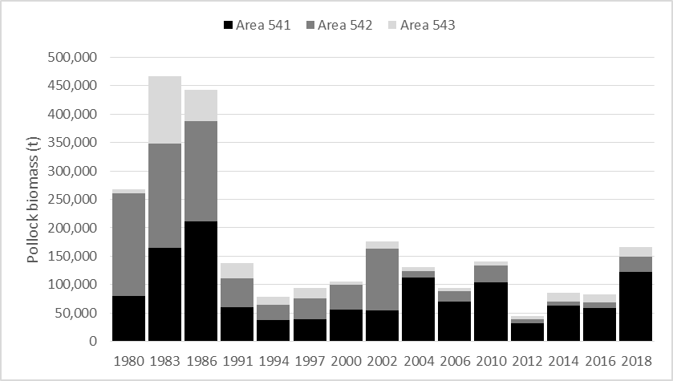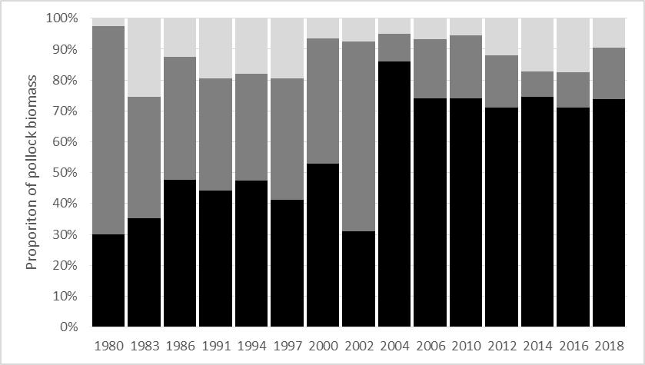

Figure 1A.1 Aleutian Islands bottom trawl survey pollock biomass (top) and proportion of biomass (bottom) for the three Aleutian Island management regions.

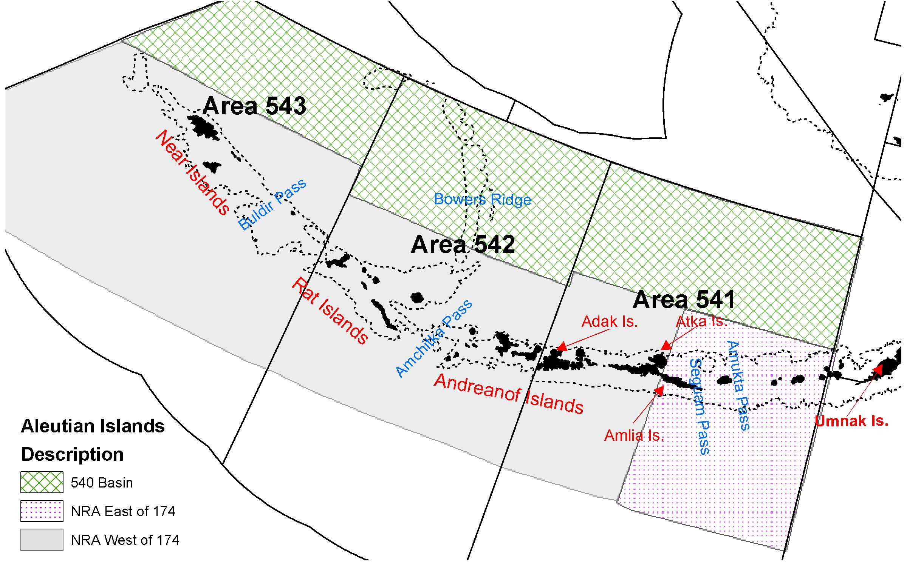

Figure 1A. 2. Regions defined for consideration of alternative data partitions for Aleutian Islands Region pollock. The abbreviation “NRA” represents the Near, Rat, and Andreanof Island group. There are no models for 2018 that consider the NRA east-west partition at 174° W.

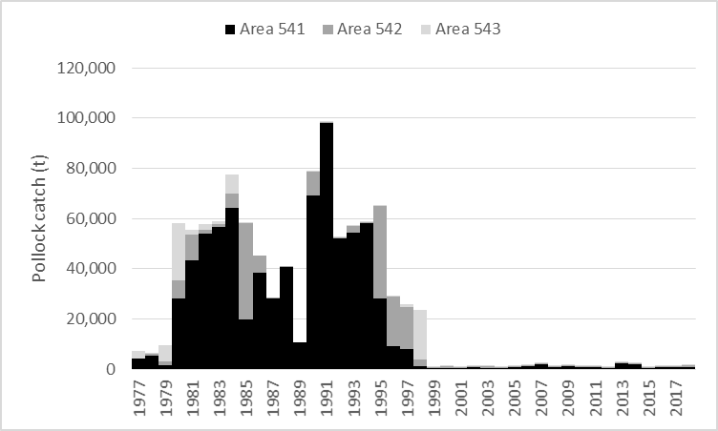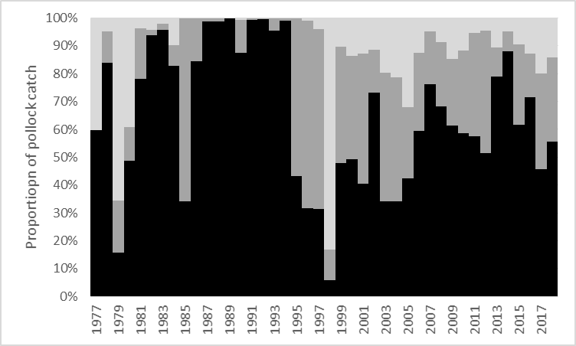

Figure 1A.3. Pollock catch by NMFS reporting area for 1977- 2022 by total catch (top) and percentage of catch by area (bottom).

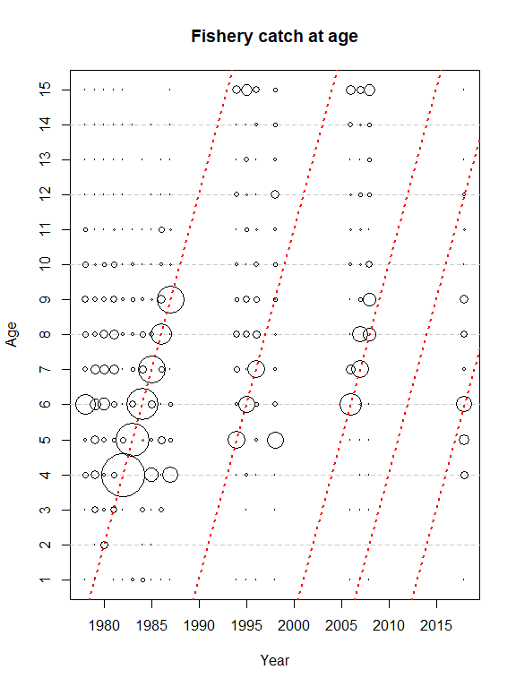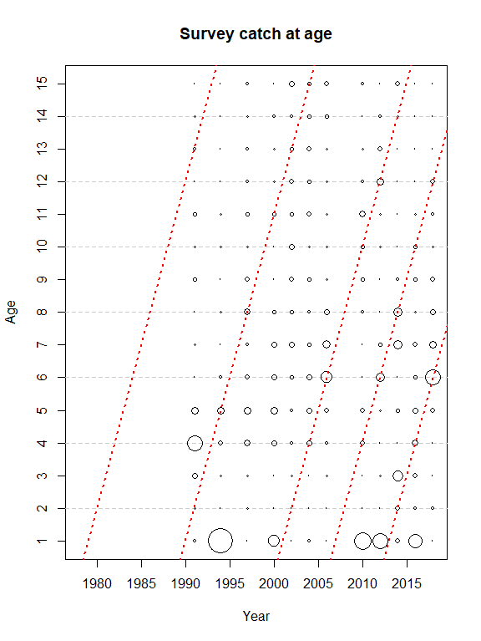

B

A

Figure 1A.4. Age distributions for 1978-2018 Aleutian Islands pollock fishery (A; left) and 1991 - 2018 Aleutian Islands Bottom Trawl surveys (B; right). The 1978, 1989, 2000, 2006, and 2012 year classes are indicated by the diagonal dashed lines.

###### 

Figure 1A.5. Catch per unit effort (kgha-1) for surveys of pollock in the Aleutian Islands Region, 2010-2018. The shaded area is the Aleutian Islands shelf area less than 300m depth.

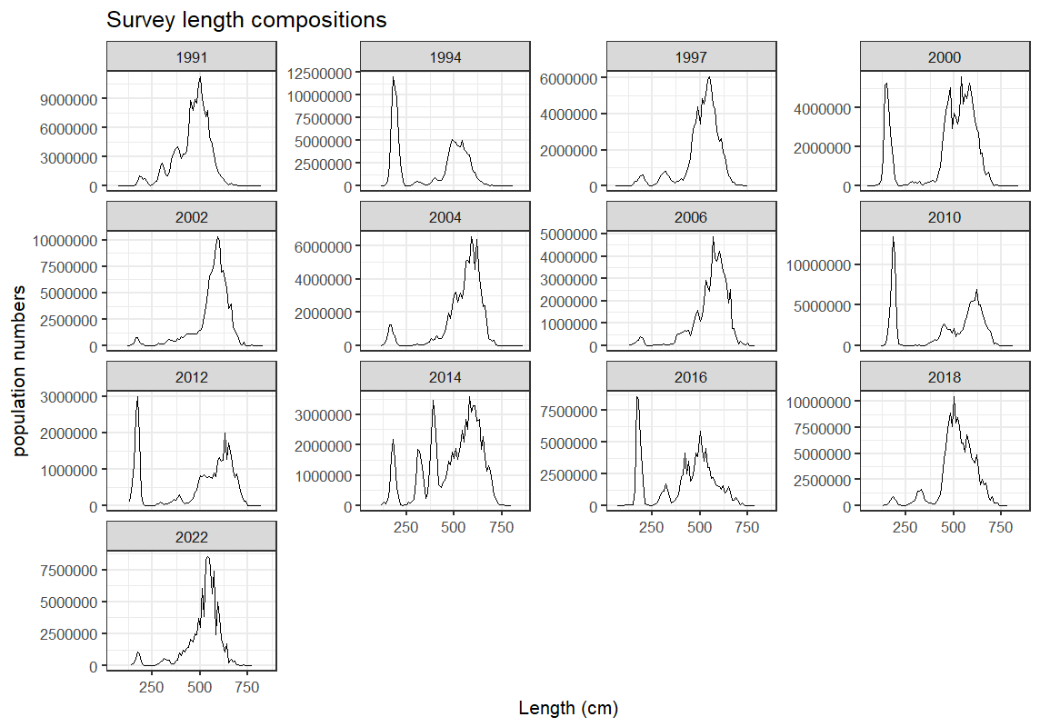

Figure 1A.6. Distribution by length for 1991-2022 Aleutian Islands bottom trawl surveys.

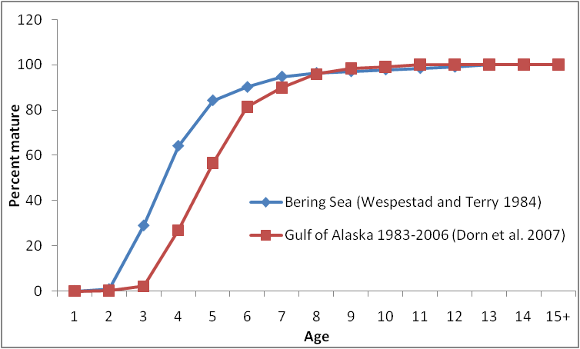

Figure 1A.7. Percent mature at age for Bering Sea pollock (Wespestad and Terry 1984) and the mean percent mature at age for 1983-2006 for Gulf of Alaska pollock (Dorn *et al.* 2007).

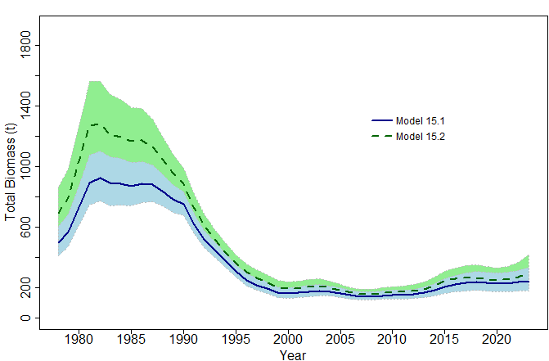 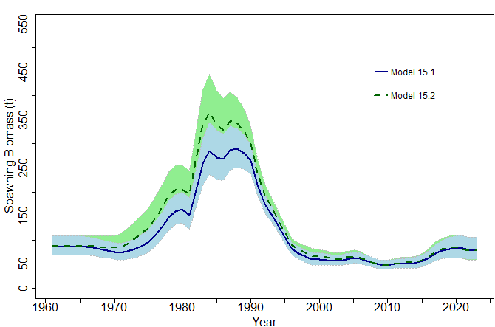

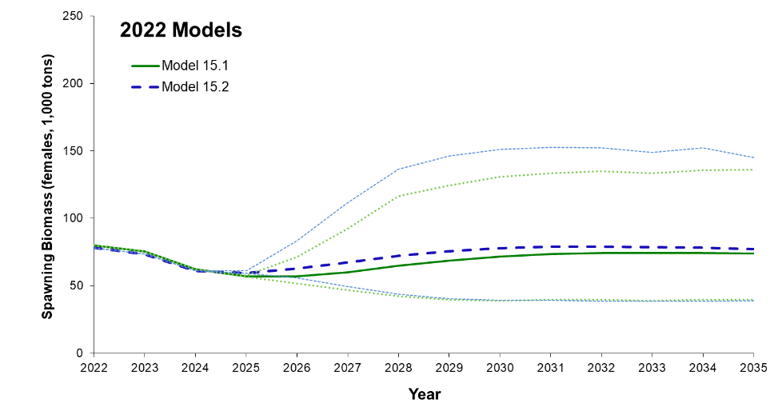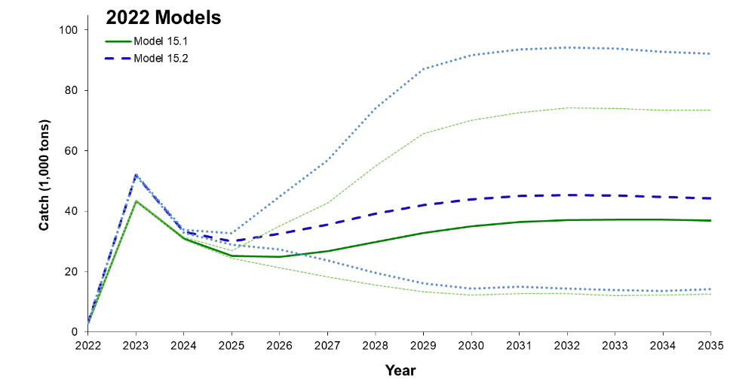

Figure 1A.8. Total biomass (top left), spawning biomass (top right), and spawning biomass projection (bottom left) and catch projection (bottom right) from Model 15.1. and Model 15.2.

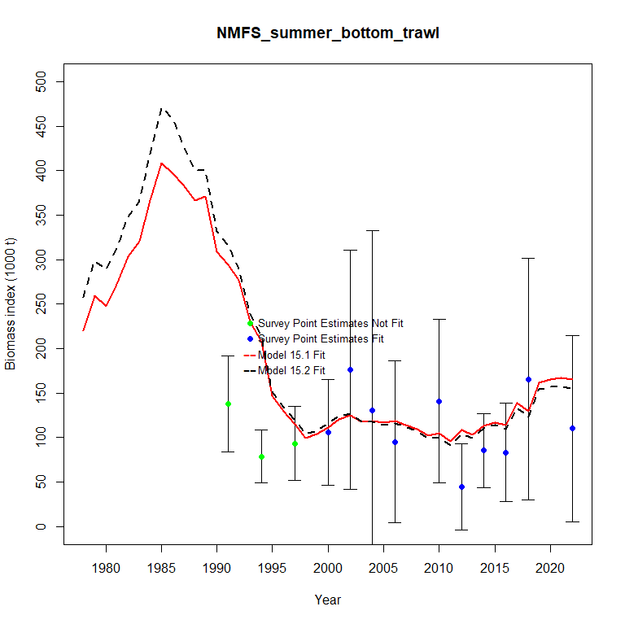

Figure 1A.9. Model fits to NMFS summer bottom trawl survey.

**Model 15.1 Model 15.2**

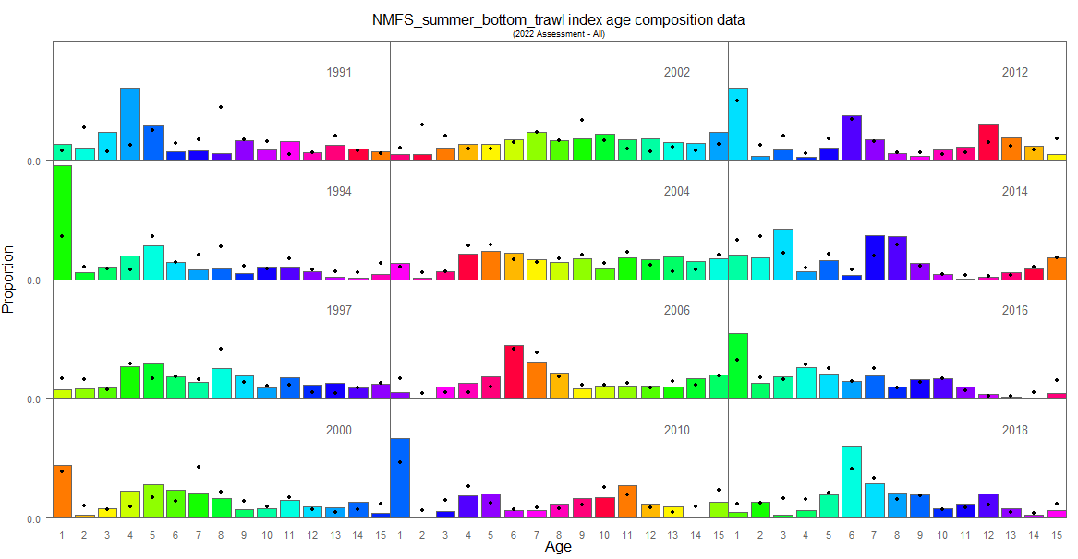 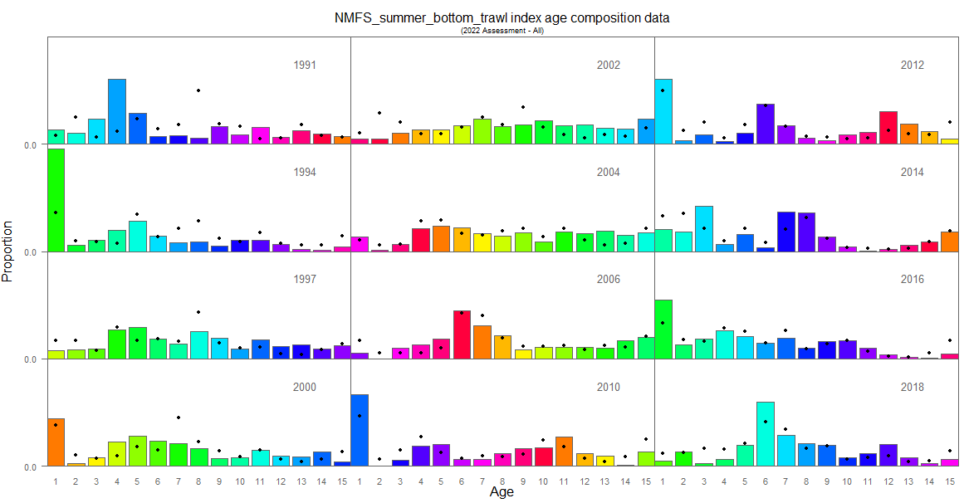

Figure 1A.10. Aleutian Islands pollock Model 15.1 and Model 15.2 fit to NMFS summer bottom trawl survey age composition data. The “•” symbol are the model predictions and columns are the observed proportions at age (with colors corresponding to cohorts).

**Model 15.1 Model 15.2**

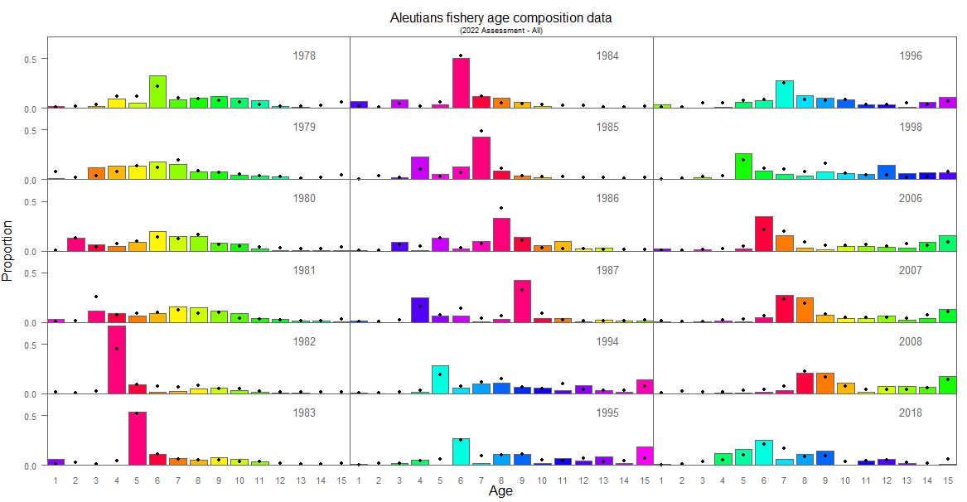 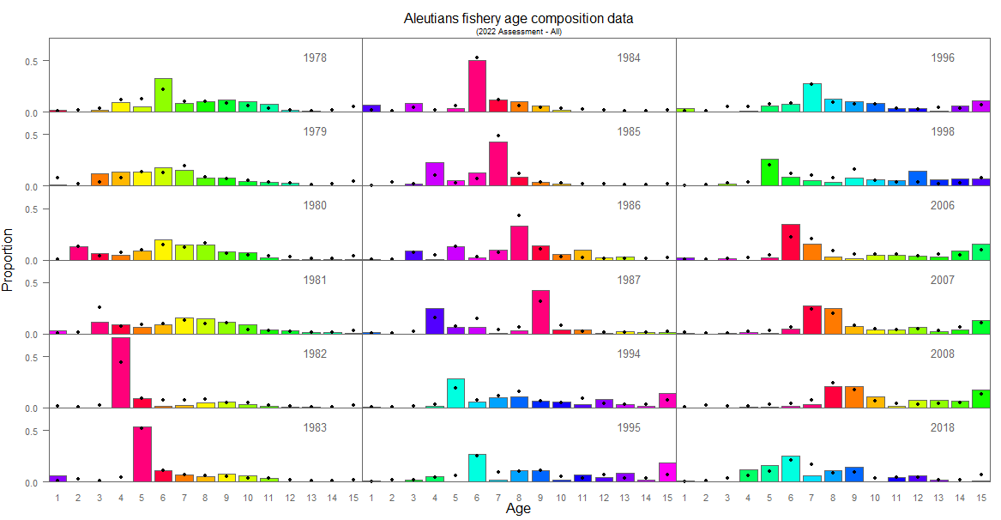

Figure 1A.11. Model 15.1 and Model 15.2. fits to fishery age composition data for Aleutian Islands pollock. The “•” symbol are the model predictions and columns are the observed proportions at age (with colors corresponding to cohorts).

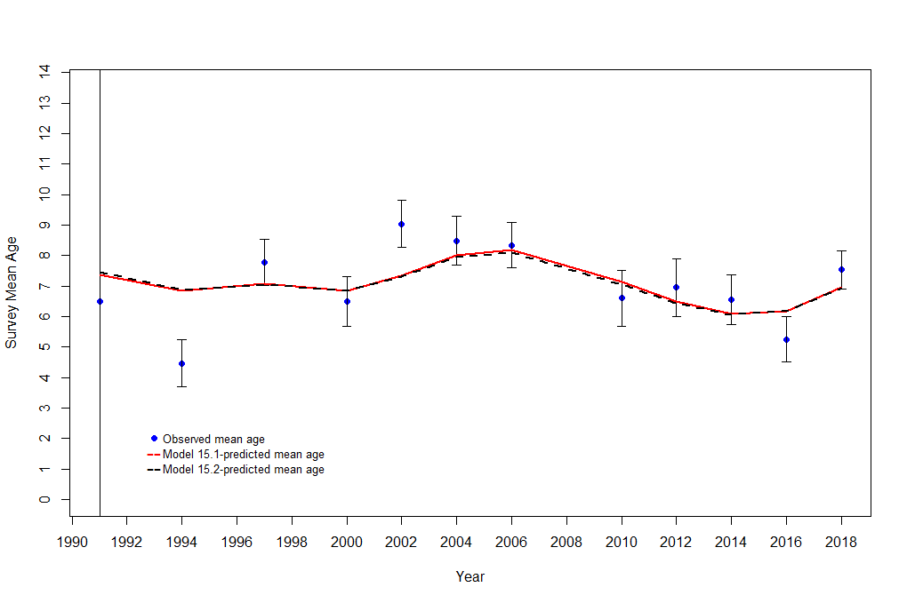

**Survey**

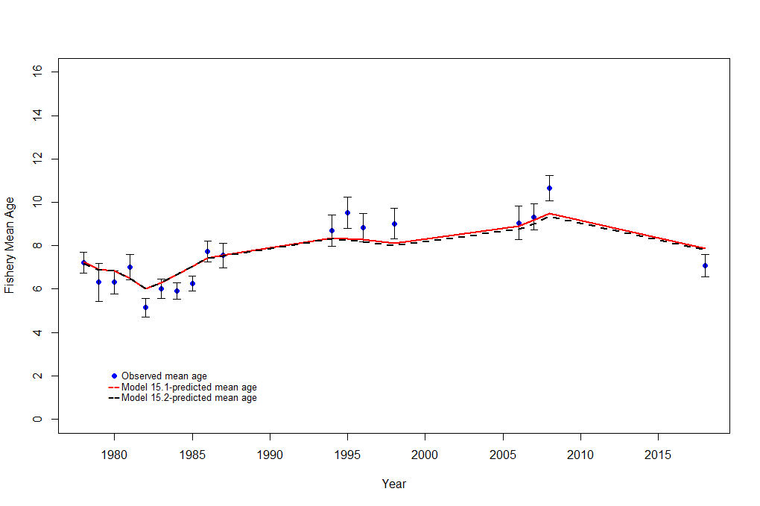

**Fishery**

Figure 1A.12. Observed mean age and model derived mean age from the AIBTS (top) and fishery catch at age data (bottom) for Model 15.1 and Model 15.2. The confidence intervals are adjusted by the multinomial sample sizes used in the models.

**Fishery Proportion-at-age Residuals**

**Model 15.1 (Max = 0.14, Min = - 0.24) Model 15.2 (Max = 0.13, Min = -0.25)**

###### 

**Survey Proportion-at-age Residuals**

**Model 15.1 (Max = 0.19, Min = - 0.23) Model 15.2 (Max = 0.23, Min = -0.22)**

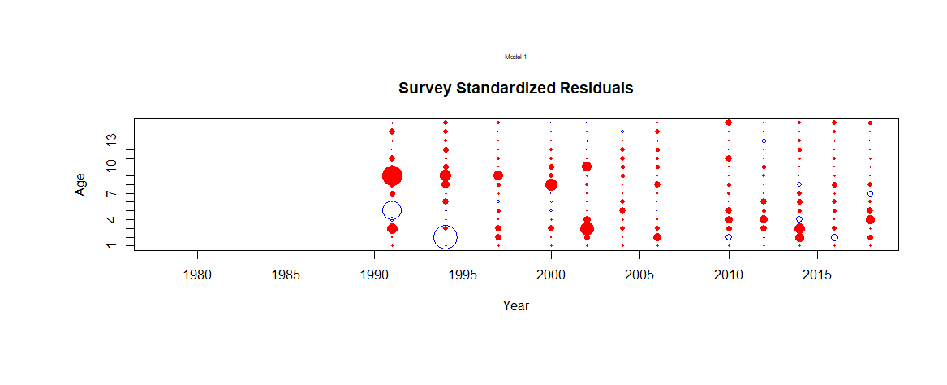 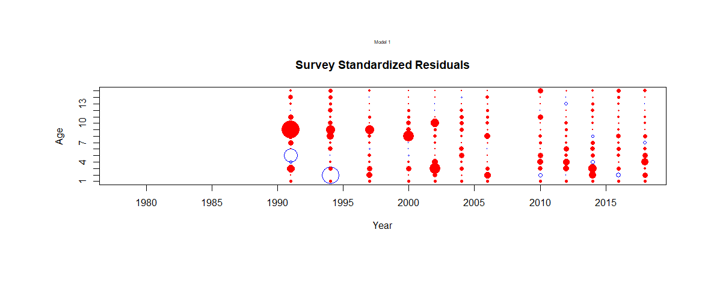

Figure 1A.13. Standardized residuals for fits to the fishery (top) and survey (bottom) proportion-at-age data for AI pollock Model 15.1 and Model 15.2.

###### 

Model 15.1

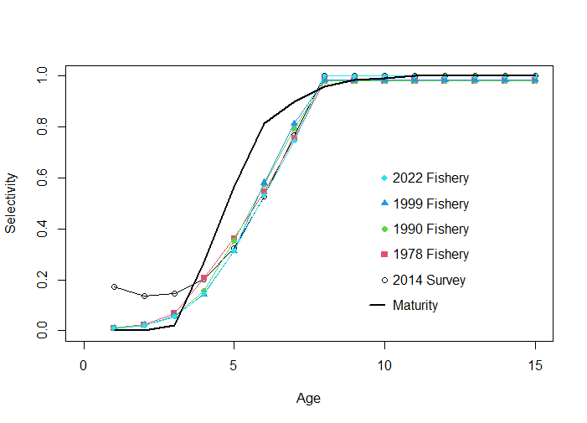

Model 15.2

Figure 1A.14. Fishery and survey selectivity estimates with maturity at age for Aleutian Islands pollock models.

###### 

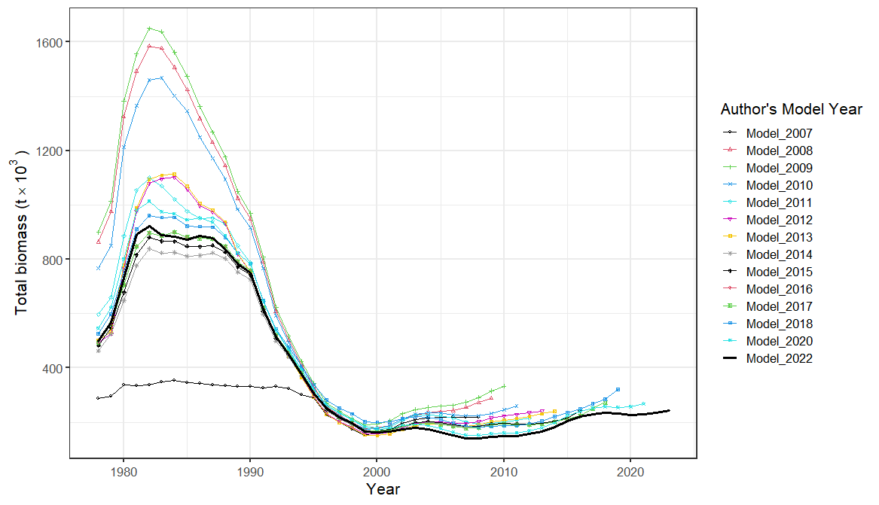

Figure 1A.15. Female spawning (top) and total (bottom) biomass trajectories for the 2022 Authors’ preferred model compared with the 2007 through 2020 Authors’ preferred models. Note: 2019 and 2021 were partial assessment years and therefor no models available.

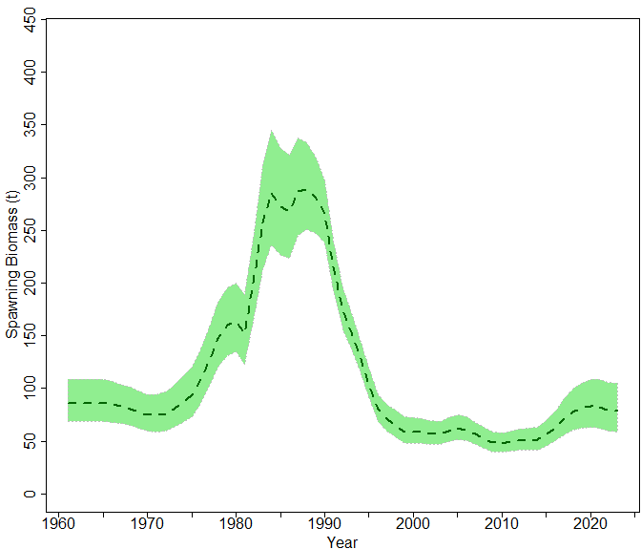 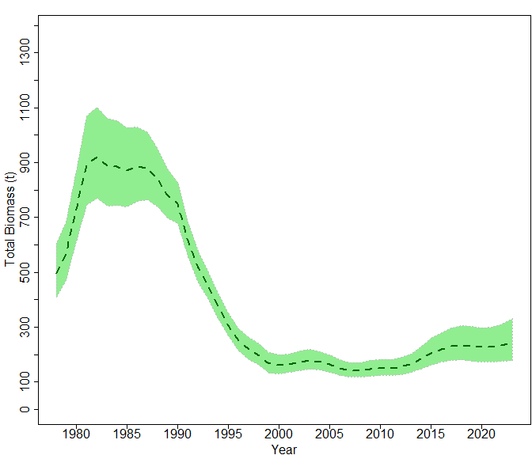

Figure 1A.16. Estimates of Aleutian Islands pollock spawning biomass (left) and age 1+ total biomass (right) in 1,000s of tons from the authors’ preferred Model 15.1. Confidence intervals are two standard deviations.

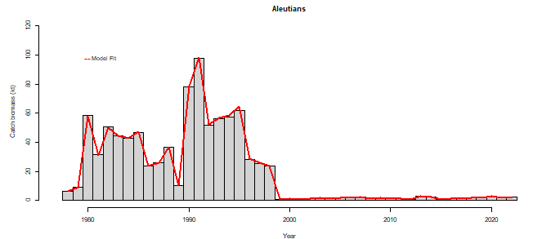

Figure 1A.17 Fits to total catch in 1,000s of tons for AI pollock over time 1978-2022.

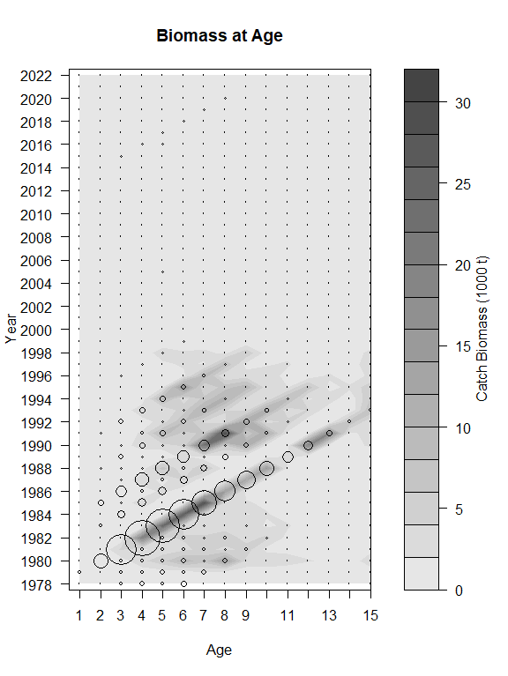 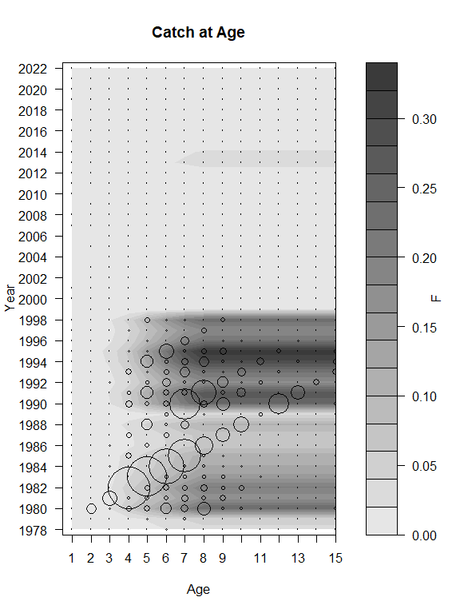

**A**

**B**

Figure 1A.18 AI pollock authors’ preferred Model 15.1 (A-contour) catch biomass in 1,000s of tons and (A-bubbles) total biomass and (B-contour) fishing mortality rates and (B-bubbles) catch biomass by age. Total biomass is scaled to 1/20th of the catch biomass in the bubble plots.

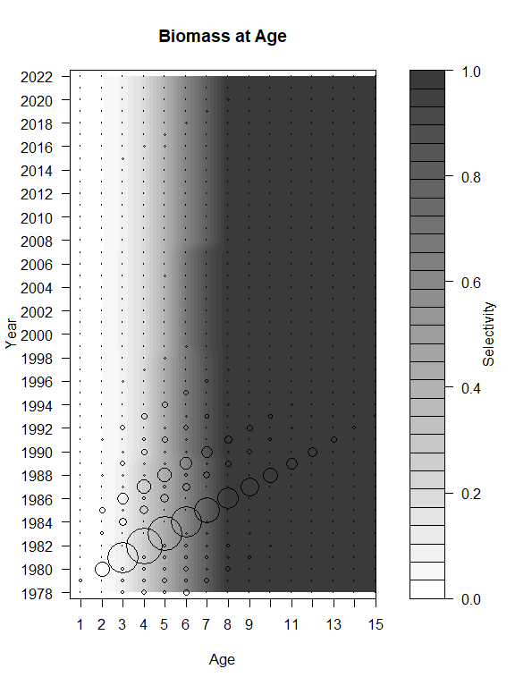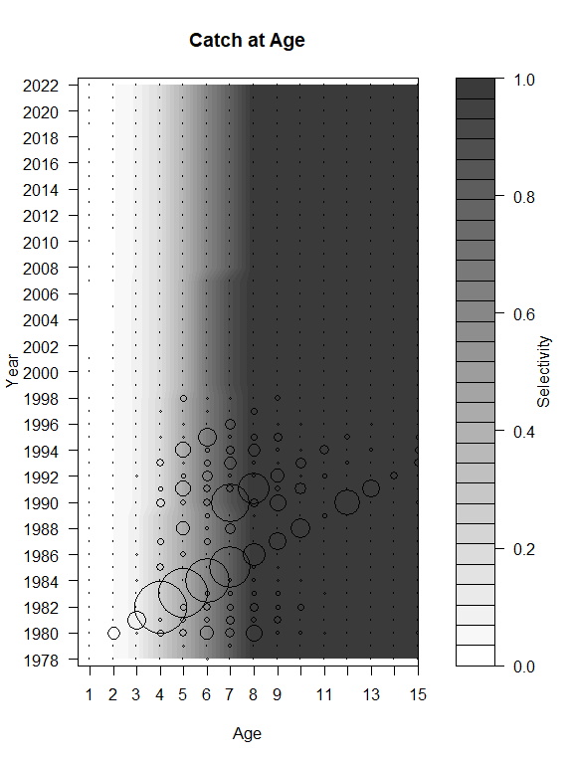

**B**

**A**

Figure 1A.19 Contour plots of fishery selectivity by age for AI pollock with bubble plots of (A) total biomass at age and (B) catch biomass at age for the Authors’ preferred Model 1.0. Total biomass is scaled to 1/20 of the catch biomass bubbles.

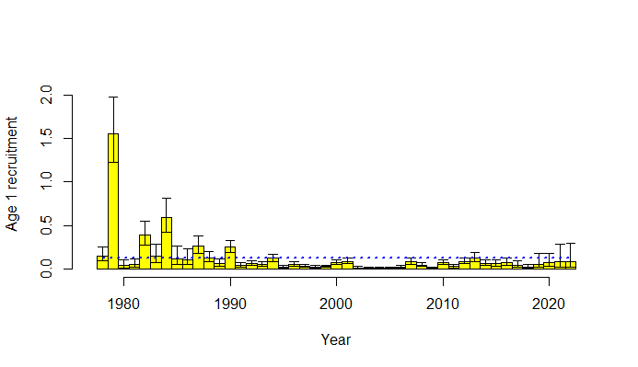

Figure 1A.20. Authors’ preferred model estimates of Aleutian Islands pollock age 1 recruitment. The vertical bars represent the upper and lower 95% confidence bounds. The dotted line is the 1978-2020 mean age-1 recruitment.

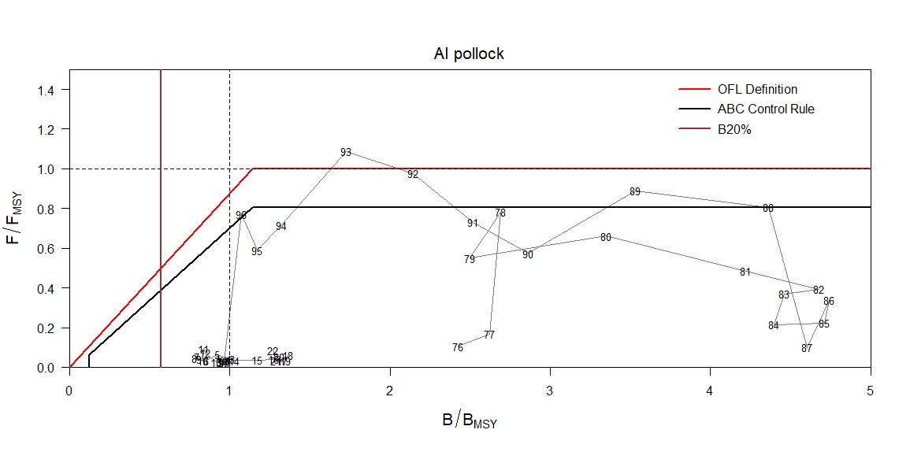

Figure 1A.21. Aleutian Islands pollock spawning biomass relative to *Bmsy* and full-selection fishing mortality relative to *Fmsy* (1978-2024). The ratio of fishing mortality to *Fmsy* is calculated using the estimated selectivity pattern in that year. 2023 and 2024 are plotted with catch assumed to be at the 5-year average (Alternative 3).

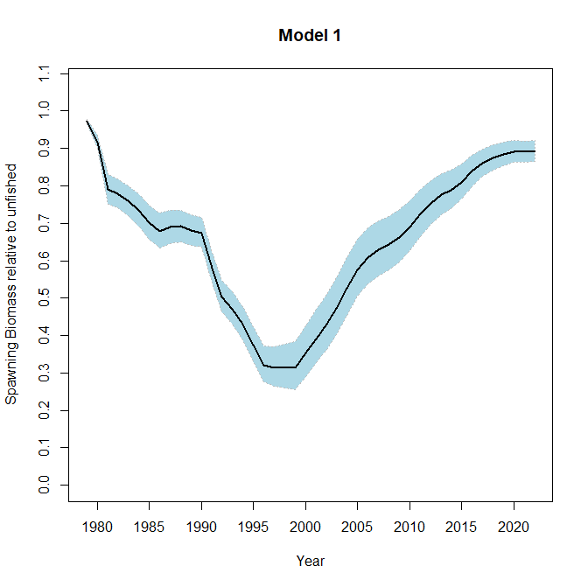

Figure 1A.22. Aleutian Islands pollock ratio of spawning biomass with fishing relative to spawning biomass without fishing for the authors’ preferred model with 95% confidence interval.

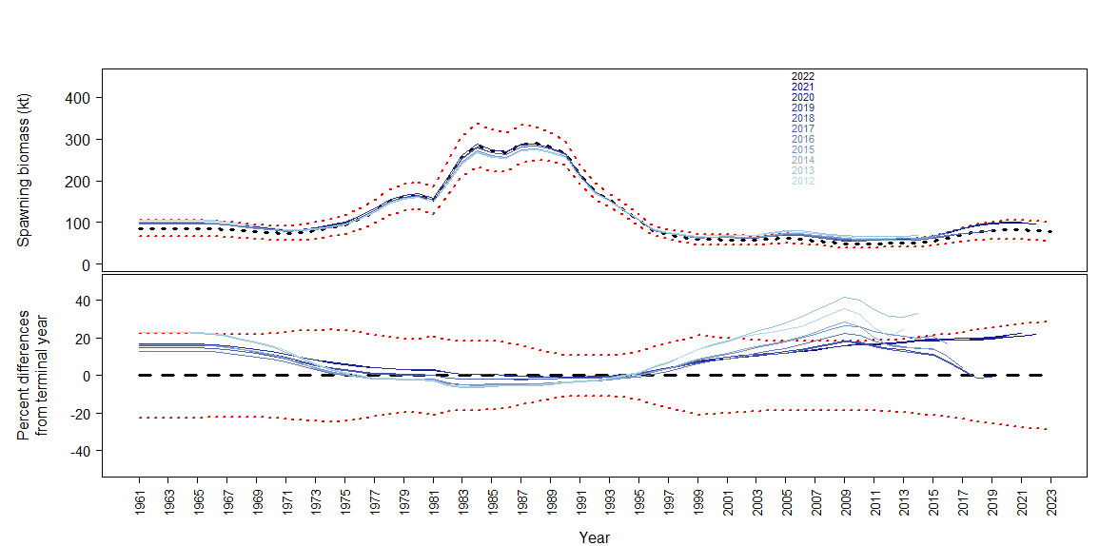

Figure 1A.23 Retrospective analysis for Authors’ preferred Model 15.1 with data for the previous 10 years being systematically removed from the model. Black dashed line is the 2022 Model 15.1 estimate, the red dotted lines are the 95% confidence intervals calculated as ±1.96×standard deviation.

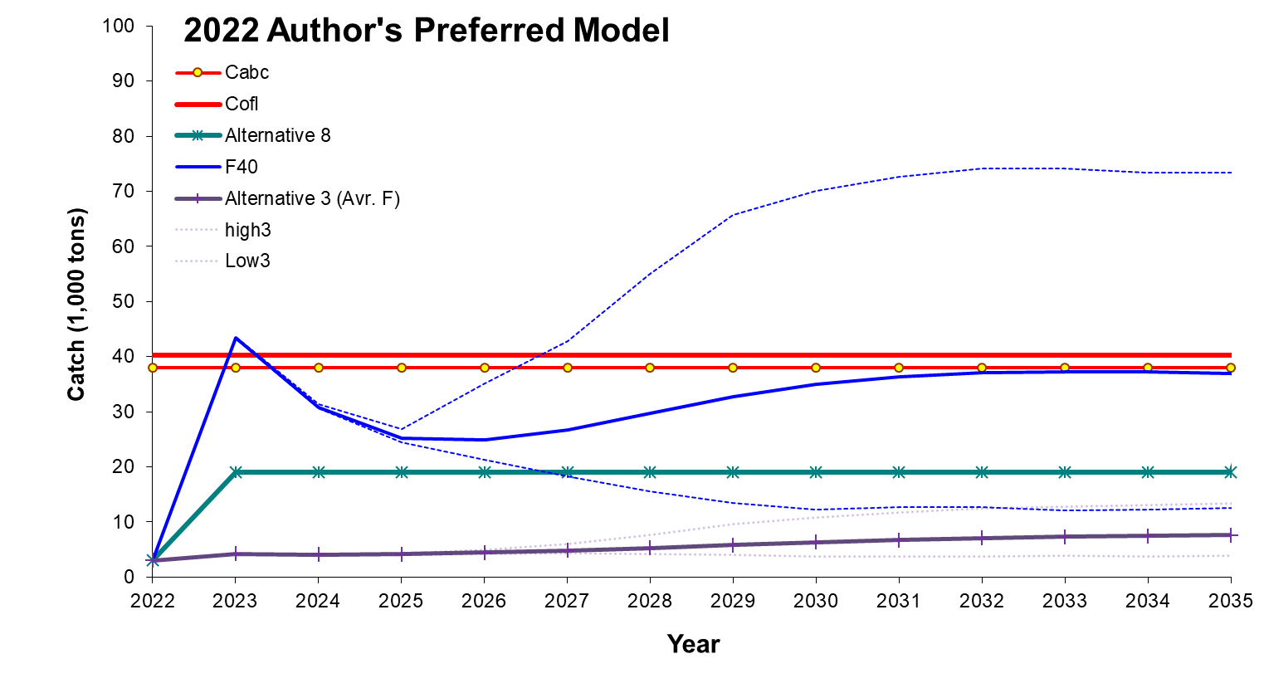

Figure 1A.24 Authors’ preferred Model 15.1 projected catch for *F*40% , Alternative 3 (average *F*), and Alternative 8 (19,000t)ABC scenarios.

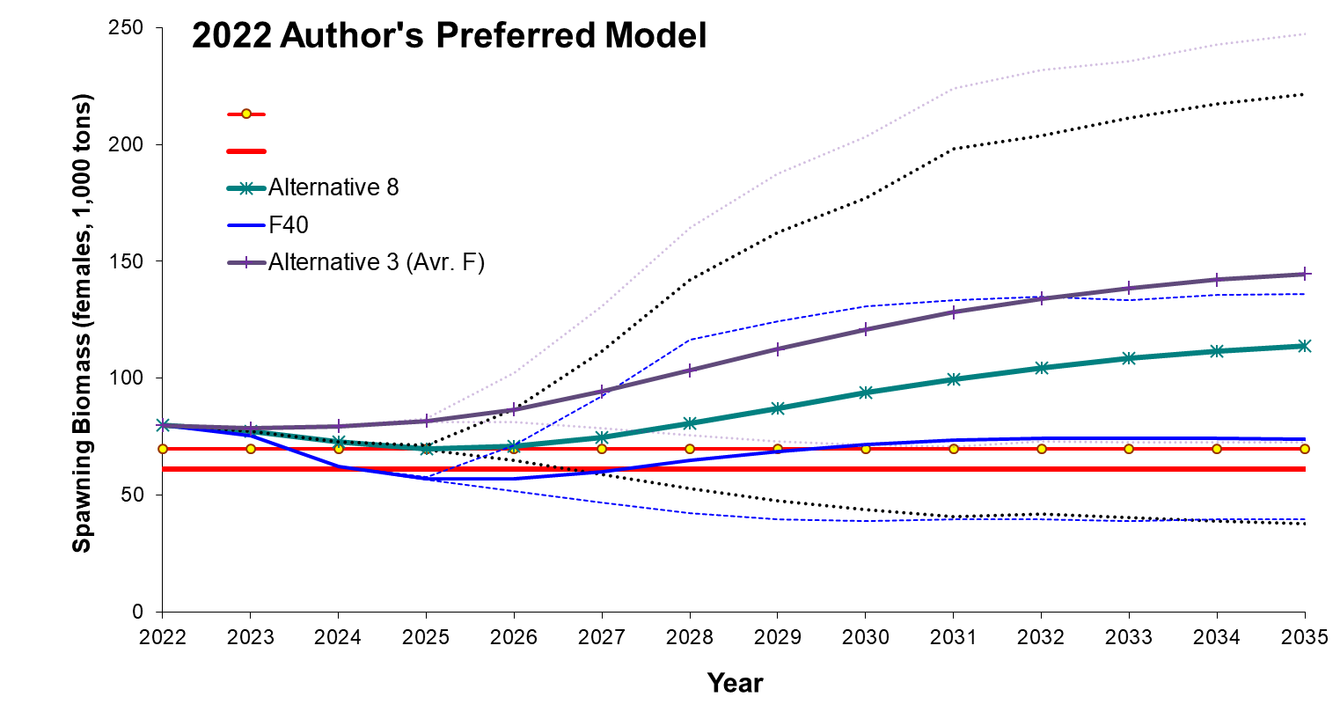

Figure 1A.25 Authors’ preferred Model 15.1 projected spawning biomass for *F*40% Alternative 3 (average *F*), and Alternative 8 (19,000t) ABC scenarios.

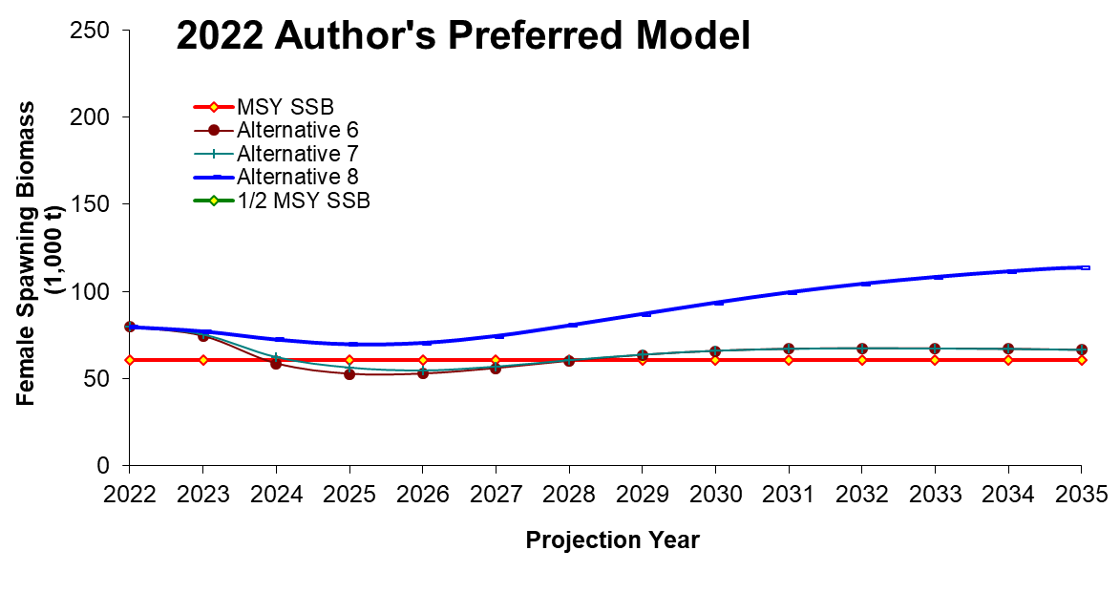

Figure 1A.26 Authors’ preferred Model 15.1 projected spawning biomass for MSY, ½MSY, and Alternatives 6, 7, and 8 ABC scenarios from the authors’ preferred model.

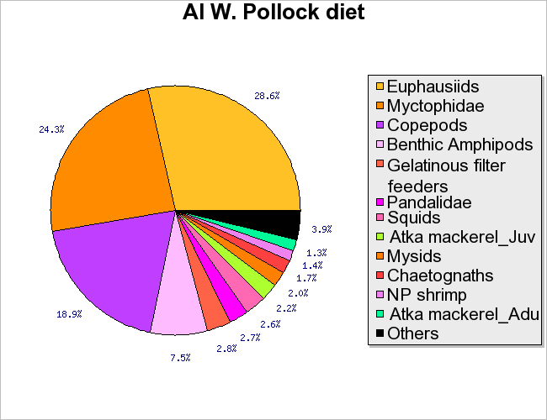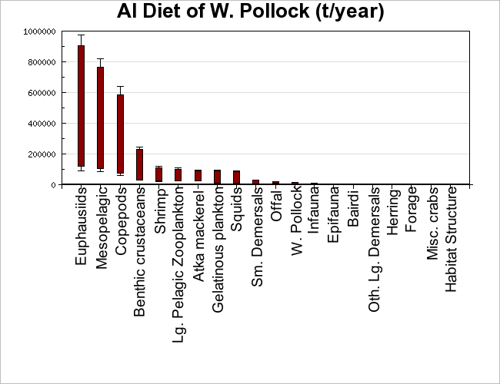

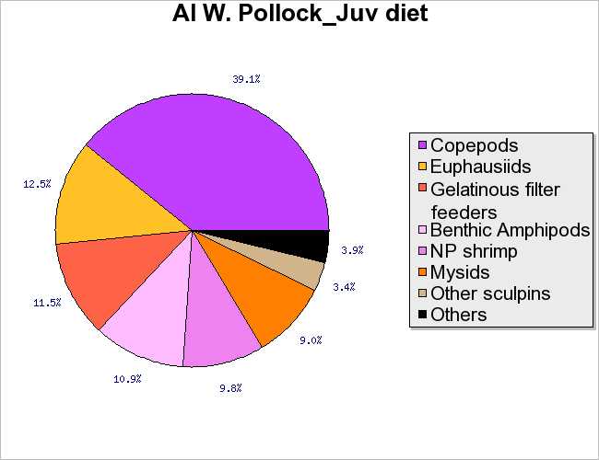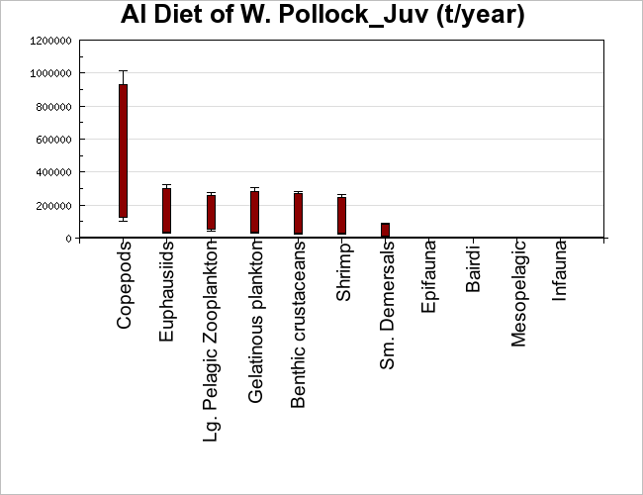

Figure 1A.27. Diet composition (left) and estimated consumption of prey (right) by AI adult (top) and juvenile (bottom) pollock. Diets are estimated from stomach collections taken aboard NMFS bottom trawl surveys in 1991-1994. See Appendix A Barbeaux *et al.* 2006 for detailed methods.

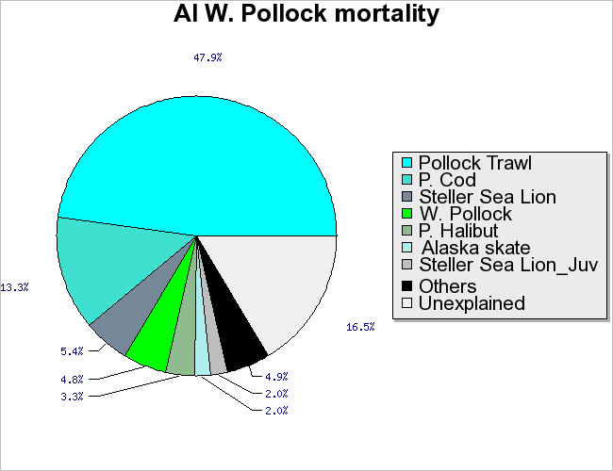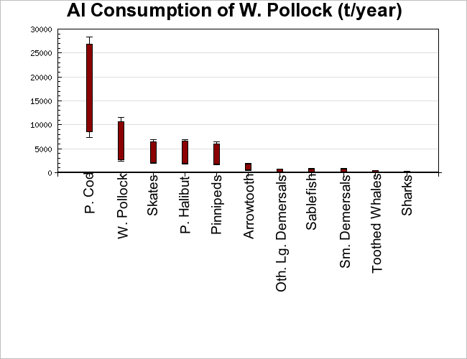

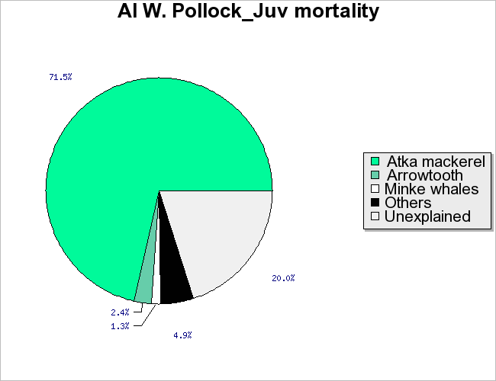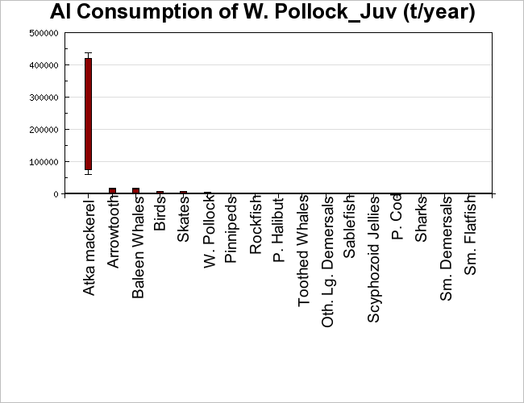

Figure 1A.28. Mortality sources (left) and estimated consumption by predators (right) of AI adult (top) and juvenile (bottom) pollock. Mortality sources reflect pollock predator diets estimated from stomach collections taken aboard NMFS bottom trawl surveys in 1991-1994, pollock predator consumption rates estimated from stock assessments and other studies, and catch of pollock by all fisheries in the same time periods. Annual consumption ranges incorporating uncertainty in food web model parameters were estimated by the Sense routines (Aydin *et al.* 2004). See Appendix A Barbeaux *et al.* 2006 for detailed methods.

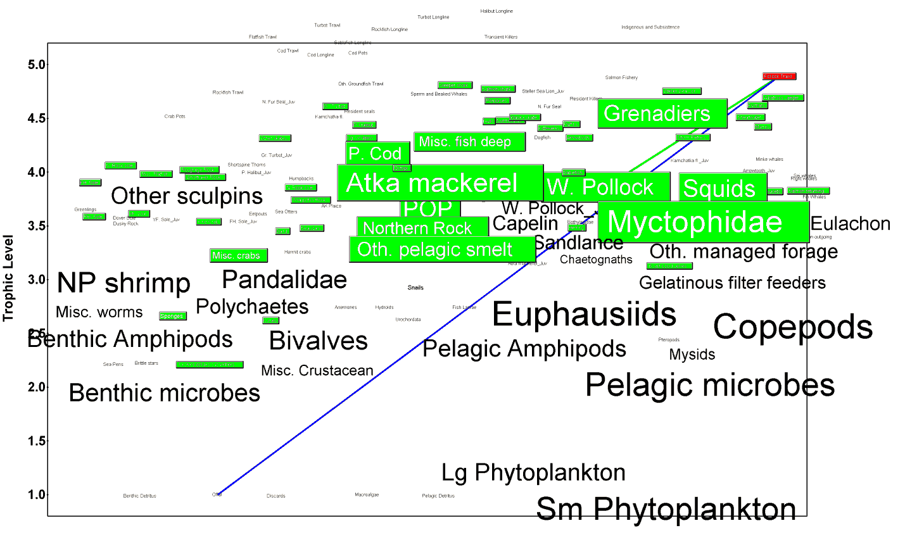

Figure 1A.29. The pollock trawl fishery in the AI food web. Species taken by the pollock fishery (in red) are highlighted in green, with the most significant flow to pollock indicated with a green line. Box size is proportional to biomass and lines between boxes represent the most significant energy flows. From Aydin *et al.* (2007).

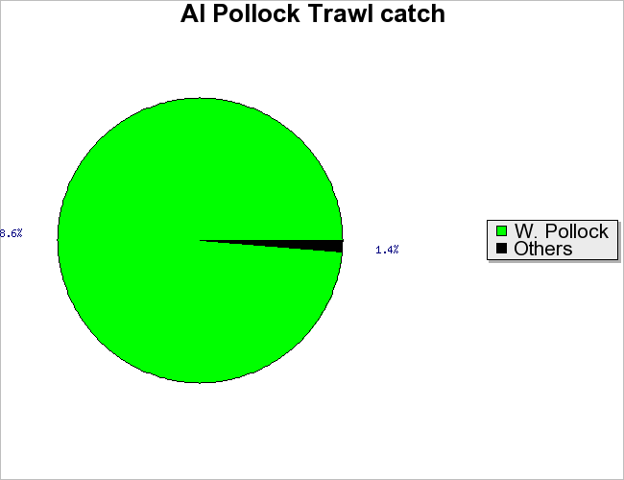

Figure 1A.30. Catch composition of the AI pollock trawl fishery during the early 1990’s, as used in the food web model (Aydin *et al.* 2004).

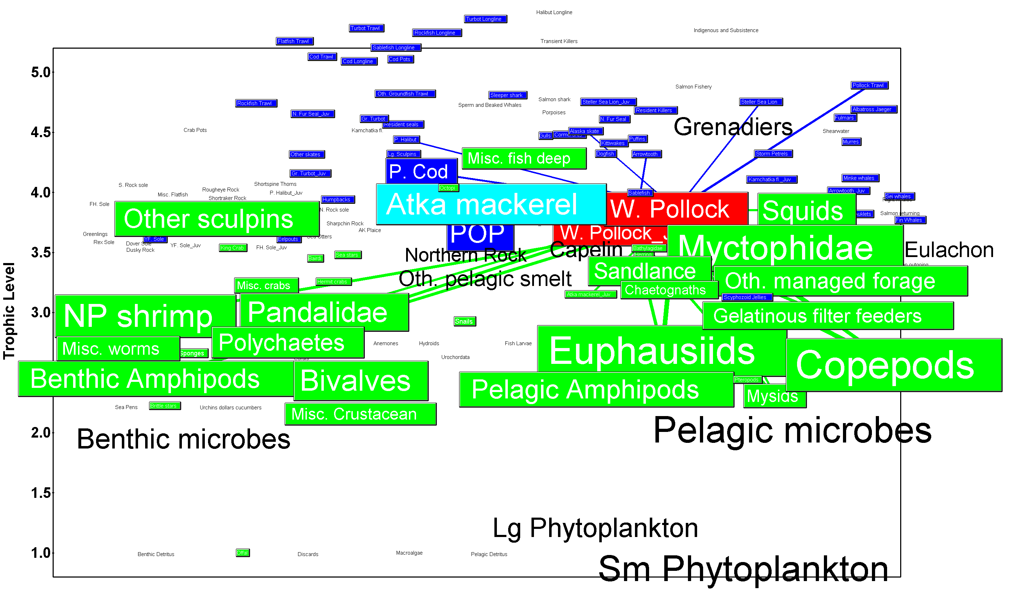

Figure 1A.31. Adult and juvenile pollock (highlighted in red) in the AI food web (Aydin et al 2004). Predators of pollock are dark blue, prey of pollock are green, and species that are both predators and prey of pollock are light blue. Box size is proportional to biomass and lines between boxes represent the most significant energy flows.

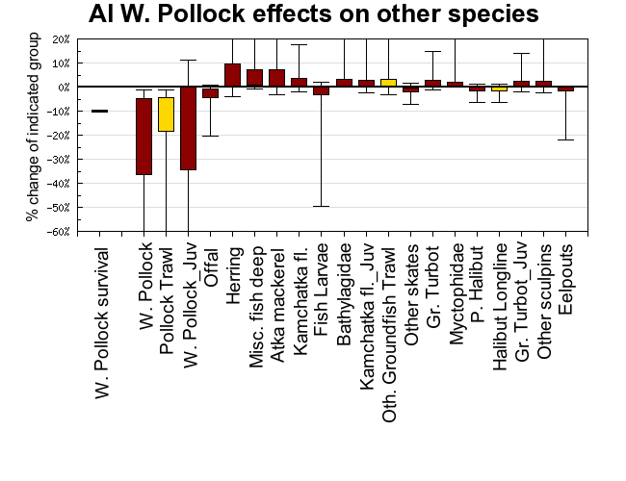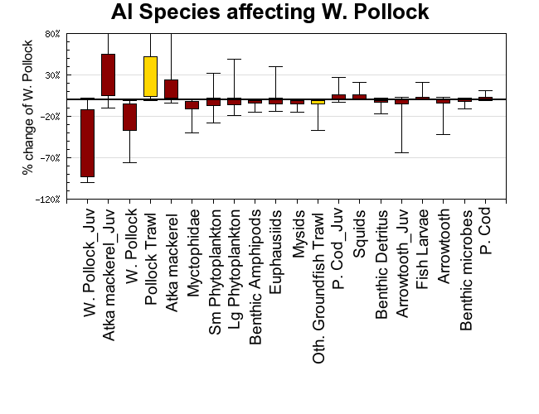

Figure 1A.32. (upper panel) Effect of changing pollock survival on fishery catch (yellow) and biomass of other species (dark red), from a simulation analysis where pollock survival was decreased by 10% and the rest of the ecosystem adjusted to this decrease for 30 years. (lower panel) Effect of reducing fisheries catch (yellow) and other species survival (dark red) on pollock biomass, from a simulation analysis where survival of each x axis species group was decreased by 10% and the rest of the ecosystem adjusted to this decrease for 30 years. In both panels, boxes show resulting percent change in the biomass of each species on the x axis after 30 years for 50% of feasible ecosystems, error bars show results for 95% of feasible ecosystems (see Aydin *et al.* 2007 for detailed Sense methods).

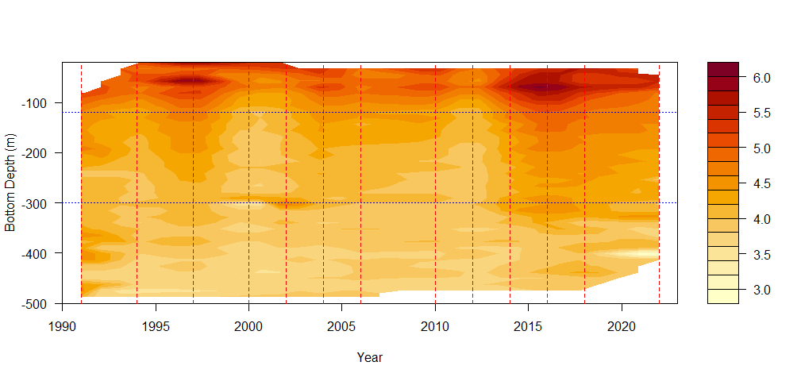 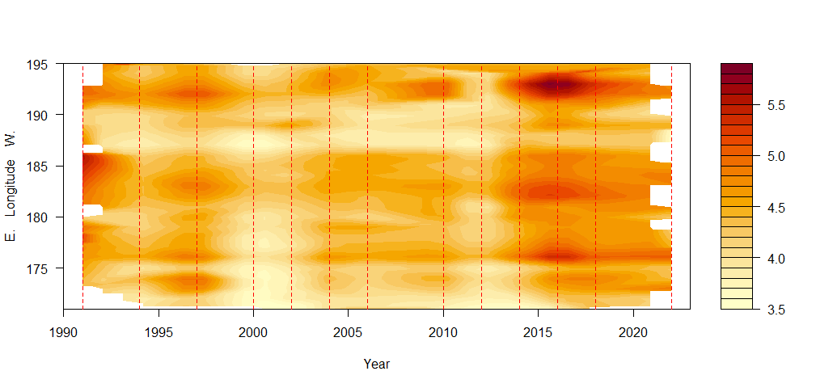

Figure 1A.33 Mean bottom temperatures by 10 m bottom depth (top) and by 1 degree longitude (bottom) by year. Red lines indicate years with survey data. Note the E longitudes (>180) are further west in the Aleutian Islands. Blue lines are at -120 and -300, the area of highest densities for pollock in the AI.

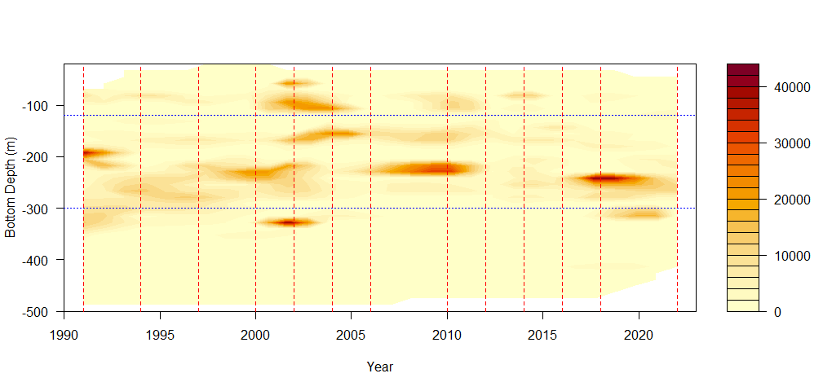 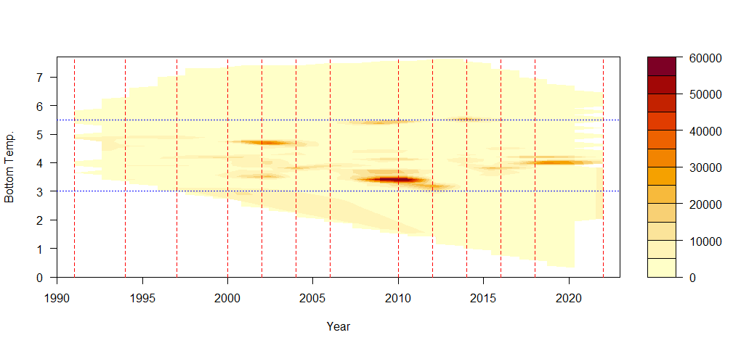 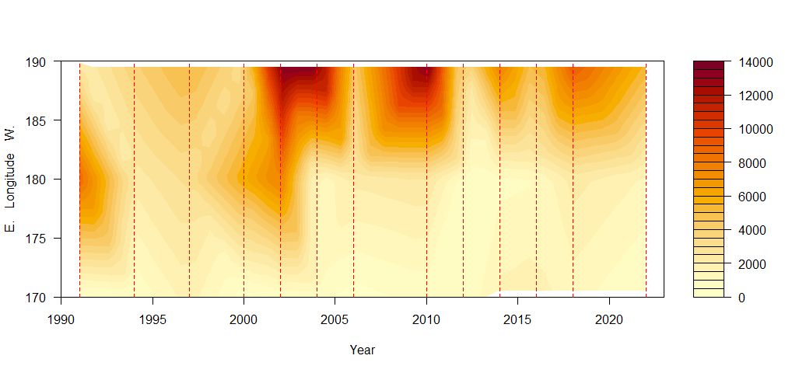

Figure 1A.34 Pollock CPUE kgha-1by 10 m bottom depth (top), 0.1 °C bottom temperature(middle), and 10° longitude (bottom). Note the E longitudes (<180) are further west in the Aleutian Islands.

# Appendix 1A-A

Table A-1. Variable descriptions and model specification for Authors’ Preferred Model.

|  |  |  |
| --- | --- | --- |
| **General Definitions** | **Symbol/Value** | **Use in Catch at Age Model** |
| Year index: *i* = {1963, …., 2015} | *I* | |
| Age index: *j* = {1, 2, 3, …, 14+} | *j* |  |
| Mean weight by age *j* | *Wj* |  |
| Maximum age beyond which selectivity is constant | *Maxage* | Selectivity parameterization |
| Instantaneous Natural Mortality | *M* | Fit with *M*=0.20 and CV = 0.2, constant over all ages for Models 15.1 Model 15.2 M = vector fit as deviates from initial M. |
| Proportion females mature at age *j* |  | Definition of spawning biomass |
| Sample size for proportion at age *j* in year *i* |  | Scales multinomial assumption about estimates of proportion at age |
| Survey catchability coefficient |  | Prior distribution = lognormal(1.0 , ) |
| Stock-recruitment parameters |  | Unfished equilibrium recruitment |
|  |  | Stock-recruitment steepness |
|  |  | Recruitment variance |
| **Estimated parameters** |  |  |
|  | | |

Note that the number of selectivity parameters estimated depends on the model configuration.

Table A-2. Variables and equations describing implementation of the Assessment Model for Alaska(AMAK).

|  |  |  |
| --- | --- | --- |
| **Description** | **Symbol/Constraints** | **Key Equation(s)** |
| Survey abundance index (*s*) by year |  |  |
| Catch biomass by year |  |  |
| Proportion at age *j,* in year *i* | , |  |
| Initial numbers at age | *j = 1* |  |
|  | *1 < j < 13* |  |
|  | *j = 14+* |  |
| Subsequent years (*i >1963*) | *j = 1* |  |
|  | *i < j < 13* |  |
|  | *j = 14+* |  |
| Year effect, *i* = 1963, …, 2015 | *i,* |  |
| Index catchability  Mean effect    Age effect |  |  |
| Instantaneous fishing mortality |  |  |
| mean fishing effect | *f* |  |
| annual effect of fishing in year *i* | *i*, |  |
| age effect of fishing (regularized) In year time variation allowed  In years where selectivity is constant over time | , | *,* |
| Natural Mortality | *M* |  |
| Total mortality |  |  |
| Recruitment   Beverton-Holt form |  | *h=0.8* |

Table A-3. Specification of objective function that is minimized (i.e., the penalized negative of the log-likelihood).

|  |  |  |
| --- | --- | --- |
| Likelihood /penalty component |  | Description / notes |
| Abundance indices |  | Survey abundance |
| Prior on smoothness for selectivities |  | Smoothness (second differencing),  Note: *l={s,* or *f}* for survey and fishery selectivity |
| Prior on recruitment regularity |  | Influences estimates where data are lacking (e.g., if no signal of recruitment strength is available, then the recruitment estimate will converge to median value). |
| Catch biomass likelihood |  | Fit to catch biomass in each year ( |
| Proportion at age likelihood |  | *L={s, f}* for survey and fishery age composition observations |
| Fishing mortality regularity |  | (relaxed in final phases of estimation) |
| Priors |  | Prior on natural mortality, and survey catchability (reference case assumption that these are precisely known at 0.3 and 1.0, respectively). |
| Overall objective function to be minimized |  |  |

# Appendix 1A-B Supplemental catch data

In order to comply with the Annual Catch Limit (ACL) requirements, we present non-commercial removals and estimates of pollock removals from the halibut fishery from the Halibut Fishery Incidental Catch Estimation (HFICE) to help estimate total catch and removals from NMFS managed stocks in Alaska.

Estimates of total removals that do not occur during directed groundfish fishing activities includes removals incurred during research, subsistence, personal use, recreational, and exempted fishing permit activities, but does not include removals taken in fisheries other than those managed under the groundfish FMP. These estimates represent additional sources of removals to the existing Catch Accounting System (CAS) estimates. Current pollock research removals are insignificant relative to the fishery catch, being smaller than the observation error assumed for the catch estimate. Total removals from activities other than directed fishery were near 29.2 tons in 2018 (Table C-1). This is 0.07% of the 2018 recommended ABC of 40,788 t. There were no data available on pollock removals due to subsistence, personal use, or recreational catch. It is assumed that pollock catches during these activities would be minimal in AI management area.

**References:**

Cahalan J., J. Mondragon., and J. Gasper. 2010. Catch Sampling and Estimation in the Federal Groundfish Fisheries off Alaska. NOAA Technical Memorandum NMFS-AFSC-205. 42 p.

Hanselman, D. H., C. Lunsford, and C. Rodgveller. 2010. Alaskan Sablefish. In Stock assessment and fishery evaluation report for the groundfish resources of the GOA and BS/AI as projected for 2010. North Pacific Fishery Management Council, 605 W 4th Ave, Suite 306 Anchorage, AK 99501.pp.

Tribuzio, CA, S Gaichas, J Gasper, H Gilroy, T Kong, O Ormseth, J Cahalan, J DiCosimo, M Furuness, H Shen, K Green. 2011. Methods for the estimation of non-target species catch in the unobserved halibut IFQ fleet. August Plan Team document. Presented to the Joint Plan Teams of the North Pacific Fishery Management Council.

Table C-1 Total removals of walleye pollock (t) from the NRA area from activities not related to directed fishing, since 1978.

|  |  |  |  |  |  |  |  |  |
| --- | --- | --- | --- | --- | --- | --- | --- | --- |
|  | NMFS Acoustic | Bottom Trawl | ABL Long Line | AICASS* | IPHC | Japanese Surveys | Atka Tagging | Total |
| 1978 |  |  |  |  |  |  |  |  |
| 1979 |  |  |  |  |  |  |  |  |
| 1980 | 2.5 | 37.9 |  |  |  | 97.7 |  | 138.1 |
| 1981 |  |  |  |  |  |  |  |  |
| 1982 | 5.7 | 0.8 |  |  |  |  |  | 6.5 |
| 1983 |  | 28.1 |  |  |  | 396.7 |  | 424.8 |
| 1984 |  |  |  |  |  |  |  |  |
| 1985 |  |  |  |  |  |  |  |  |
| 1986 |  | 10.6 |  |  |  | 248.1 |  | 258.7 |
| 1987 |  |  |  |  |  |  |  |  |
| 1988 |  |  |  |  |  |  |  |  |
| 1989 |  |  |  |  |  |  |  |  |
| 1990 |  |  |  |  |  |  |  |  |
| 1991 |  | 30.0 |  |  |  |  |  | 30.0 |
| 1992 |  |  |  |  |  |  |  |  |
| 1993 |  |  |  |  |  |  |  |  |
| 1994 |  | 26.9 |  |  |  |  |  | 26.9 |
| 1995 |  |  |  |  |  |  |  |  |
| 1996 |  |  | 0.09 |  |  |  |  | 0.1 |
| 1997 |  | 23.2 |  |  |  |  |  | 23.2 |
| 1998 |  |  | 0.11 |  |  |  |  | 0.1 |
| 1999 |  |  |  |  |  |  |  |  |
| 2000 |  | 30.9 | 0.05 |  |  |  |  | 31.0 |
| 2001 |  |  |  |  |  |  |  |  |
| 2002 |  | 35.5 | 0.10 |  |  |  |  | 35.6 |
| 2003 |  |  |  |  |  |  |  |  |
| 2004 |  | 18.2 | 0.06 |  |  |  |  | 18.3 |
| 2005 |  |  |  |  |  |  |  |  |
| 2006 |  | 17.8 | 0.05 |  |  |  |  | 17.9 |
| 2007 |  |  |  |  |  |  |  |  |
| 2008 |  |  | 0.05 | 7.6 |  |  |  | 7.7 |
| 2009 |  |  |  |  |  |  |  |  |
| 2010 |  | 35.3 | 0.26 |  | 0.02 |  |  | 35.6 |
| 2011 |  |  |  |  | 0.06 |  | 3.2 | 3.3 |
| 2012 |  | 13.0 | 0.16 |  | 0.01 |  |  | 13.2 |
| 2013 |  |  |  |  | 0.05 |  |  | 0.1 |
| 2014 |  | 20.7 | 0.23 |  | 0.10 |  |  | 21.0 |
| 2015 |  |  |  |  | <0.01 |  |  | <0.01 |
| 2016 |  | 17.8 | 0.08 |  | 0.02 |  |  | 17.9 |
| 2017 | 0.16 |  |  |  |  |  |  | 0.16 |
| 2018 |  | 29.2 | 0.01 |  |  |  |  | 29.2 |
| 2019 | 0.43 |  |  |  | 0.02 |  |  | 0.45 |
| 2020 |  |  | 0.08 |  | <0.01 |  |  | 0.09 |

*Aleutian Islands Cooperative Acoustic Survey, 2008 only; 2006 and 2007 AICASS catch included in CAS

1. The likelihood is *quasi* because model penalties (e.g., non-parametric smoothers) are included.